Intent-Aware Logic-Constrained Neuro-Symbolic Decision Support System with Trust Calibration for SME Multi-Channel Marketing

By

Ng Jing Yong



FACULTY OF COMPUTING AND
INFORMATION TECHNOLOGY

TUNKU ABDUL RAHMAN UNIVERSITY OF MANAGEMENT AND TECHNOLOGY
KUALA LUMPUR

ACADEMIC YEAR
2025/26

Intent-Aware Logic-Constrained Neuro-Symbolic Decision Support System with Trust Calibration for SME Multi-Channel Marketing

By

Ng Jing Yong

Supervisor: Mr. Low Choon Keat

A project report submitted to the
Faculty of Computing and Information Technology
in partial fulfillment of the requirement for the
Bachelor of Software Engineering (Honours)

Department of Software Engineering and Technology
Faculty of Computing and Information Technology
Tunku Abdul Rahman University of Management and Technology
Kuala Lumpur

Copyright by Tunku Abdul Rahman University of Management and Technology.
All rights reserved. No part of this project documentation may be reproduced, stored in retrieval system, or transmitted in any form or by any means without prior permission of Tunku Abdul Rahman University of Management and Technology.

Declaration
The project submitted herewith is a result of my own efforts in totality and in every aspect of the project works. All information that has been obtained from other sources had been fully acknowledged. I understand that any plagiarism, cheating or collusion or any sorts constitutes a breach of TAR University rules and regulations and would be subjected to disciplinary actions.

________NJY__________________
Ng Jing Yong
Bachelor of Software Engineering (Honours)
ID: 25WMR10019

Abstract
This is a one-page summary of the project (without any subheading) of usually not more than 300 words. It is often used to help the reader to quickly ascertain the documentation’s purpose. Like all summaries, abstract covers the main points of a piece of writing that includes the field of study, problem statement, methodology adopted, research process, conclusion and planning of the project work, etc. It helps readers understand the project by acting as a pre-reading outline of key points.
The contents that you may include in an abstract are as follows:
Purpose: Describes the main purpose of carrying the project, i.e. to justify the existence of the project by stating the existing problem to be solved. Explain why it is necessary to solve it and how the project contributes to the solution.
Scope: This covers areas or size of the project in terms of function and features of the system, modules or sub-modules involved, and functional areas covered in an organization.
Methodology: To describe the methodology, tools, techniques and models that are used throughout the project.
Testing criteria used: To describe the various assessment areas this project has undergone.
Results and Conclusion: To brief the outcome, strengths and weakness of the system or the entire project.
Note: Your abstract SHOULD NOT have bullet points or headings according to the contents listed above. Refer to abstracts of research papers for examples of abstracts.

Acknowledgement
First and foremost, I would like to express my deepest gratitude to my project supervisor, Mr. Low Choon Keat, for his continuous guidance, valuable advice, constructive feedback, and unwavering support throughout the duration of this Final Year Project. His insights and encouragement have greatly contributed to the successful completion of this project.
I would also like to sincerely thank the lecturers and faculty members of the Faculty of Computing and Information Technology, Tunku Abdul Rahman University of Management and Technology, for providing the necessary academic foundation, resources, and learning environment that enabled me to carry out this project effectively.
I would also like to express my sincere gratitude to my moderator, Dr. Chin Wan Yoke and Ms. Joan Hau, for her valuable guidance, constructive feedback, and continuous support throughout this research. Her insightful advice and recommendations have greatly contributed to the improvement and refinement of this study.
I am also grateful to the SME practitioners and individuals who participated, directly or indirectly, in providing feedback and insights for the evaluation of this project. Their contributions have helped strengthen the practical relevance of the proposed system.
Last but not least, I would like to thank my family for their endless love, patience, moral support, and encouragement throughout my academic journey. Their continuous motivation has been a great source of strength and inspiration.
This project would not have been possible without the support and contributions of all the individuals mentioned above. Thank you.

Table of Contents
Declaration ii
Abstract iii
Acknowledgement iv
Table of Contents v
1 Introduction 2
1.1 Project Background 3
1.2 Problem Statement 5
1.3 Research Questions 6
1.4 Project Aim and Objectives 7
1.5 Project Scope and Exclusions 7
1.6 Development Approach 8
1.7 Project Contributions 9
1.8 Chapter Summary and Chapter 2 Handoff 10
2 Literature Review 12
2.1 Marketing Analytics and the Attribution-to-Action Gap 12
2.2 SME Decision Context and Strategic Intent 13
2.3 Neuro-Symbolic AI for Constraint-Aware Recommendation 14
2.4 Explainability, Trust Calibration and Appropriate Reliance 16
2.5 Critical Comparison of Related Work 17
2.6 Research Gaps 18
2.7 Link to Proposed Methodology 19
2.8 Literature-Derived Conceptual Framework 20
2.8.1 Design Requirements Derived from the Literature 21
2.8.2 Baseline Families and Expected Failure Modes 22
2.8.3 Literature Support for Human-in-the-Loop Boundaries 22
2.8.4 Summary of Technical Distinction 23
2.8.5 Practical Implications for SME Marketing Decision Support 24
2.9 Chapter Summary 25
3 Methodology and Requirements Analysis 28
3.1 Research Design or Framework 28
3.1.1 Overview 29
3.1.2 Literature Analysis 29
3.1.3 Problem Analysis 29
3.1.4 Framework Synthesis 30
3.2 Development Strategy and Research Workflow 30
3.3 Research Question and Objective Mapping 32
3.4 Dataset, Corpus or Data Source 33
3.5 Data Collection, Sampling and Ground Truth 35
3.6 Data Preprocessing and Leakage Prevention 36
3.7 Baseline Selection and Justification 37
3.8 Proposed Method or Approach 38
3.8.1 Predictive-Attribution Backbone 40
3.8.2 Candidate Action Generation 40
3.8.3 Weighted Soft-Rule Reasoning 41
3.8.4 Intent-Aware Decision Module 42
3.8.5 Trust Calibration Module 42
3.8.6 Structured Explanation Generation 43
3.9 Experimental Design 44
3.10 Evaluation Metrics and Acceptance Criteria 46
3.11 Testing and Validation Procedures 48
3.12 Tools, Software, Hardware and Reproducibility 49
3.12.1 Development Environment 49
3.12.2 Software Versions 50
3.12.3 Dependency Management 51
3.12.4 Experimental Reproducibility 52
3.12.5 Reproducibility Measures 52
3.12.6 Discussion 53
3.13 Ethical, Privacy, Security and Validity Considerations 54
3.13.1 Ethical Considerations 54
3.13.2 Privacy and Data Governance 54
3.13.3 Experimental Reliability and Reproducibility 54
3.13.4 Study Limitations and Validity 54
3.14 Chapter Summary 55
4 System Design 57
4.1 System Requirements Analysis 57
4.1.1 Functional Requirements 57
4.1.2 Non-Functional Requirements 58
4.1.3 Use Case Analysis 59
4.1.4 System Constraints 59
4.2 Overall System Architecture 59
4.3 System Workflow Design 62
4.3.1 High-Level Workflow 62
4.4 Module Design 64
4.4.1 User Management Module 64
4.4.2 Campaign Input Module 64
4.4.3 Predictive Attribution Module 64
4.4.4 Neuro-Symbolic Reasoning Module 65
4.4.5 Explanation Generation Module 65
4.4.6 Recommendation History Module 65
4.5 UML Design 66
4.5.1 Class Diagram 66
4.5.2 Use Case Diagram 68
4.5.3 Activity Diagram 71
4.5.4 Sequence Diagram 81
4.6 Database Design 90
4.6.1 ER Diagram 90
4.6.2 Database Schema 93
4.7 Algorithm Design 96
4.7.1 Algorithm 1: Predictive Attribution 96
4.7.2 Algorithm 2: Logic-Constrained Reasoning 98
4.7.3 Algorithm 3: Trust Calibration 99
4.7.4 Algorithm 4: Explanation Generation 101
4.8 Security and Privacy Design 103
4.8.1 Authentication and Access Control 103
4.8.2 Secure Data Storage 103
4.8.3 Privacy Protection and Data Minimisation 103
4.8.4 Responsible AI Decision Support 104
4.9 User Interface Design 104
4.9.1 Login 104
4.9.2 Dashboard 105
4.9.3 Campaign Management 106
4.9.4 Add/Edit Campaign 106
4.9.5 Campaign Analysis 107
4.9.6 Generate Recommendation 108
4.9.7 Recommendation Details 109
4.9.8 Recommendation History 110
4.9.9 Evaluation 111
4.9.10 Profile 112
4.9.11 Rule Management (Admin) 113
4.10 Evaluation Support Design 114
4.10.1 Recommendation Logging 114
4.10.2 Baseline Comparison Support 115
4.10.3 Confidence and Trust Recording 115
4.10.4 Rule Activation and Explanation Logging 115
4.10.5 User Confirmation and Correction History 115
4.10.6 Performance Monitoring 116
4.11 Chapter Summary and Evaluation 116
5 Implementation and Testing 118
5.1 Sub-section 1 Heading 118
5.1.1 Sub-subsection Heading 118
5.2 Sub-section 2 Heading 118
5.3 Sub-section 1 Heading 118
5.3.1 Sub-subsection Heading 118
5.4 Sub-section 1 Heading 119
5.4.1 Sub-subsection Heading 119
5.5 Chapter Summary and Evaluation 119
6 Discussions and Conclusion 121
7.1 Summary 121
7.2 Achievements 121
7.3 Contributions 121
7.4 Limitations and Future Improvements 121
7.5 Issues and Solutions 121
References 122
Appendices 125

Chapter 1

Introduction

Introduction
Small and Medium Enterprises (SMEs) are increasingly leveraging multiple digital channels for their marketing activities. These channels encompass social media platforms, e-commerce systems, customer relationship management applications, online advertising networks, and transactional databases. This generates diverse data regarding customer behaviour, campaign exposure, engagement, acquisition costs, conversion rates, and revenue. While this data theoretically supports improved campaign planning and resource allocation, its mere availability does not automatically lead to better managerial decisions. This is particularly true for SMEs, which often contend with limited expertise, constrained budgets, and evolving market priorities (Wedel & Kannan, 2016).
Current marketing analytics solutions predominantly focus on prediction and attribution. Predictive models forecast future outcomes such as customer response, conversion likelihood, or campaign performance. Attribution models, on the other hand, estimate the relative contribution of different channels and touchpoints to business outcomes (Li & Kannan, 2014; Berman, 2018). These capabilities are undoubtedly valuable, as they help managers understand past events and anticipate future trends. However, they frequently stop at analytical interpretation, failing to consistently address the practical managerial question of what specific action should be taken after a prediction or attribution result is generated.
This limitation creates an "attribution-to-action gap." In this context, the attribution-to-action gap describes a situation where a system can identify influential marketing signals but struggles to translate them into transparent, feasible, and context-aware recommendation actions. For instance, an attribution model might reveal a strong channel contribution to conversions. Yet, the SME manager still faces the critical decision of whether to increase investment, maintain the current strategy, reduce spending, or delve deeper into the campaign. This decision cannot be based solely on attribution evidence, as it also depends on strategic intent, operational constraints, available budget, and acceptable risk.
This gap presents a more significant challenge for SMEs compared to large enterprises. SMEs often lack dedicated analytics teams and may rely on simplified dashboards or manual judgment. A recommendation suitable for a growth-oriented business, for example, may not be appropriate for a business prioritising short-term survival. A campaign with promising conversion potential might still be too risky if acquisition costs are high and the organisation needs to preserve cash flow. Conversely, a conservative recommendation could be detrimental when an organisation is deliberately focused on customer acquisition and market expansion. Therefore, SME marketing decision support requires not only prediction and attribution, but also intent-aware reasoning and explicit consideration of business constraints.
Artificial intelligence (AI) offers significant opportunities to enhance marketing decision support, though it also introduces challenges related to trust and accountability. Many machine learning models operate as "black boxes," making it difficult for users to comprehend the rationale behind a recommendation (Ribeiro et al., 2016). Explainable AI can improve transparency by identifying influential features or providing local explanations. Nevertheless, explanation alone may not guarantee appropriate reliance. Users might over-rely on incorrect recommendations when explanations appear convincing, or they might under-utilise reliable recommendations when uncertainty is not clearly communicated (Green & Chen, 2019; Schemmer et al., 2023; Vasconcelos et al., 2023).
Neuro-symbolic artificial intelligence offers a suitable foundation for this project by combining data-driven learning with explicit symbolic reasoning. Neural or machine learning components can learn patterns from marketing data, while symbolic components can represent business rules, constraints, and decision logic in a more interpretable format. This project operationalises the neuro-symbolic concept through a predictive-attribution backbone, a weighted soft-rule recommendation layer, an intent-aware decision module, a trust calibration module, and a structured explanation module. The goal is not to develop a fully autonomous marketing platform, but rather to create a bounded decision support system that assists human managers.
This project proposes an Intent-Aware Logic-Constrained Neuro-Symbolic Decision Support System with Trust Calibration for SME Multi-Channel Marketing. The system is designed to generate bounded recommendation actions, articulate the reasoning behind those actions, and provide calibrated confidence information. It operates as a human-in-the-loop system, where the manager reviews the recommendation, explanation, and confidence level before making the final decision. This approach preserves managerial accountability while enhancing the actionability and auditability of AI-assisted marketing decision support.

Project Background
Marketing decision support has evolved significantly, moving beyond simple descriptive reporting to embrace predictive and prescriptive analytics. While descriptive dashboards offer valuable summaries of past performance and predictive analytics forecasts future outcomes, a deeper understanding comes from attribution modelling, which clarifies how various channels and touchpoints contribute to business results. Although these tools are undeniably useful, they typically require managers to interpret complex analytical outputs and manually determine subsequent actions.
This interpretation process presents a particular challenge for small and medium-sized enterprises (SMEs) engaged in multi-channel marketing. Managers must simultaneously evaluate signals from diverse sources such as social media, e-commerce, advertising, and customer relationship management. They also need to balance multiple objectives, including customer acquisition, retention, profitability, cost control, and brand visibility. A system that merely reports performance indicators may reduce information uncertainty, but it falls short of providing actionable recommendations that align with specific intent and constraints.
Our project specifically addresses this decision-support layer. The predictive-attribution component serves as an evidence generator, not the primary innovation. Our core contribution lies in converting this analytical evidence into bounded, auditable, and trust-calibrated recommendation actions. The system, therefore, recommends whether a campaign should be increased, maintained, decreased, or investigated, based on predictive signals, attribution evidence, business intent, and soft-rule constraints.
Three bounded business intent scenarios have been defined for this project: survival, retention, and growth. Survival prioritises short-term stability, cash discipline, and risk reduction. Retention focuses on repeat purchases, customer value, and relationship maintenance. Growth emphasises customer acquisition and market expansion where potential benefits justify increased investment. These categories are intentionally limited to allow for a controlled and reproducible evaluation of intent-aware recommendation behaviour, rather than attempting to represent all possible SME strategies.
Business constraints are incorporated through weighted soft rules, rather than absolute hard rules. This approach is crucial because SME marketing decisions often involve multiple objectives. A hard-rule system could prematurely reject many feasible recommendations if even one condition is not fully met. A weighted soft-rule approach allows the system to balance predictive evidence, budget feasibility, channel saturation, margin protection, and intent compatibility. This design promotes graceful degradation and generates recommendations that are more readily justifiable.
Trust calibration is an integral part of our system, recognizing that a recommendation is only valuable when users understand both its rationale and its reliability. The system provides calibrated confidence levels and a structured explanation comprising four fixed components: driver, implication, action, and caveat. The driver elucidates the primary evidence supporting the recommendation, the implication clarifies its expected business impact, the action states the suggested response, and the caveat communicates any associated uncertainty or limitations. This structure enhances managerial understanding while preserving human accountability.

Problem Statement
Small and medium-sized enterprises (SMEs) are increasingly gathering marketing data from various digital platforms. However, many still lack a reliable method for transforming analytical results into practical and trustworthy decisions. While current tools can forecast outcomes or attribute channel contributions, they often fall short in supporting strategic alignment, considering business constraints, providing calibrated confidence, and ensuring auditability. This project directly addresses five interconnected challenges:
P1. Attribution-to-action gap. Predictive and attribution models effectively identify crucial marketing signals, yet they frequently fail to translate these signals into clear, actionable managerial directives such as "increase," "maintain," "decrease," or "investigate." This forces SME managers to manually interpret analytical outputs, which can lead to inconsistent decision-making.
P2. Limited strategic intent awareness. A recommendation appropriate for a growth-focused SME may be entirely unsuitable for one prioritizing survival. Existing systems often optimize for generic objectives, neglecting to explicitly model whether the business is prioritizing survival, retention, or growth. Consequently, recommendations, while technically sound, can be strategically misaligned.
P3. Limited integration of business constraints. Marketing decisions are profoundly influenced by factors such as budget availability, risk tolerance, margin protection, channel saturation, campaign policies, and operational capacity. Solely data-driven models may generate analytically appealing recommendations that are operationally unfeasible. A truly practical decision support system must, therefore, merge analytical evidence with explicit business reasoning.
P4. Explainability without calibrated trust. Explanations certainly enhance transparency, but they do not inherently convey the reliability of a recommendation. Without calibrated confidence, users might over-trust weak recommendations or, conversely, dismiss reliable ones. This becomes particularly critical when decisions involve financial expenditure, uncertainty, and managerial accountability.
P5. Limited auditability and managerial accountability. SME managers are required to justify marketing decisions, especially those involving financial investment and business risk. A decision support system that fails to record the evidence utilized, constraints applied, confidence levels, and explanations significantly hinders auditability and complicates future reviews.
The central research problem this project tackles is how to design and evaluate an SME marketing decision support system that transforms predictive and attribution evidence into recommendations that are consistent with intent, aware of constraints, and calibrated for trust, all while maintaining human oversight. Our proposed system addresses this by integrating predictive-attribution analysis, weighted soft-rule reasoning, business intent conditioning, calibrated confidence estimation, and structured explanation generation within a bounded software engineering prototype.

Research Questions
The project is guided by four research questions that correspond directly to the objectives and evaluation plan:
RQ1. Can an integrated predictive-attribution backbone with weighted soft-rule reasoning generate more actionable SME marketing recommendations than purely predictive or attribution-based baselines?
RQ2. Can calibrated confidence scores and structured explanations support more appropriate reliance on AI-assisted recommendations?
RQ3. Does business intent conditioning improve the contextual relevance of marketing recommendations across survival, retention and growth scenarios?
RQ4. Is the proposed system feasible for an FYP-scale prototype in terms of auditability, recommendation latency and implementation complexity?
RQ1 focuses on the attribution-to-action problem by examining whether the proposed reasoning layer improves recommendation quality. RQ2 focuses on trust calibration and explanation usefulness. RQ3 evaluates whether intent modelling produces contextually appropriate recommendations. RQ4 ensures that the system remains realistic within the technical and time constraints of a Final Year Project.

Project Aim and Objectives
This project focuses on the creation, refinement, and assessment of an intent-aware, logic-constrained neuro-symbolic decision support system. Its purpose is to deliver transparent, actionable, and trust-calibrated recommendations specifically for multi-channel marketing within small and medium-sized enterprises (SMEs).
To achieve this overarching goal, four distinct research objectives have been established:
RO1. To construct an anonymised and frozen benchmark dataset consisting of SME multi-channel marketing decision cases with predefined business intent scenarios. This objective ensures that the evaluation is performed on a stable set of decision cases and reduces the risk of arbitrary changes after experimentation begins.
RO2. To implement a predictive-attribution backbone integrated with a weighted soft-rule recommendation layer for generating intent-consistent marketing actions. The predictive-attribution component provides analytical evidence, while the soft-rule layer converts that evidence into recommendation actions constrained by business logic.
RO3. To develop a trust calibration and structured explanation module that communicates recommendation confidence, decision drivers, implications, actions and caveats. This objective addresses the need for both transparency and appropriate reliance when managers interact with AI-assisted recommendations.
RO4. To evaluate the proposed system against partial baselines in terms of recommendation actionability, scenario fit, logical consistency, calibration quality and interaction latency. This objective ensures that the proposed framework is assessed beyond prediction accuracy and is evaluated as a decision support system.

Project Scope and Exclusions
The project scope focuses exclusively on providing decision support for multi-channel marketing to Small and Medium-sized Enterprises (SMEs). This system rigorously analyses campaign-related data, generating precise, bounded recommendations. It meticulously applies business constraints, estimates confidence levels, and presents structured explanations for each recommendation. To ensure consistency, audibility, and suitability for controlled evaluation, the recommendation action space is deliberately confined to "increase," "maintain," "decrease," and "investigate."
The scope of this project encompasses data preprocessing, predictive-attribution analysis, candidate action generation, weighted soft-rule reasoning, intent-aware decision modelling, trust calibration, and structured explanation generation. We will also evaluate the system against baseline or ablation configurations. This system will function as a prototype, demonstrating the decision support workflow and generating evidence to evaluate the quality of its recommendations.
The excluded scope includes autonomous execution of marketing campaigns, direct integration with live enterprise systems, real-time streaming analytics, automatic legal or regulatory decision-making, unrestricted generative marketing content and autonomous learning of business rules. The symbolic rules are predefined and remain under developer control. These exclusions are necessary to maintain FYP feasibility and to ensure that the project does not overclaim beyond its implementation and evaluation capacity.
The target users for this system are SME owners, marketing managers, or campaign executives who require assistance in interpreting multi-channel marketing evidence. The system is not intended to replace these users. Instead, it offers decision support by presenting a recommended action, the underlying reasoning, and a confidence level to guide human review. Ultimate decision-making authority always remains with the human user.

Development Approach
The project utilises a Design Science Research approach. This methodology is ideal as our primary deliverable is a software-based decision support system, specifically crafted to bridge a recognized practical and research void. The development process systematically moves through problem identification, objective definition, artefact design and development, demonstration, evaluation, and communication. This framework aligns perfectly with the goals, as it is focused on constructing and assessing a system, not merely analysing existing practices.
The implementation follows a bounded research-track strategy. Dataset construction, business intent definitions, recommendation actions and evaluation procedures are fixed before the main experiments. This reduces arbitrary post-hoc adjustment and improves reproducibility. The system is developed modularly so that the predictive backbone, soft-rule reasoning layer, intent module, trust calibration module and explanation module can be tested together and separately.
Evaluation will compare the proposed framework with partial baselines such as heuristic scorecards, predictive-only recommendations and attribution-based recommendations. Ablation testing will examine the effect of removing intent awareness, soft-rule reasoning or trust calibration. The main evaluation dimensions are recommendation actionability, scenario fit, logical conflict rate, calibration quality and recommendation latency.
This development methodology effectively serves both software engineering and research objectives. From a software engineering standpoint, the modular architecture directly enhances maintainability and testability. Concurrently, from a research perspective, the baseline comparisons and ablation testing provide compelling evidence regarding the meaningful contribution of each component to the final decision support outcome.

Project Contributions
This project’s contributions are categorised into three distinct areas: technical, methodological, and practical.
Technical contribution. The project delivers an intent-aware neuro-symbolic decision support architecture. This architecture seamlessly integrates predictive-attribution evidence, weighted soft-rule reasoning, calibrated confidence estimation, and structured explanation generation within a single SME marketing prototype. Our technical contribution lies not in a novel marketing attribution algorithm, but in establishing a robust decision pipeline that transforms analytical signals into auditable recommendation actions.
Methodological contribution. The project establishes a bounded evaluation framework. This framework utilizes predefined intent scenarios, fixed recommendation actions, partial baselines, and ablation variants. This design enables individual examination of the contributions from intent awareness, soft rules, and trust calibration, rather than solely comparing the final prototype against a singular baseline.
Practical contribution. The project equips SME managers with an advisory tool. This tool presents recommendations alongside supporting drivers, implications, suggested actions, caveats, and confidence levels. The system enhances decision-making without automatically executing campaigns or diminishing managerial responsibility. This approach is particularly suitable for SMEs that require practical decision support but may lack dedicated analytics teams.
These combined contributions position the project as a focused yet impactful FYP research artifact. The work demonstrates substantial technical depth through the integration of prediction, reasoning, intent modelling, and trust calibration. Simultaneously, feasibility is maintained by clearly limiting the action space, intent taxonomy, data requirements, and evaluation procedures.

Chapter Summary and Chapter 2 Handoff
This chapter outlined the project's motivation, aim, research questions, problem statement, expected contributions, scope, and development approach. A core assertion of this work is that marketing decision support for SMEs necessitates more than just predictive accuracy or attribution measurement. Recommendations must align with strategic intent, adhere to business logic, be supported by calibrated confidence, and be presented in a format readily reviewable by managers.
The proposed system addresses these requirements by integrating predictive-attribution evidence with weighted soft-rule reasoning, intent-aware decision modelling, trust calibration, and structured explanations. This project is confined to an FYP-scale prototype. We have deliberately excluded autonomous campaign execution, enterprise-scale integration, and unrestricted automated marketing decisions. These boundaries ensure project feasibility while still delivering substantial technical and research contributions.
Chapter 2 provides a comprehensive literature review covering marketing analytics, attribution models, neuro-symbolic artificial intelligence, explainable AI, trust calibration, and human-AI decision support. This review establishes the detailed theoretical foundation for the chosen components and further substantiates the research gaps introduced in this chapter. Subsequent chapters will then translate these gaps into an implementable and evaluable decision support framework through a detailed methodology and system design.

Chapter 2

Literature Review

Literature Review
This chapter examines the research streams that support an intent-aware logic-constrained neuro-symbolic decision support system with trust calibration for SME multi-channel marketing. The discussion is organised by technical problem: converting marketing analytics into action, modelling SME strategic intent, combining predictive evidence with symbolic constraints, calibrating trust in human-AI decision-making, and positioning the proposed framework against related approaches. This structure makes the literature review directly traceable to the Chapter 1 problem statement and the methodology in Chapter 3.
The central claim developed in this chapter is that SME marketing decision support cannot be solved by prediction, attribution, explanation or calibration alone. Prediction and attribution provide evidence about campaign performance and channel contribution, but they do not decide the next managerial action. Symbolic rules can represent business constraints, but strict rules may be too rigid for multi-objective marketing decisions. Explanations improve transparency, but they do not necessarily communicate reliability. A stronger solution therefore requires an integrated decision-support pipeline that combines evidence, constraints, strategic intent, calibrated confidence and structured explanation.

Marketing Analytics and the Attribution-to-Action Gap
Marketing analytics provides the evidence base for data-driven marketing decisions. Descriptive analytics summarises campaign performance, diagnostic analytics explains observed outcomes, predictive analytics estimates future customer or campaign behaviour, and prescriptive analytics recommends possible actions. In multi-channel marketing, these capabilities are important because customer interactions are distributed across social media, e-commerce platforms, advertising networks, customer relationship management systems and transaction records. The ability to analyse these signals can improve campaign planning and resource allocation (Wedel & Kannan, 2016; Lepenioti et al., 2020).
Attribution modelling is particularly relevant because it estimates the contribution of channels and touchpoints to marketing outcomes. Li and Kannan (2014) model conversions in a multichannel environment, while Berman (2018) examines online advertising attribution beyond last-touch logic. These studies provide strong foundations for measuring channel contribution, yet their main outcome remains analytical insight. They help managers understand which channels or touchpoints matter, but they do not fully specify which bounded action should be taken after the attribution result is obtained.
This limitation is the attribution-to-action gap. An attribution model may indicate that a channel contributes strongly to conversion, but the SME manager still needs to decide whether to increase spending, maintain the strategy, decrease allocation or investigate inconsistent performance. That decision depends on budget availability, acquisition cost, margin pressure, channel saturation, risk level and business intent. Therefore, attribution evidence must be interpreted through a decision-support layer before it becomes a practical recommendation.
Prescriptive analytics moves closer to the problem because it focuses on recommending actions. Lepenioti et al. (2020) describe prescriptive analytics as a progression beyond prediction towards decision recommendation. However, many prescriptive approaches assume that objectives and constraints are well-defined. SME marketing decisions are often less formalised. The same campaign evidence can support a conservative action under a survival intent and an expansion action under a growth intent. This weakens the suitability of generic optimisation as a complete solution.
Recent AI marketing literature also shows that AI can support targeting, personalisation, customer segmentation and campaign optimisation, but successful use depends on data quality, context and managerial interpretation (Haleem et al., 2022). This project therefore treats AI as a decision-support mechanism rather than an autonomous marketing authority. The predictive-attribution backbone supplies evidence, while the recommendation layer converts that evidence into auditable actions under explicit business conditions.
The direct implication for the proposed framework is that predictive and attribution models should not be treated as final decision makers. They should provide signals that are subsequently processed by candidate action generation, weighted soft-rule reasoning and intent-aware decision modelling. This preserves the value of analytics while addressing the missing action layer identified in the literature.

SME Decision Context and Strategic Intent
SME marketing decisions differ from large-enterprise marketing decisions because SMEs often operate with smaller budgets, fewer specialist analysts and higher sensitivity to campaign failure. A large organisation may absorb experimental spending or maintain a specialised analytics team, whereas an SME may need to make fast and defensible marketing decisions using limited data and expertise. As a result, a technically sophisticated analytics system can still be unsuitable if the output is not actionable, interpretable and aligned with the current business priority.
Strategic intent is therefore not a secondary feature; it changes how evidence should be interpreted. A campaign with positive engagement and conversion potential may justify expansion when the organisation is pursuing growth, but the same campaign may require caution when the organisation is focused on short-term survival. Similarly, a retention-oriented business may value repeat purchase and customer relationship indicators more heavily than acquisition metrics. This means that recommendation quality depends on both analytical evidence and the strategic condition under which the recommendation is made.
The proposed project operationalises this issue through three bounded intent scenarios: survival, retention and growth. Survival emphasises cash preservation, margin protection and risk reduction. Retention emphasises repeat purchase, customer value and relationship maintenance. Growth emphasises customer acquisition and market expansion when the potential reward justifies higher risk. These scenarios are intentionally limited so that the recommendation process can be evaluated consistently across controlled decision cases.
The literature on decision support systems supports this human-in-the-loop framing. Decision support systems are designed to combine data, analytical models and human judgement for semi-structured decisions (Power, 2002). SME marketing decisions fit this category because some evidence is measurable, but the final decision still requires judgement about feasibility, risk and business context. This supports the decision to design the proposed system as an advisory tool rather than an autonomous campaign execution platform.
Strategic intent becomes an input to the system and an evaluation target. The intent-aware module adjusts recommendation priorities according to whether the scenario is survival, retention or growth. Scenario-fit rate then evaluates whether recommended actions are suitable for the selected intent. This design makes strategic alignment observable rather than rhetorical, and it connects the literature review directly to the methodology chapter.

Neuro-Symbolic AI for Constraint-Aware Recommendation
Neuro-symbolic artificial intelligence combines the pattern-recognition strength of neural or statistical learning with the explicit reasoning capability of symbolic systems. This direction is relevant because modern machine learning models can learn complex relationships from data but often provide limited support for transparent constraint handling. Symbolic systems can encode domain knowledge, business policies and decision rules, but may be too rigid or difficult to scale when used alone. Combining these approaches offers a way to connect data-driven evidence with explicit reasoning (Garcez & Lamb, 2023; Shakarian et al., 2023).
The proposed framework adopts a pragmatic neuro-symbolic pipeline. The predictive-attribution backbone functions as the data-driven evidence component. It analyses campaign indicators such as impressions, clicks, conversions, revenue, acquisition cost, return on investment and engagement. The symbolic component is implemented through weighted soft rules that evaluate candidate actions against constraints such as budget feasibility, margin protection, channel saturation and intent compatibility. The final recommendation is therefore not produced by prediction alone; it is shaped by explicit reasoning.
This design addresses a limitation of pure machine learning recommendation. A model may estimate that a campaign has high conversion potential, but this does not guarantee that increasing investment is feasible. If acquisition cost is excessive, the campaign is near saturation or the selected business intent is survival, a more conservative action may be appropriate. Symbolic reasoning makes these constraints visible and testable rather than leaving them to informal manual interpretation after the prediction is produced.
Hard-rule reasoning also has limitations. Marketing decisions are rarely governed by absolute rules. A campaign may slightly exceed a preferred cost threshold but still be acceptable if projected revenue is high and the business intent is growth. Conversely, a campaign may satisfy a performance threshold but remain unsuitable when it conflicts with risk or budget constraints. Weighted soft-rule reasoning is therefore more appropriate than strict rule rejection because it supports partial satisfaction, trade-offs and graceful degradation.
Constraint-based recommender systems show the value of explicitly modelling requirements during recommendation, although they require careful representation of constraints and preferences (Felfernig et al., 2015). Probabilistic soft logic and related approaches also demonstrate how uncertain or partially satisfied rules can support reasoning under imperfect knowledge (Pryor et al., 2023). These sources justify the use of weighted soft rules as a method-defining component in the proposed system, even though the project is applied specifically to SME marketing.
A further advantage of the neuro-symbolic pipeline is auditability. In a purely black-box recommendation model, the manager may see only the output. In the proposed architecture, a recommendation can be traced from predictive evidence to candidate action, rule score, intent adjustment, confidence estimate and explanation. This traceability is important for marketing decisions involving expenditure because the basis of the recommendation should be reviewable after the decision is made.

Explainability, Trust Calibration and Appropriate Reliance
Trust is central to AI-assisted decision support because the usefulness of a recommendation depends on appropriate reliance. Overtrust may cause a manager to accept an unreliable recommendation and allocate resources inefficiently. Undertrust may cause a manager to reject a useful recommendation and miss a viable opportunity. The trust in automation literature therefore argues that trust should be calibrated to system capability rather than maximised unconditionally (Lee & See, 2004).
Explainable AI addresses part of this problem by helping users understand why a model produced a result. Ribeiro et al. (2016) introduced local explanation methods for black-box predictions, while Barredo Arrieta et al. (2020) provide a broad taxonomy of explainable AI concepts, opportunities and challenges. In SME marketing, explanations can help managers understand whether a recommendation is driven by conversion, revenue, acquisition cost, engagement or channel performance. However, an explanation does not necessarily state how reliable the recommendation is.
Human-AI interaction research shows that explanations can influence reliance, but they do not automatically guarantee better decisions. Green and Chen (2019) demonstrate limits of algorithm-in-the-loop decision-making, while Schemmer et al. (2023) conceptualise appropriate reliance as accepting correct AI advice and rejecting incorrect advice. This distinction is crucial because a clear explanation may still accompany an unreliable recommendation. Explanation quality and confidence reliability must therefore be considered together.
Calibration research provides the technical basis for reliability communication. Guo et al. (2017) show that modern neural networks can produce poorly calibrated confidence estimates, where reported confidence does not match observed accuracy. Expected Calibration Error is commonly used to measure the mismatch between confidence and correctness across reliability bins. In this project, calibration is used not only as a technical metric but also as a decision-support signal that helps managers decide how much reliance to place on a recommendation.
Recent studies also separate subjective trust from behavioural reliance. Vasconcelos et al. (2023) show that explanations can reduce overreliance in AI-assisted decisions, while Scharowski et al. (2023) emphasise that trust and reliance should not be treated as identical constructs. This means that evaluating the proposed system should go beyond asking whether users trust it. The evaluation should examine whether users understand the recommendation, whether the confidence level is meaningful and whether the caveat discourages blind acceptance of low-confidence outputs.
The proposed explanation format therefore uses four standardised components: driver, implication, action and caveat. The driver states the main evidence behind the recommendation. The implication translates that evidence into business meaning. The action states the recommended response. The caveat communicates uncertainty, risk or boundary conditions. This format shifts explanation from a purely technical feature-attribution output to a managerial decision-support explanation.
Structured explanation and trust calibration are complementary. A confidence score without an explanation is difficult to interpret, while an explanation without calibrated confidence may create misplaced certainty. By combining both, the proposed system supports appropriate reliance and auditability. This directly motivates the use of Expected Calibration Error, trust alignment gap, overtrust rate and explanation usefulness in the methodology.

Critical Comparison of Related Work
The reviewed literature indicates that existing approaches each address part of the problem but leave important gaps. Marketing analytics and attribution models provide evidence, but usually stop before action recommendation. Prescriptive analytics moves towards recommendation, but often assumes clear objectives and constraints. Neuro-symbolic AI provides a mechanism for combining learning and reasoning, but many studies focus on general benchmarks rather than SME marketing decision support. Explainable AI improves transparency, but trust-calibration research shows that transparency alone does not ensure appropriate reliance.
The proposed framework integrates selected strengths from these research streams. Predictive and attribution models provide the evidence layer. Candidate action generation converts evidence into bounded choices. Weighted soft rules represent business constraints. Intent conditioning adapts recommendations to survival, retention or growth scenarios. Trust calibration communicates reliability. Structured explanations make the final recommendation reviewable. The contribution lies in connecting these mechanisms into a coherent SME-oriented decision-support workflow.
Table 2.1 compares the main related approaches and summarises their implications for the proposed framework.
Table 2.1: Critical Comparison of Related Literature and Implications for the Proposed System
Approach | Main paradigm | Limitation for this project | Implication for proposed system
Predictive marketing analytics | Forecasts customer or campaign outcomes from historical data. | Prediction does not specify the next managerial action. | Use prediction as evidence, not as the final decision layer.
Marketing attribution | Estimates channel or touchpoint contribution to outcomes. | Attribution measures contribution but leaves action choice to managers. | Convert attribution evidence into bounded recommendations.
Prescriptive analytics | Recommends actions using optimisation or decision rules. | Often assumes clear objectives and constraints that SMEs may not formalise. | Represent business intent and constraints explicitly.
Rule-based decision support | Uses explicit business logic for transparent decisions. | Hard rules can be too rigid for multi-objective marketing decisions. | Use weighted soft rules to support trade-offs.
Neuro-symbolic AI | Combines data-driven learning with symbolic reasoning. | Many applications remain general and are not tailored to SME marketing. | Adapt the principle into a bounded recommendation pipeline.
Explainable AI | Explains model behaviour or prediction drivers. | Explanation alone does not communicate reliability. | Pair structured explanations with calibrated confidence.
Trust calibration | Aligns confidence with observed reliability. | Confidence without context may not support managerial understanding. | Report calibrated confidence with driver, implication, action and caveat.

Research Gaps
Gap 1 is the attribution-to-action gap. Existing predictive and attribution models can identify patterns and channel contribution, but they do not consistently convert these insights into bounded managerial actions. This gap motivates the candidate action generation and recommendation layer of the proposed system.
Gap 2 is limited strategic intent modelling. Many analytics systems optimise generic performance objectives without explicitly representing whether the business is pursuing survival, retention or growth. This can produce recommendations that are statistically reasonable but strategically unsuitable. The proposed intent-aware module addresses this gap by conditioning recommendation scoring on predefined business scenarios.
Gap 3 is insufficient constraint-aware reasoning. Data-driven models do not inherently ensure that recommendations satisfy business constraints such as budget feasibility, margin protection or channel saturation. Pure rule-based systems may be transparent but too rigid. The proposed weighted soft-rule layer addresses this gap by representing constraints explicitly while allowing partial satisfaction and trade-offs.
Gap 4 is the separation between explainability and trust calibration. Explainable AI can clarify why a recommendation was generated, but it does not necessarily communicate reliability. Confidence calibration can communicate uncertainty, but it may be difficult to interpret without a meaningful explanation. The proposed system combines calibrated confidence with a structured explanation template to support appropriate reliance.
Gap 5 is the lack of a unified SME-oriented framework. Existing studies often address marketing analytics, neuro-symbolic reasoning, explanation or trust calibration separately. Few integrate these components into a software engineering prototype designed for SME multi-channel marketing decision support. This gap motivates the overall architecture and evaluation strategy of the proposed project.

Link to Proposed Methodology
The literature reviewed in this chapter directly informs the methodology. The attribution-to-action gap justifies the use of a predictive-attribution backbone followed by candidate action generation. The limitations of generic optimisation justify business intent conditioning. The need for feasibility and auditability justifies weighted soft-rule reasoning. The trust and reliance literature justifies calibrated confidence scores, structured explanations and human-centred evaluation.
The evaluation design follows the same logic. Recommendation actionability measures whether analytical evidence becomes a useful action. Scenario-fit rate measures whether recommendations match survival, retention or growth priorities. Logical conflict rate measures whether recommendations violate predefined constraints. Expected Calibration Error evaluates whether confidence scores reflect observed reliability. Trust alignment and overtrust rate examine whether users rely on recommendations appropriately. Explanation usefulness measures whether the rationale can support managerial review.
Ablation testing is necessary because the framework integrates multiple components. If removing the intent module reduces scenario fit, the result supports the claim that strategic context matters. If removing the soft-rule layer increases conflict rate, the result supports the claim that explicit constraint reasoning improves feasibility. If removing calibration worsens confidence reliability, the result supports the claim that confidence adjustment is necessary for appropriate reliance. These tests make the contribution of each module observable rather than assumed.
Baseline selection should also reflect the literature gap. A heuristic scorecard baseline represents simple rule-based decision support. A predictive-only baseline represents data-driven forecasting without explicit reasoning. A predictive-attribution baseline represents channel contribution without intent-aware decision logic. The full framework then adds weighted soft rules, strategic intent, trust calibration and structured explanation. This comparison is meaningful because each baseline corresponds to a partial solution found in the literature.

Literature-Derived Conceptual Framework
The final conceptual framework contains five linked layers. The first layer is the evidence layer, where marketing data are processed to produce predictive and attribution-related signals. The second layer is the candidate action layer, where evidence is translated into actions such as increase, maintain, decrease or investigate. The third layer is the reasoning layer, where weighted soft rules evaluate whether candidate actions fit constraints and intent conditions. The fourth layer is the trust layer, where confidence is calibrated and uncertainty is communicated. The fifth layer is the presentation layer, where the system provides a structured explanation for managerial review.
Each layer corresponds to a system component and an evaluation concern. The evidence layer is evaluated through predictive and attribution performance. The candidate action and reasoning layers are evaluated through actionability, scenario fit and conflict rate. The trust layer is evaluated through calibration and reliance-related measures. The presentation layer is evaluated through explanation usefulness and user acceptance. This layered view ensures that the literature review directly shapes the implementation and evaluation plan.
The framework also clarifies the expected novelty. The project does not claim to introduce a new attribution algorithm, a new machine learning model or a fully general neuro-symbolic reasoning method. Instead, the contribution is architectural and evaluative: the project integrates existing ideas into a coherent SME marketing decision-support pipeline and evaluates whether the integration improves recommendation actionability, contextual fit, constraint consistency and trustworthy use. This claim is narrow, measurable and defensible.

Design Requirements Derived from the Literature
The literature leads to several design requirements for the proposed system. First, the system should use marketing data as evidence without treating the predictive output as the final recommendation. Second, the system should generate bounded action categories so that recommendations are comparable and auditable. Third, the system should incorporate strategic intent because the same analytical evidence may imply different actions under different business priorities. Fourth, the system should represent business constraints explicitly because recommendations must remain feasible in resource-constrained contexts. Fifth, the system should provide calibrated confidence and structured explanation so that managers can review the recommendation responsibly.
These requirements shape the architecture. The predictive-attribution backbone addresses the need for evidence. Candidate action generation addresses the need to convert evidence into possible decisions. Weighted soft-rule reasoning addresses feasibility and constraint handling. Intent-aware decision modelling addresses strategic alignment. Trust calibration addresses reliability communication. Structured explanation addresses transparency and accountability. The literature review therefore provides a direct rationale for system components rather than only describing related technologies.
The resulting research position is that SME marketing decision support is an analytical, reasoning and human-AI interaction problem. Analytical models provide evidence, but evidence alone does not decide action. Reasoning mechanisms make constraints and intent explicit, but they still require data-driven support. Confidence and explanations help managers review recommendations, but they must be embedded in an auditable workflow. The proposed system is justified as an integrated response to these combined limitations.

Baseline Families and Expected Failure Modes
The first baseline family is heuristic scorecard decision support. A scorecard can be transparent because the decision logic is visible, but it usually depends on manually selected thresholds. A scorecard may recommend reducing a campaign when cost exceeds a threshold, yet it may not incorporate learned relationships between engagement, conversion and revenue. This makes it useful as a simple benchmark but insufficient as the main solution for heterogeneous multi-channel marketing data.
The second baseline family is predictive-only recommendation. This approach uses a model output, such as predicted conversion or expected revenue, to rank campaign actions. Its strength is data-driven estimation, but its expected failure mode is operational infeasibility. A predictive-only model may favour a high-performing campaign even when the action conflicts with budget, margin or risk constraints. This baseline is necessary because it tests whether the added reasoning layer improves recommendation quality beyond prediction.
The third baseline family is attribution-based decision support. Attribution can identify which channel or touchpoint contributes to outcomes, but contribution does not automatically imply action. A channel with high contribution may already be saturated, too costly or unsuitable for the selected business intent. This baseline is important because it represents the closest marketing analytics alternative to the proposed framework, but it also illustrates why the attribution-to-action gap remains unresolved.
The fourth baseline family is post-hoc rule overlay. In this approach, a predictive or attribution output is generated first, then rules are applied afterwards to filter obviously unsuitable actions. This is more practical than prediction alone, but it may treat rules as an afterthought rather than part of the scoring process. The proposed weighted soft-rule layer differs by integrating rule satisfaction into recommendation scoring, allowing trade-offs to be evaluated instead of only rejecting actions after the model has already selected them.
These baseline families make the evaluation more meaningful because each baseline corresponds to a recognised partial solution. If the proposed system performs better than the heuristic scorecard, the result suggests that learned evidence contributes value. If it performs better than predictive-only and attribution-only versions, the result suggests that action reasoning is necessary. If it performs better than a post-hoc rule overlay, the result suggests that integrated soft-rule reasoning is more suitable than late-stage filtering.

Literature Support for Human-in-the-Loop Boundaries
The human-in-the-loop boundary is central to the proposed framework. Marketing decisions involve spending, risk and accountability; therefore, the system should support managerial judgement rather than replace it. This boundary is also consistent with the trust-calibration literature, which emphasises appropriate reliance instead of unconditional automation. The system can recommend an action and explain the supporting evidence, but the final decision remains with the manager who understands organisational context beyond the dataset.
This boundary also affects the explanation design. A recommendation does not need to expose every internal calculation to be useful, but it should reveal the information that matters for managerial review. The driver identifies the strongest evidence, the implication translates the evidence into business meaning, the action states the recommended response and the caveat communicates uncertainty or risk. This structure is more suitable for marketing decision support than a purely technical explanation that only lists feature weights.
The same boundary applies to confidence communication. A calibrated confidence score is not a command to accept the system output. Instead, it indicates the degree of reliability suggested by validation performance. A low-confidence recommendation should prompt additional checking, while a high-confidence recommendation can support faster review. This interpretation links technical calibration to human decision behaviour and prevents the confidence score from being treated as a substitute for managerial responsibility.
The proposed system also avoids autonomous campaign execution. This exclusion is not a weakness; it is part of the research design. Automated execution would require live system integration, continuous monitoring, budget authorisation and governance controls that exceed the decision-support focus. By limiting the system to recommendation, explanation and confidence communication, the project remains focused on the research problem identified in the literature: transforming analytical evidence into auditable and trustworthy managerial actions.

Summary of Technical Distinction
The technical distinction of the proposed framework can be summarised through the interaction among its components. The predictive-attribution backbone supplies evidence, but does not directly decide the action. Candidate action generation defines a bounded decision space. Weighted soft-rule reasoning evaluates feasibility and constraint satisfaction. Intent-aware decision modelling adjusts recommendation priorities according to the selected business scenario. Trust calibration estimates reliability, and structured explanation presents the recommendation in a form that managers can review. The value of the framework lies in this ordered interaction rather than in any single isolated component.
This distinction also clarifies the research contribution. The project is not positioned as a new marketing analytics model, a general recommender system or a universal neuro-symbolic architecture. It is positioned as an SME-oriented decision-support framework for converting predictive and attribution evidence into constraint-aware, intent-consistent and trust-calibrated actions. This is the gap that the literature review identifies and the methodology is designed to test.
The related-work synthesis therefore supports a precise research claim: when marketing recommendations must be actionable, context-aware and trustworthy, an integrated evidence-reasoning-trust pipeline is more appropriate than isolated prediction, attribution, explanation or rule filtering. The remaining chapters should evaluate this claim through baselines, ablation variants, calibration metrics, scenario-fit analysis and human-centred feedback.

Practical Implications for SME Marketing Decision Support
The practical implication of the reviewed literature is that SME managers require recommendations that are both simple enough to act on and sufficiently justified for later review. A dashboard metric may show that a campaign is performing well, but managers still need to know whether the appropriate response is to increase expenditure, maintain the current plan, reduce allocation or investigate abnormal behaviour. A useful decision-support system should therefore reduce the interpretation burden without removing managerial control. The proposed bounded action space addresses this need by translating analysis into a small number of operationally meaningful choices.
The literature also implies that recommendation consistency matters. If the same campaign profile produces different recommendations under similar conditions, users may find the system difficult to trust. Weighted soft-rule reasoning can improve consistency by applying the same constraint structure across decision cases. At the same time, intent conditioning allows legitimate variation when the business priority changes. This balance between consistency and contextual flexibility is central to the proposed system because SME decisions must be repeatable, but not context-blind.
Another practical issue is explanation usefulness. Managers may not benefit from highly technical explanations that describe model internals without business interpretation. A structured explanation should therefore connect the evidence to the decision. For example, a recommendation to reduce a campaign should indicate whether the driver is high acquisition cost, weak conversion, channel saturation or a mismatch with the selected intent. The implication should clarify the expected business consequence, while the caveat should identify uncertainty or data limitations. This makes the explanation easier to review and more suitable for managerial accountability.
The literature on trust calibration further suggests that confidence should be communicated as decision support rather than as an absolute guarantee. A high-confidence recommendation can support faster approval, but it should still be reviewed by the manager. A low-confidence recommendation should not be discarded automatically; it may indicate that the system has found a possible action but requires further human checking. This interpretation is important because calibrated confidence supports appropriate reliance only when users understand how to use the signal.
These practical implications reinforce the need for a unified framework. Prediction improves evidence quality, attribution improves channel understanding, soft rules improve feasibility, intent awareness improves contextual relevance, calibration improves reliability communication and structured explanation improves accountability. The proposed system combines these elements so that recommendation output is not only technically generated but also suitable for human review in SME marketing conditions.

Chapter Summary
This chapter synthesised literature on marketing analytics, SME decision support, neuro-symbolic AI, explainable AI and trust calibration. The review showed that marketing analytics and attribution models provide valuable evidence, but they often do not produce direct managerial actions. SME recommendations must also consider strategic intent and constraints because the same analytical evidence may imply different actions under survival, retention or growth scenarios.
The review further established that neuro-symbolic AI provides a suitable foundation for combining predictive evidence with explicit reasoning, while weighted soft rules are more appropriate than rigid hard rules for multi-objective SME marketing decisions. Trust calibration and structured explanations are also necessary because transparency alone cannot ensure appropriate reliance. Users need to understand both why a recommendation is produced and how reliable it is.
The literature therefore supports the proposed Intent-Aware Logic-Constrained Neuro-Symbolic Decision Support System with Trust Calibration. The system addresses the identified gaps by integrating predictive-attribution analysis, intent-aware reasoning, soft-rule constraints, calibrated confidence and structured explanations into a bounded human-in-the-loop decision-support framework. The next chapter translates these findings into the methodology, system requirements and evaluation design used to implement and assess the proposed artefact.

Chapter 3

Research Methodology

Methodology and Requirements Analysis
This chapter presents the methodology for the proposed Intent-Aware Logic-Constrained Neuro-Symbolic Decision Support System with Trust Calibration for SME multi-channel marketing. The methodology translates the Chapter 2 research gaps into a reproducible development and evaluation plan. Predictive and attribution evidence are converted into bounded marketing actions, weighted soft rules test business feasibility, business intent adjusts the recommendation to survival, retention or growth scenarios, and trust calibration communicates recommendation reliability before human review.
The methodological position of this project is that SME marketing decision support is not solved by prediction, attribution, explanation or calibration in isolation. Prediction and attribution provide evidence, but evidence does not automatically become a managerial action. Rules provide transparency, but rigid rules may be unsuitable when marketing decisions involve trade-offs among budget, acquisition cost, channel saturation and strategic intent. Calibration provides a reliability signal, but confidence is more useful when it is connected to a clear explanation. The proposed methodology therefore evaluates the complete evidence-reasoning-trust pipeline rather than only the predictive model.
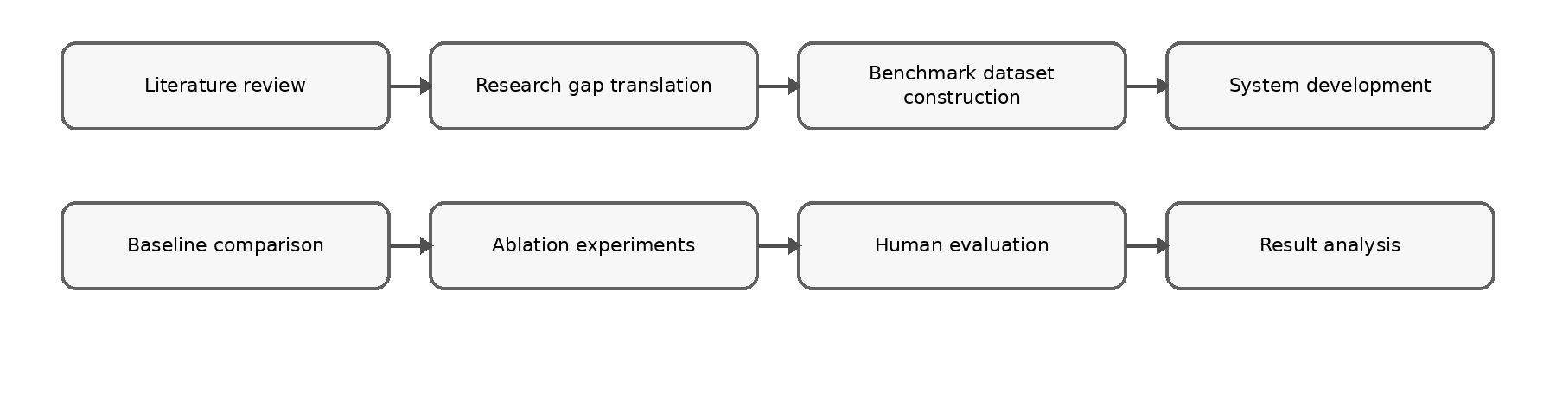Figure 3.1: Research Methodology Framework
Accordingly, this chapter defines the research design and workflow, research question and objective mapping, dataset and ground-truth preparation, preprocessing and leakage prevention, baseline selection, proposed AI method, experimental protocol, evaluation metrics, validation procedures, tools and reproducibility controls, and ethical, privacy, security and validity considerations.

Research Design or Framework
This research adopts a design science research approach supported by quantitative experimentation and human-centred evaluation. Design science is appropriate because the main output of the study is an artefact: a decision-support system that addresses a practical and research problem through design, implementation, demonstration and evaluation (Peffers et al., 2007). The artefact is evaluated as an AI-assisted methodology for producing actionable, intent-consistent, logically constrained and trust-calibrated marketing recommendations.
The research approach is bounded and experiment-driven. The dataset, decision-case representation, business intent taxonomy, recommendation action space, baseline configurations, ablation variants and evaluation metrics are fixed before final testing. This reduces arbitrary post-hoc adjustment and improves reproducibility. Offline benchmark evaluation is used because the project does not claim production deployment or long-term business impact. Human-centred evaluation is included because recommendation usefulness depends not only on technical correctness but also on whether users can understand and appropriately rely on the generated recommendation.
The design also follows a modular method structure. Each AI module is defined by its motivation, input representation, forward process, output and evaluation role. This organisation makes the methodology easier to reproduce because another researcher can identify what each module receives, how the module transforms the input and which metric assesses its contribution. The system is therefore evaluated as a transparent decision-support pipeline rather than as a monolithic black-box application.

Overview
Requirement gathering is literature-driven and problem-driven. Since the project addresses a research gap rather than a conventional client-commissioned system, requirements are derived from Chapter 2 literature synthesis, Chapter 1 problem statements and the methodological need to evaluate the proposed AI contribution. The process consists of literature analysis, problem analysis and framework synthesis:

Literature Analysis
The literature analysis identifies the need for predictive evidence, action recommendation, constraint-aware reasoning, strategic intent modelling, calibrated confidence and structured explanation. These findings become functional requirements for the data, reasoning, trust and explanation modules. The literature also defines the evaluation need for baselines, ablation variants, calibration metrics and human-centred assessment.

Problem Analysis
Problem analysis translates the attribution-to-action gap into technical requirements. Since SMEs may lack dedicated analytics expertise, the system must reduce interpretation burden by producing actionable recommendations. Since recommendations may affect spending, the system must expose evidence, constraints and confidence. Since business priorities vary, the system must condition recommendations on explicit intent scenarios.

Framework Synthesis
Framework synthesis combines literature analysis and problem analysis into a unified requirement set. The predictive-attribution backbone addresses evidence generation. Candidate action generation addresses actionability. Weighted soft-rule reasoning addresses feasibility and constraint handling. Intent-aware ranking addresses strategic alignment. Trust calibration and structured explanation address appropriate reliance and auditability. Figure 3.2 shows how research gaps are translated into functional and non-functional requirements.

Figure 3.2 Requirement Gathering Process

Development Strategy and Research Workflow
The proposed system is developed as a modular decision-support pipeline. The pipeline separates predictive-attribution analysis, candidate action generation, weighted soft-rule reasoning, intent-aware decision modelling, trust calibration and structured explanation generation. This modular design supports maintainability and directly supports ablation-first evaluation because individual modules can be removed or modified without rewriting the entire system.
The development sequence begins with data preparation because all later components depend on a consistent decision-case representation. Predictive and attribution outputs are then produced as evidence signals. These signals are not treated as final decisions. Candidate actions are generated and subsequently evaluated against rule-based constraints and business intent. Trust calibration and explanation generation are applied after the recommendation has been selected, so the final output includes both a recommended action and the information needed for human review.
The prototype remains a human-in-the-loop decision-support system. It recommends actions, reports confidence and explains reasoning, but it does not execute campaigns, modify advertising budgets or connect directly to live advertising platforms. This boundary preserves human accountability and keeps the project within a realistic software engineering scope. It also supports the ethical position that marketing decisions involving expenditure and risk should remain reviewable by a human manager.
Table 3.1 Research Methodology Framework
Phase | Research Activity | Methods / Techniques | Output
1 | Literature Review | Systematic review of marketing analytics, neuro-symbolic AI, trust calibration, explainable AI | Research gaps and design requirements
2 | Requirement Analysis | Problem analysis, framework synthesis, requirement elicitation | Functional and non-functional requirements
3 | Dataset Construction | Data collection, cleaning, preprocessing, feature engineering, decision case construction | Benchmark dataset with business intent labels
4 | System Development | Design Science Research, predictive-attribution model, weighted soft-rule reasoning | Proposed decision support system
5 | Ablation Experiments | Component removal experiments | Effect of each module on system performance
6 | Quantitative Evaluation | Accuracy, Scenario-Fit Rate, Conflict Rate, ECE, Latency | Performance evaluation
7 | Human Evaluation | Practitioner questionnaire, usefulness assessment, trust evaluation | User acceptance and trust analysis
8 | Result Analysis | Statistical comparison, baseline comparison, discussion | Findings and interpretation
9 | Conclusion | Summary, limitations, future work | Final conclusions

Research Question and Objective Mapping
Each research objective and research question is connected to a method, evidence source and measurable acceptance criterion. This traceability prevents the evaluation from depending on broad claims such as system usefulness or recommendation intelligence. Instead, each major claim must be supported by a dataset, baseline, metric, ablation variant or human-centred assessment.
The mapping is especially important because the research questions assess different qualities of the system. RQ1 focuses on whether predictive and attribution evidence can be converted into actionable recommendations. RQ2 focuses on confidence calibration and appropriate reliance. RQ3 focuses on intent-aware contextual fit across survival, retention and growth scenarios. RQ4 focuses on feasibility, auditability and prototype-level implementation constraints. The evaluation design therefore uses multiple metrics rather than treating prediction accuracy as the only indicator of success.
Table 3.2 summarises the relationship between the research objectives, research questions, implementation methods, experimental procedures, and evaluation metrics adopted throughout this study.
Table 3.2: Mapping of Research Objectives, Research Questions and Evaluation
Research Objective | Research Question | Method / System Component | Evaluation Evidence | Acceptance Criterion
RO1: Construct an anonymised benchmark dataset consisting of SME multi-channel marketing decision cases with predefined business intent scenarios. | RQ4 | Data audit, preprocessing, feature derivation, intent assignment, action labelling and benchmark freezing. | Dataset completeness, feature coverage, missing-value report, label review and reproducible split. | The dataset is sufficient for the selected experimental configuration and remains fixed before final evaluation.
RO2: Implement a predictive-attribution backbone integrated with weighted soft-rule recommendation reasoning. | RQ1 | Predictive evidence, attribution signals, bounded candidate actions and weighted rule scoring. | Baseline comparison against heuristic, predictive-only, attribution-only and post-hoc rule overlay systems. | The full framework improves actionability and reduces logical conflict compared with relevant partial baselines.
RO3: Develop a trust calibration and structured explanation module for AI-assisted recommendations. | RQ2 | Temperature scaling, confidence bins, Expected Calibration Error and driver-implication-action-caveat explanations. | Calibration analysis, overtrust rate, trust alignment and explanation-usefulness feedback. | The calibrated version reports lower calibration error and clearer reliance guidance than the uncalibrated variant.
RO4: Evaluate the proposed decision support system against existing baseline approaches. | RQ1–RQ4 | Controlled comparison across full framework, baselines and component-removal variants. | Accuracy, scenario-fit rate, conflict rate, actionability, ECE, latency and human-centred scores. | The complete system performs competitively while preserving acceptable latency and auditability.

Dataset, Corpus or Data Source
The dataset must provide enough variation for predictive modelling, attribution evidence and decision-case construction. The target configuration requires at least 500 campaign-period records, at least three marketing channels, a minimum observation period of six months and at least one measurable business outcome such as conversion, revenue, acquisition cost or return on investment. These conditions are selected to support meaningful evaluation of cross-channel marketing evidence and bounded recommendation generation.
If the dataset does not fully satisfy the target configuration, the experiment is reported as a simplified configuration and cross-channel conclusions are treated as exploratory. This fallback condition prevents the project from overclaiming beyond the available evidence. The system can still be evaluated as a decision-support pipeline, but conclusions about multi-channel interaction effects must be limited when the dataset contains fewer channels or insufficient observation periods.
The benchmark dataset is frozen before final evaluation. Freezing the benchmark means that the final test cases, intent labels, action labels and evaluation split are not changed after model tuning begins. This improves reliability because the system cannot be repeatedly adjusted to fit the final test cases. It also supports replication because the same cases can be reused for baselines, ablation variants and final comparison.
The primary data source is the Nykaa Marketing Campaign Performance Dataset from Kaggle. The dataset contains campaign-level attributes such as campaign type, target audience, marketing channel, impressions, clicks, leads, conversions, revenue, acquisition cost, ROI, engagement score, customer segment, language and campaign date. These attributes support both predictive evidence and decision-case reasoning because they capture performance, cost, channel and contextual factors.
The dataset is used as a structured academic benchmark rather than as a live business deployment dataset. The system does not require personally identifiable customer information, live customer tracking or direct social media account credentials. Only attributes required for modelling, rule evaluation, calibration, explanation and evaluation are retained. This design supports privacy-by-design and reduces unnecessary data exposure.
Derived features are constructed to support recommendation reasoning. Examples include click-through rate, conversion rate, cost per acquisition, revenue per conversion, ROI band, engagement band and channel saturation indicator. These features help translate raw campaign records into decision cases that can be interpreted by both predictive and symbolic components. Each derived feature is defined before final evaluation to avoid inconsistent interpretation during testing.
The target benchmark contains at least 500 campaign-period records covering at least three marketing channels and six months of observations. Its unit of analysis is the campaign-period record. Input fields cover campaign context, channel exposure, engagement, cost and outcome variables; derived fields include click-through rate, conversion rate, cost per acquisition, revenue per conversion, ROI band, engagement band and channel saturation. The controlled labels are the business-intent classes Survival, Retention and Growth and the recommendation classes Increase, Maintain, Decrease and Investigate. The final record count, class distribution and excluded records are reported after the reproducible data audit.

Data Collection, Sampling and Ground Truth
Each cleaned campaign-period record is transformed into a structured decision case. A decision case contains campaign features, derived performance indicators, a business intent label and a benchmark recommendation label where available. The decision-case representation is necessary because the project is not only predicting a numerical outcome; it is recommending a bounded managerial response under a specified strategic condition.
The three business intent categories are Survival, Retention and Growth. Survival prioritises cost control, risk reduction and cash preservation. Retention prioritises repeat customers, customer value and relationship maintenance. Growth prioritises acquisition and expansion when expected returns justify greater spending. These categories are intentionally bounded so that the same evidence can be evaluated under controlled strategic scenarios.
The action space is limited to Increase, Maintain, Decrease and Investigate. Increase indicates that additional investment or expansion is supported. Maintain indicates that the current strategy remains acceptable. Decrease indicates that reduced allocation is justified due to weak performance, excessive cost or conflict with constraints. Investigate indicates that the evidence is uncertain, contradictory or insufficient for confident action. This fixed action set makes recommendation accuracy, scenario fit and actionability measurable across all configurations.
Records are included when the fields needed to compute the selected performance, cost and outcome indicators are available or can be handled by a predefined missing-value rule. Duplicated records, unusable records and cases whose labels remain unresolved after review are excluded. Sampling preserves representation across channel and intent classes; where usable dates exist, chronological ordering is retained for splitting. The Kaggle dataset is accessed only under the access conditions published with the source and is stored in the controlled project workspace. Because the benchmark uses secondary campaign-level data and excludes personally identifiable customer information, individual customer consent is not collected; any separate human evaluation follows participant information and voluntary-consent procedures.
Ground-truth recommendation and intent labels are prepared using documented definitions for the three intents and four actions. Label quality is checked through independent review where more than one annotator is available. Cohen's Kappa measures nominal agreement beyond chance, disagreements are discussed against the written labelling rules, and cases that cannot be resolved are removed before the benchmark is frozen.

Data Preprocessing and Leakage Prevention
Preprocessing includes duplicate removal, missing-value handling, categorical encoding, feature standardisation, derived-feature validation and outlier checking. Derived metrics such as click-through rate, conversion rate, cost per acquisition and ROI are recomputed or validated where necessary. Missing numerical values are handled using documented imputation rules, while missing categorical values are assigned explicit unknown categories when appropriate.
Data leakage is controlled by learning preprocessing parameters from the training subset and applying them to validation and test data. The validation set is used for calibration and parameter selection, while the test set is reserved for final evaluation only. If campaign dates are available and sufficiently distributed, time-based splitting is preferred because it better represents a realistic scenario where future campaign cases are not available during model development. If time-based splitting is not feasible, stratified splitting by intent and channel is used to preserve class balance.
For manually labelled decision cases, annotation consistency is reviewed before the benchmark is frozen. Cohen’s Kappa is used when two or more annotators assign nominal labels because it accounts for chance agreement (Cohen, 1960). Disagreements are resolved through documented review, and unresolved cases can be excluded from final evaluation to protect benchmark reliability. Figure 3.3 summarises the data preparation workflow.

Figure 3.3 Data Preparation Workflow

Baseline Selection and Justification
The proposed framework is compared with baseline systems that represent partial solutions identified in the literature review. A heuristic scorecard baseline represents transparent rule-based decision support. A predictive-only baseline represents using model output without symbolic reasoning. An attribution-only baseline represents channel contribution without full action reasoning. A post-hoc rule overlay represents applying rules only after an initial action has already been selected.
Table 3.3: Baseline Systems and Expected Failure Modes
System | Purpose | Expected Failure Mode
Heuristic Scorecard | Tests whether manually defined thresholds are sufficient. | May ignore learned relationships across heterogeneous campaign cases.
Predictive-Only | Tests whether prediction alone can generate useful actions. | May recommend infeasible actions because constraints and intent are not considered.
Attribution-Only | Tests whether channel contribution can guide action selection. | May overvalue high-contribution channels despite cost, risk or saturation.
Post-Hoc Rule Overlay | Tests late-stage rule filtering against integrated soft-rule scoring. | May reject actions only after selection instead of balancing trade-offs during scoring.

For a fair comparison, every baseline receives the same prepared decision cases, uses the same four-action output space and is evaluated on the identical frozen test subset. Thresholds, model parameters and calibration choices are selected using training or validation data only. No baseline is allowed access to test labels, additional features or a different sampling procedure.

Proposed Method or Approach
Figure 3.4 shows the implementation pipeline. Marketing data are first cleaned and converted into decision cases. The predictive-attribution backbone then produces performance evidence and attribution signals. Candidate action generation converts evidence into bounded action alternatives. Weighted soft-rule reasoning evaluates feasibility and constraint satisfaction. Intent-aware ranking adjusts the recommendation for survival, retention or growth. Trust calibration and structured explanation then prepare the recommendation for human review.
The outputs of earlier stages become inputs to later stages. For example, the predictive-attribution backbone produces a performance score and evidence drivers, but it does not decide whether the campaign should be increased or reduced. Candidate action generation uses these signals to create possible actions. The soft-rule module then evaluates whether each action is feasible under cost, budget and channel constraints. The intent-aware module adjusts the ranking so that the same evidence can be interpreted differently under survival, retention and growth objectives.
The final recommendation package contains the selected action, calibrated confidence, activated reasoning evidence and structured explanation. This package supports auditability because a recommendation can be traced from the input case to predictive evidence, rule satisfaction, intent adjustment, confidence calibration and explanation. This trace also supports later testing in Chapter 5 because each stage produces measurable outputs.
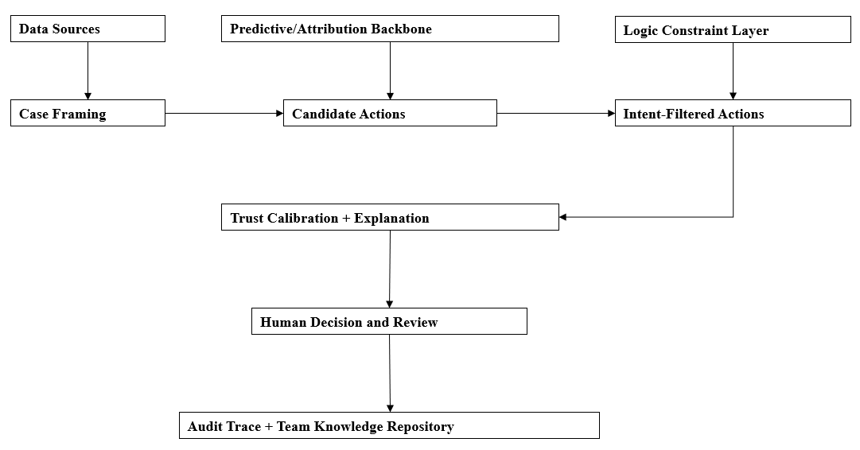
Figure 3.4: Implementation Pipeline for Decision Support System
Table 3.4: End-to-End Method Pipeline
Stage | Input | Processing | Output | Evaluation Link
Data preparation | Raw campaign records | Clean, validate, derive features and construct decision cases. | Frozen benchmark cases. | Dataset completeness and reproducibility.
Predictive-attribution backbone | Prepared decision cases | Estimate campaign outcome and attribution-related evidence. | Prediction score and evidence drivers. | Predictive and attribution baseline performance.
Candidate action generation | Prediction and attribution evidence | Generate Increase, Maintain, Decrease or Investigate alternatives. | Candidate action list. | Recommendation accuracy and actionability.
Weighted soft-rule reasoning | Candidate actions and rule base | Score budget, cost, risk, saturation and feasibility constraints. | Constraint-aware ranking. | Logical conflict rate.
Intent-aware decision module | Action ranking and intent label | Adjust priorities for Survival, Retention or Growth. | Intent-consistent recommendation. | Scenario-fit rate.
Trust and explanation layer | Final recommendation and evidence trace | Calibrate confidence and generate driver, implication, action and caveat. | Recommendation package for human review. | ECE, trust alignment and explanation usefulness.

The AI methodology is organised using a consistent module structure: motivation, module design and technical advantage. This makes the method easier to understand and evaluate because each component explains why it is needed, how it operates and which metric should show its contribution. Figure 3.5 summarises the main AI component architecture.
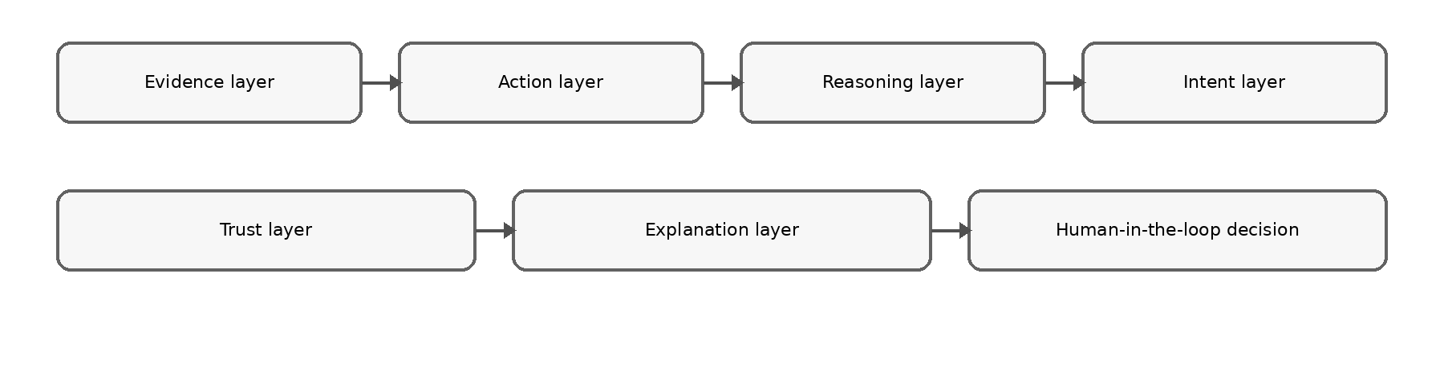
Figure 3.5: AI Component Architecture

Predictive-Attribution Backbone
The predictive-attribution backbone supplies campaign evidence before symbolic reasoning begins. A purely rule-based system may be transparent, but it may ignore learned relationships between campaign exposure, engagement, cost and revenue. A predictive model can estimate likely performance, while attribution-related evidence identifies which channel or campaign factors contribute to the predicted outcome. The backbone therefore provides an empirical evidence layer for later recommendation reasoning.
Given a prepared decision case, the module extracts channel exposure, engagement, conversion, revenue and cost features. It estimates a campaign performance signal and derives attribution-related evidence indicating influential channels or campaign factors. The output contains a prediction score, evidence drivers and confidence-related signals. These outputs are passed to candidate action generation and later reused by the explanation module.
The technical advantage of this separation is evaluability. The predictive-attribution backbone can be compared with the full framework to determine whether the reasoning, intent and trust layers add value beyond evidence generation. If the full framework improves actionability, scenario fit or conflict rate over the backbone-only configuration, the results support the need for integrated decision reasoning rather than prediction alone.

Candidate Action Generation
Candidate action generation addresses the attribution-to-action gap by converting analytical evidence into a bounded set of possible managerial actions. Prediction and attribution may indicate that a campaign performs well or poorly, but managers require a decision option such as increasing investment, maintaining the current strategy, decreasing allocation or investigating uncertain results. This module creates those action alternatives before rule and intent evaluation.
The module receives prediction scores, attribution drivers and derived performance indicators. It then generates eligible actions from the four-action set: Increase, Maintain, Decrease and Investigate. Strong performance and acceptable cost may make Increase eligible. Stable moderate performance may support Maintain. Weak performance or excessive acquisition cost may support Decrease. Conflicting evidence or low confidence may support Investigate. Multiple candidates can be generated, allowing the reasoning layer to rank alternatives instead of forcing an immediate decision.
The main advantage of a bounded action generator is consistent evaluation. All baselines and ablation variants use the same action labels, so recommendation accuracy, actionability and scenario-fit rate can be compared directly. The fixed action set also strengthens auditability because each recommendation category has a clear managerial interpretation.

Weighted Soft-Rule Reasoning
Weighted soft-rule reasoning tests whether candidate actions are feasible under SME business constraints. Prediction alone may recommend expansion for a campaign with strong conversion potential, but the same action may be unsuitable if acquisition cost is excessive, budget is limited, margin is weak or the channel appears saturated. Symbolic rules make these constraints explicit and reviewable.
The module evaluates each candidate action against predefined rule categories. Budget feasibility checks whether the action can be supported by available resources. Cost efficiency checks acquisition cost and return. Channel saturation checks whether increasing investment may produce diminishing returns. Risk rules penalise aggressive actions under uncertain evidence. Intent compatibility rules adjust the suitability of an action under Survival, Retention or Growth. Each rule returns a satisfaction score, and the final action score is computed through weighted aggregation.
Soft rules are used instead of strict hard rules because SME marketing decisions often involve partial trade-offs. A campaign may slightly exceed a preferred cost threshold but still be reasonable under a growth strategy if revenue potential is high. Conversely, a campaign may satisfy a performance threshold but remain unsuitable under a survival strategy. Weighted satisfaction therefore supports flexible reasoning while preserving transparency.
This module is evaluated mainly through logical conflict rate and actionability. A conflict occurs when the selected recommendation violates an important predefined constraint. If removing the soft-rule module increases conflict rate, the results support the contribution of explicit constraint-aware reasoning.

Intent-Aware Decision Module
The intent-aware decision module adjusts action ranking according to the selected strategic context. The same campaign evidence can justify different actions depending on whether the business is trying to survive, retain customers or grow. Without intent awareness, the system may optimise a generic performance target while producing recommendations that are misaligned with the current business objective.
Under Survival, the module places higher weight on cost control, risk reduction, margin protection and cash preservation. Under Retention, the module places greater emphasis on repeat-customer value, engagement quality and relationship-oriented indicators. Under Growth, the module gives greater weight to acquisition potential, conversion momentum and scalable channel performance, provided that rule violations remain controlled. The output is an intent-adjusted ranked list of candidate actions.
The main evaluation metric for this component is scenario-fit rate. Scenario-fit measures whether the selected action is compatible with the assigned strategic intent. If the no-intent ablation performs worse on scenario-fit, the result supports the claim that intent conditioning improves contextual relevance.

Trust Calibration Module
Trust calibration aligns confidence scores with observed recommendation reliability. Calibration is required because predictive models may produce overconfident or underconfident probabilities, and poorly calibrated confidence can encourage inappropriate reliance. A high confidence score should correspond to a higher likelihood of correctness, while a low confidence score should encourage additional checking.
The module applies temperature scaling as a post-processing calibration method. Temperature scaling adjusts predicted probabilities using a validation set without changing the ranking order of recommendations. Expected Calibration Error is then computed by grouping predictions into confidence bins and comparing average confidence with observed correctness in each bin (Guo et al., 2017). Lower ECE indicates better alignment between confidence and actual reliability.
The output of this module is a calibrated confidence score and a confidence category. High-confidence recommendations can support faster review, medium-confidence recommendations require normal review and low-confidence recommendations should trigger caution or investigation. The module is evaluated through ECE, overtrust rate and trust alignment. Removing this component should mainly affect confidence reliability rather than the action label itself.

Structured Explanation Generation
The explanation module generates a fixed explanation package consisting of Driver, Implication, Action and Caveat. The Driver states the main evidence behind the recommendation. The Implication translates the evidence into business meaning. The Action states the suggested response. The Caveat communicates uncertainty, risk or assumptions. This format is suitable for SME decision support because it avoids purely technical explanations while still preserving auditability.
Given the final recommendation, the module extracts the strongest evidence drivers, activated rules, selected intent and calibrated confidence. It then produces a concise explanation that links data evidence to the suggested action. For example, a recommendation to decrease investment may be explained by high acquisition cost, weak conversion and a survival intent. A recommendation to investigate may be explained by inconsistent evidence or low confidence.
The explanation module is evaluated through explanation usefulness and trust alignment. The goal is not to make users accept every recommendation. The goal is to help users understand why a recommendation was produced and how much caution is required before acting. This supports appropriate reliance and human accountability.

Figure 3.6 System Component Architecture

Experimental Design
The experimental framework combines baseline comparison and ablation testing. Baseline comparison determines whether the full framework improves upon simpler alternatives, while ablation testing determines whether each architectural component contributes measurable value. This design is necessary because the proposed framework integrates predictive evidence, attribution, symbolic rules, intent conditioning, calibration and explanation. Without ablation testing, any observed improvement could not be attributed to a specific component.
The overall experiment proceeds in four stages. First, the benchmark cases are prepared, labelled and frozen. Second, baseline systems are implemented using the same input cases and the same action labels. Third, the full system and ablation variants are run under controlled conditions. Fourth, technical and human-centred metrics are computed and compared. The same test cases are used across configurations to ensure that performance differences are caused by methodological differences rather than by changes in data.
The benchmark is divided into training, validation and testing subsets. Training data are used for model fitting, validation data are used for parameter tuning and confidence calibration, and the test set is reserved for final evaluation. Bootstrap confidence intervals are used to estimate uncertainty in metric differences, and Holm correction is applied where multiple pairwise comparisons are conducted (Efron, 1979; Holm, 1979). This statistical design supports cautious interpretation of results, especially when the benchmark size is limited.
Ablation experiments remove one major component at a time from the full framework. The same benchmark inputs are used across all configurations. The expected interpretation is component-specific: removing intent awareness should mainly affect scenario-fit, removing soft-rule reasoning should mainly affect logical conflict rate and actionability, and removing trust calibration should mainly affect Expected Calibration Error and overtrust rate.
The ablation design supports causal interpretation within the limits of the benchmark experiment. If the full framework outperforms the variant without soft rules on conflict rate, the difference can be attributed to explicit constraint reasoning. If the full framework outperforms the variant without intent awareness on scenario-fit, the difference can be attributed to strategic intent conditioning. If the full framework outperforms the variant without trust calibration on ECE or overtrust rate, the difference can be attributed to calibration. Figure 3.7 summarises the evaluation workflow.
Table 3.5: Ablation Configurations
Configuration | Predictive Backbone | Soft Rules | Intent Awareness | Trust Calibration | Explanation
Full Framework | Yes | Yes | Yes | Yes | Yes
Without Trust Calibration | Yes | Yes | Yes | No | Yes
Without Intent Awareness | Yes | Yes | No | Yes | Yes
Without Soft-Rule Reasoning | Yes | No | Yes | Yes | Yes
Backbone Only | Yes | No | No | No | No

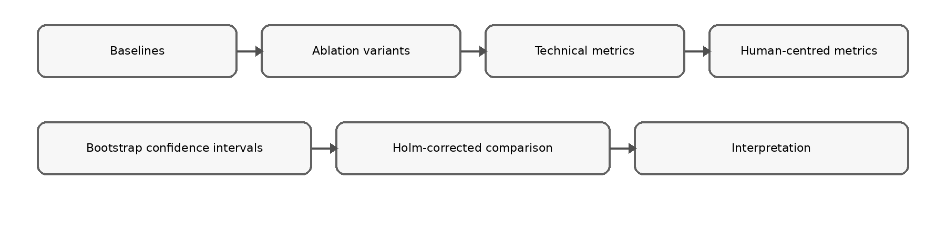
As shown in Table 3.5, the ablation study progressively removes selected architectural components to evaluate their individual contributions to the overall decision-support performance. By comparing these configurations, the research can determine whether weighted soft-rule reasoning, intent-aware decision modelling, and trust calibration provide measurable improvements over conventional predictive approaches.
Figure 3.7: Evaluation Workflow
Training, validation and test partitions remain identical across the full framework, baselines and ablations. Training fits predictive parameters; validation supports hyperparameter selection, rule-weight selection where applicable and temperature scaling; testing is performed once for final comparison. Fixed random seeds and logged configurations control stochastic variation. If repeated stochastic runs are required, the same predefined seed set is applied to every configuration and aggregate results are reported. Fairness controls include identical features, action labels, test cases, compute setting and metric implementations across comparison groups.

Evaluation Metrics and Acceptance Criteria
The evaluation uses technical and human-centred metrics. Technical metrics assess recommendation correctness, scenario alignment, constraint consistency, calibration and latency. Human-centred metrics assess actionability, explanation usefulness, trust alignment and user acceptance. This combination is necessary because the project evaluates a decision-support system rather than only a predictive model.
Table 3.6 Evaluation Metrics and Acceptance Criteria
Metric | Purpose | Acceptance Criterion
Recommendation Accuracy | Measures agreement with benchmark action labels. | Full framework should be competitive with or better than partial baselines.
Scenario-Fit Rate | Measures alignment with Survival, Retention and Growth scenarios. | Intent-aware variant should exceed the no-intent ablation.
Logical Conflict Rate | Measures violations of predefined constraints. | Full framework should reduce conflict rate compared with predictive-only and attribution-only baselines.
Expected Calibration Error | Measures confidence reliability. | Calibrated variant should report lower ECE than the uncalibrated variant.
Actionability Score | Measures practical usefulness using human ratings. | Mean score should indicate acceptable decision-support usefulness.
Explanation Usefulness | Measures clarity and reviewability of the explanation package. | Structured explanations should receive acceptable usefulness ratings.
Recommendation Latency | Measures response time for recommendation generation. | Latency should remain acceptable for prototype-level interactive use.

Recommendation Accuracy is the number of test cases whose recommended action matches the benchmark action divided by the total number of test cases; higher values are better. Scenario-Fit Rate is the proportion of recommendations judged compatible with the assigned intent; higher values are better. Logical Conflict Rate is the proportion of recommendations that violate at least one predefined important constraint; lower values are better. Expected Calibration Error is the confidence-weighted average absolute difference between mean confidence and empirical accuracy across confidence bins; lower values indicate better calibration.
Actionability and Explanation Usefulness are mean five-point participant ratings, where higher scores indicate more practical and reviewable outputs. Overtrust Rate is the proportion of incorrect or low-confidence recommendations that participants indicate they would accept without further checking; lower values are better. Recommendation Latency is elapsed time from a submitted decision case to the complete recommendation package; lower values are better provided that decision quality is preserved. Acceptance is determined by the directional criteria in Table 3.6 and by whether the full framework improves the objective-linked metric over the corresponding baseline or ablation.
Experimental results are reported using means, standard deviations, percentage differences and confidence intervals. Bootstrap confidence intervals estimate uncertainty in metric differences, Holm correction is used for multiple pairwise comparisons, and Cohen’s Kappa assesses agreement for manually labelled nominal categories (Cohen, 1960; Efron, 1979; Holm, 1979).
Statistical results are interpreted together with practical significance. A small improvement in prediction accuracy may be less important than a meaningful reduction in logical conflict rate or overtrust rate. Conversely, a system that is accurate but difficult to understand may still be unsuitable for SME decision support. The final interpretation therefore considers both quantitative results and human-centred feedback.

Testing and Validation Procedures
Participants are presented with selected benchmark scenarios, AI-generated recommendations, calibrated confidence scores and structured explanations. They rate recommendation relevance, actionability, explanation clarity, confidence appropriateness and overall usefulness using a five-point Likert scale. The purpose is to evaluate appropriate reliance rather than simple persuasion.
The evaluation materials are designed so that participants can review the same information that would be available in the prototype: campaign context, selected intent, recommended action, confidence level, driver, implication, action and caveat. Participants are not required to execute the recommendation. Their feedback is used to assess whether the output supports informed review. Low-confidence recommendations should encourage additional checking rather than blind acceptance.
Model validation compares predictions, recommendations, confidence and rule activations with frozen benchmark labels and constraint definitions. Functional validation verifies that campaign input, preprocessing, prediction, candidate generation, rule scoring, intent selection, calibration, explanation and recommendation logging produce the expected outputs. Reliability validation reruns-controlled configurations from recorded seeds and parameters. Usability validation uses the participant procedure above, while security and privacy checks verify access control, data minimisation, exclusion of personally identifiable information and aggregate reporting. Failed cases and unexpected outputs are logged for correction and regression testing.

Tools, Software, Hardware and Reproducibility

Development Environment
The proposed neuro-symbolic decision support system was developed as a web-based application using a modern full-stack architecture consisting of React, FastAPI, MySQL, and Python-based machine learning libraries. The frontend was implemented using React with the Vite build tool and TypeScript to provide a responsive, component-based user interface for SME users. React enables modular interface development, while Vite offers fast development and optimized production builds. TypeScript improves software reliability through static type checking and enhanced maintainability.
The backend services were implemented using FastAPI, a high-performance Python web framework designed for RESTful API development. FastAPI was selected because it integrates naturally with Python-based machine learning libraries, allowing prediction models and neuro-symbolic reasoning modules to be deployed without requiring cross-language communication.
MySQL was used as the relational database management system to store campaign records, recommendation history, business rules, evaluation results, and user information. Database access was managed using SQLAlchemy, which provides object-relational mapping (ORM) capabilities that simplify database interaction while improving maintainability.
The predictive component of the proposed framework was implemented using PyTorch, which provides a flexible deep learning framework for constructing neural network models. pandas was used for data preprocessing and feature engineering, while scikit-learn was used for dataset splitting, preprocessing utilities, baseline models, and evaluation metrics.
Table 3.7 Development Environment
Category | Technology | Purpose
Frontend Framework | React | Interactive user interface
Build Tool | Vite | Fast frontend development and production build
Programming Language | TypeScript | Type-safe frontend development
Backend Framework | FastAPI | RESTful API and AI service integration
Programming Language | Python | AI implementation and backend logic
Database | MySQL | Persistent storage of campaigns, recommendations, and evaluations
ORM | SQLAlchemy | Database access and object-relational mapping
Deep Learning Framework | PyTorch | Neural predictive model implementation
Data Processing | pandas | Data cleaning, preprocessing, and feature engineering
Machine Learning Utilities | scikit-learn | Dataset splitting, preprocessing, baseline models, and evaluation metrics
Version Control | GitHub | Source code management
IDE | Visual Studio Code | Software development
Operating System | Windows 11 | Development environment
Hardware | Intel Core i5 Processor, 24 GB RAM | Experimental platform

Software Versions
To ensure consistency and reproducibility, all software components were maintained using fixed versions throughout development and experimentation.
Table 3.8 Software Versions
Software | Version
Python | 3.12.x
React | 19.x
Vite | 7.x
TypeScript | 5.x
FastAPI | 0.115.x
SQLAlchemy | 2.x
MySQL | 8.x
PyTorch | 2.7.x
pandas | 2.x
scikit-learn | 1.7.x
Git | 2.x
Visual Studio Code | Latest Stable
Windows | Windows 11

Dependency Management
The project adopts standard dependency management practices to ensure that all development environments remain consistent.
Frontend dependencies are managed using npm, while backend Python packages are managed using pip and recorded in a requirements.txt file. This enables the complete software environment to be recreated on another machine using the same package versions.
Version control is maintained using GitHub, where source code revisions are tracked throughout the development lifecycle.

Experimental Reproducibility
Several measures were implemented to improve the reproducibility of the experimental results.
First, the benchmark dataset was frozen before model training. Once the training, validation, and testing datasets were established, they remained unchanged throughout all experiments, ensuring that every baseline, ablation study, and proposed model was evaluated using identical data.
Second, deterministic random seeds were applied during model training and dataset splitting to minimise variations caused by random initialisation and sampling.
Third, all source code was maintained using GitHub version control. Every implementation change was recorded through commit history, enabling previous experimental configurations to be recovered if necessary.
Furthermore, evaluation metrics, prediction outputs, and experimental configurations were logged automatically after each experiment. This facilitates fair comparison among baseline models, ablation studies, and the proposed neuro-symbolic framework.
Finally, business intent definitions, recommendation rules, benchmark datasets, and evaluation procedures were fixed before experimentation to prevent post-hoc modification of the evaluation process.

Reproducibility Measures
Table 3.9 Reproducibility Measures
Aspect | Measure
Dataset | Frozen benchmark dataset
Dataset Split | Fixed training, validation, and testing partitions
Randomness | Fixed random seeds for dataset splitting and PyTorch model training
Software | Fixed package versions
Source Code | GitHub version control
Dependencies | npm and pip package management
Evaluation | Standardised metrics and benchmark procedures
Logging | Prediction results and experiment configurations recorded

Discussion
The selected technology stack provides an effective balance between software engineering, machine learning, and research reproducibility. React, Vite, and TypeScript enable the development of a responsive and maintainable user interface, allowing SME users to interact efficiently with the recommendation system. FastAPI was selected as the backend framework because of its high performance and seamless integration with Python-based artificial intelligence libraries, enabling efficient deployment of the predictive and neuro-symbolic reasoning components through RESTful APIs.
MySQL and SQLAlchemy provide a reliable and scalable data management solution for storing campaign data, recommendation history, symbolic rules, and evaluation results. Their integration simplifies database operations while maintaining data consistency throughout the system. The predictive component is implemented using PyTorch, which provides the flexibility required to construct and train neural network models that form the "neuro" component of the proposed neuro-symbolic framework. Meanwhile, pandas and scikit-learn support efficient data preprocessing, feature engineering, dataset partitioning, and evaluation, forming the foundation of the experimental workflow.
To ensure scientific rigour, reproducibility measures such as fixed software versions, dependency management, frozen benchmark datasets, deterministic random seeds, GitHub version control, and standardised evaluation procedures were incorporated into the development process. These practices minimise experimental variability and enable future researchers to reproduce the implementation and compare alternative approaches under identical conditions. Consequently, the selected tools and reproducibility measures not only support the implementation of the proposed system but also strengthen the reliability, transparency, and validity of the experimental findings.

Ethical, Privacy, Security and Validity Considerations

Ethical Considerations
The proposed system functions strictly as a decision-support tool. It generates recommendations, confidence scores and explanations for human review, but it does not execute campaigns automatically. Final marketing decisions remain with the SME manager. This boundary is important because marketing recommendations may influence expenditure, risk and business accountability.

Privacy and Data Governance
The project applies data minimisation. Only attributes required for modelling, rule evaluation, calibration, explanation and evaluation are retained. Personally identifiable customer information is excluded. Benchmark results are reported in aggregate form. These practices are consistent with the privacy principles of Malaysia’s Personal Data Protection Act 2010, including purpose limitation and protection of personal data.

Experimental Reliability and Reproducibility
Reliability is supported through benchmark freezing, fixed random seeds, documented preprocessing steps, version control and recorded experimental configurations. The same test cases are used across all baselines and ablation variants. Rule definitions, intent labels, action labels and metric formulas are fixed before final evaluation so that results can be reproduced and compared fairly.

Study Limitations and Validity
The study is bounded to a prototype-level evaluation. The dataset may not represent every SME industry or campaign context. The action space is limited to Increase, Maintain, Decrease and Investigate, while the intent taxonomy is limited to Survival, Retention and Growth. These boundaries improve experimental control but limit generalisation. The evaluation is offline and benchmark-based, so the study cannot claim long-term business impact without future live deployment.
Internal validity is protected through a frozen test set, identical comparison cases and component-removal experiments, although benchmark labelling and rule definitions may still introduce judgement bias. Construct validity is supported by mapping each objective to explicit technical and human-centred metrics, while recognising that bounded actionability and scenario-fit measures cannot represent every managerial judgement. External validity is limited by the use of one secondary benchmark and three simplified SME intents. Conclusion validity is supported by confidence intervals, multiple-comparison correction and practical-significance interpretation, but findings remain subject to benchmark size and participant coverage.

Chapter Summary
This chapter presented the methodology for the proposed Intent-Aware Logic-Constrained Neuro-Symbolic Decision Support System with Trust Calibration. The methodology connects the literature gaps to an implementable AI pipeline consisting of predictive-attribution evidence, candidate action generation, weighted soft-rule reasoning, intent-aware ranking, trust calibration and structured explanation. The chapter also defined the dataset preparation process, baseline systems, ablation variants, evaluation metrics, ethical safeguards and system requirements.
The methodology framework, implementation pipeline, data preparation workflow, component architecture, evaluation workflow and requirement gathering process provide visual traceability between the proposed AI method, system requirements and subsequent system design. This traceability supports a consistent transition from methodology to implementation and testing.

Chapter 4

System Design and Implementation

System Design
This chapter presents the system design of the proposed Intent-Aware Logic-Constrained Neuro-Symbolic Decision Support System with Trust Calibration. Building upon the methodology established in Chapter 3, this chapter translates the proposed framework into a detailed architectural and technical design suitable for implementation.
The chapter describes the overall system architecture, processing workflow, Unified Modelling Language (UML) diagrams, database structure, algorithm design, and user interface design. These design components provide a blueprint for the implementation of the proposed decision support framework and ensure consistency between the identified requirements and the developed system.
The proposed architecture adopts a modular design strategy that separates predictive analytics, candidate action generation, logic-constrained reasoning, intent-aware decision modelling, trust calibration, and explanation generation into independent but interconnected components. This modular structure improves maintainability, scalability, and experimental flexibility.
The remainder of this chapter presents the detailed system design that supports the implementation and evaluation activities described in Chapter 5.

System Requirements Analysis

Functional Requirements
Table 4.1: Functional Requirements
ID | Functional Requirement | Related Module | Evaluation Link
FR1 | Import and validate marketing campaign data. | Data preparation | Dataset completeness.
FR2 | Construct benchmark decision cases. | Data preparation | Reproducible evaluation split.
FR3 | Generate predictive and attribution evidence. | Predictive-attribution backbone | Predictive and attribution baselines.
FR4 | Generate bounded candidate actions. | Candidate action generation | Recommendation accuracy and actionability.
FR5 | Apply weighted soft-rule reasoning. | Soft-rule reasoning | Logical conflict rate.
FR6 | Support intent-aware recommendation ranking. | Intent-aware decision module | Scenario-fit rate.
FR7 | Calibrate recommendation confidence. | Trust calibration | ECE and overtrust rate.
FR8 | Generate structured explanations. | Explanation generation | Explanation usefulness.
FR9 | Display recommendations for human review. | Presentation layer | User acceptance.
FR10 | Record outputs and evaluation feedback. | Logging and evaluation support | Auditability and reproducibility.

Non-Functional Requirements
Table 4.2: Non-Functional Requirements
Quality Attribute | Requirement | Rationale
Performance | Recommendation generation should complete within acceptable interactive response time. | Supports practical use by SME managers.
Reliability | Similar inputs under the same intent and rules should produce consistent recommendations. | Supports auditability and repeatability.
Explainability | Every recommendation should include driver, implication, action and caveat. | Supports human understanding.
Trustworthiness | Confidence estimates should be calibrated and caveats should communicate uncertainty. | Reduces inappropriate reliance.
Maintainability | Modules and rules should be independently modifiable. | Supports ablation testing and future extension.
Security | User accounts, campaign records and evaluation data should be protected from unauthorised access. | Protects business information.
Privacy | Unnecessary personal or customer-identifying information should not be collected. | Supports data minimisation.
Usability | Recommendations should be understandable to SME managers. | Supports decision-support adoption.

Use Case Analysis
The primary actor is the SME Marketing Manager. The main use cases are uploading or selecting campaign data, reviewing campaign analysis, generating recommendations, reviewing confidence scores, reviewing structured explanations, making a final decision and providing evaluation feedback. Administrative use cases include managing rule definitions and benchmark configurations where authorised

System Constraints
The system requires human approval before any marketing action is executed. Direct integration with live ERP, CRM or advertising platforms is outside the project scope. The prototype focuses on decision support rather than autonomous optimisation. Recommendation quality depends on the availability and quality of historical campaign data. Findings are limited to benchmark decision cases unless future live deployment is conducted.

Overall System Architecture
The proposed system adopts a layered neuro-symbolic architecture that integrates data-driven prediction with symbolic reasoning and trust-aware decision support.
The architecture consists of six major modules that cooperate to transform marketing performance data into actionable and explainable recommendations. Each module performs a dedicated function while exchanging information with adjacent components through structured interfaces.
Marketing data are first collected and pre-processed before being analysed by the predictive-attribution backbone. Candidate marketing actions are then generated and evaluated against business rules using the logic-constrained reasoning module. The intent-aware decision module subsequently adjusts recommendation priorities according to organisational objectives. Trust calibration estimates recommendation reliability, and the explanation generation module provides transparent decision rationales to support managerial review.
The final decision remains under human control, ensuring that the proposed framework functions as a decision support system rather than an autonomous marketing execution platform.
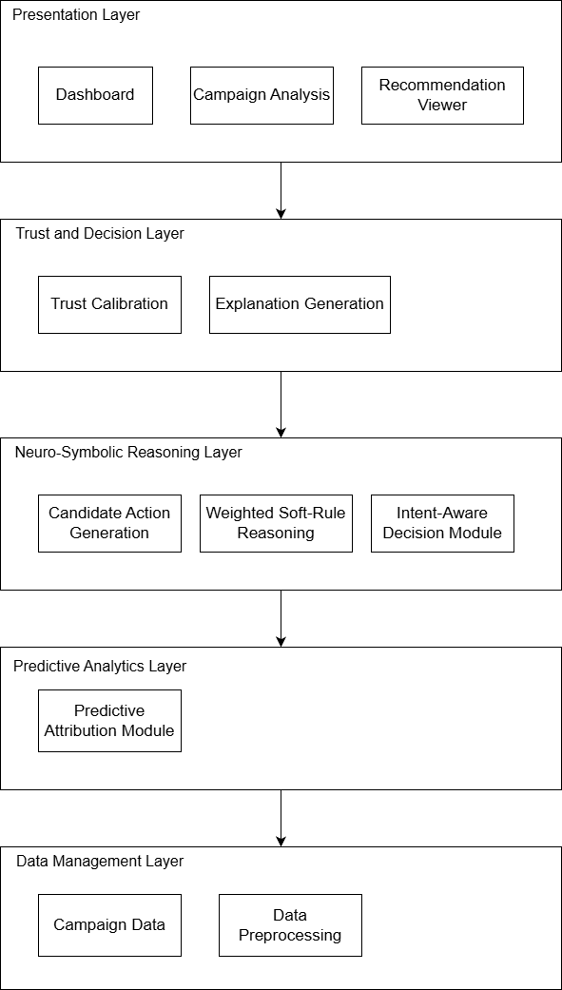
Figure 4.1 Overall System Architecture
Figure 4.1 illustrates the overall architecture of the proposed neuro-symbolic marketing recommendation system, which is organised into five functional layers: the Presentation Layer, Trust and Decision Layer, Neuro-Symbolic Reasoning Layer, Predictive Analytics Layer, and Data Management Layer. The layered architecture separates the system into independent components with well-defined responsibilities, improving modularity, maintainability, and scalability while supporting the explainable AI objectives of this research.
The Data Management Layer serves as the foundation of the system by storing campaign data and performing data preprocessing. Raw campaign information is cleaned, validated, and transformed into a structured format suitable for predictive modelling and symbolic reasoning. The processed data is then forwarded to the Predictive Analytics Layer, where the Predictive Attribution Module analyses campaign characteristics and estimates the contribution of different marketing factors. These predictive outputs provide the initial evidence for the recommendation process.
The predictions generated by the predictive attribution module are subsequently passed to the Neuro-Symbolic Reasoning Layer, which represents the core contribution of the proposed system. This layer first generates feasible candidate marketing actions based on the predictive results. The Weighted Soft-Rule Reasoning component then evaluates these candidate actions against predefined marketing knowledge rules, allowing probabilistic reasoning while accommodating uncertainty through weighted rule satisfaction. Finally, the Intent-Aware Decision Module refines the recommendations by considering the user's marketing objectives and campaign context, ensuring that the final recommendations align with business goals rather than relying solely on statistical predictions.
After the recommendation reasoning process is completed, the outputs are processed by the Trust and Decision Layer. The Trust Calibration component evaluates the reliability of each recommendation by analysing prediction confidence and symbolic rule consistency, while the Explanation Generation component produces human-readable explanations that describe the reasoning behind each recommendation. These two components improve the transparency and interpretability of the recommendation process, enabling users to understand not only what recommendation is produced but also why it is suggested.
Finally, the processed recommendations, trust scores, and explanations are presented through the Presentation Layer, which consists of the Dashboard, Campaign Analysis, and Recommendation Viewer interfaces. These interfaces enable SME users to manage campaign information, analyse campaign performance, and review AI-generated recommendations together with their associated explanations and trust scores. The top-down data flow illustrated in the architecture demonstrates how raw campaign data is progressively transformed into explainable and trustworthy marketing recommendations through the integration of predictive analytics and neuro-symbolic reasoning.

System Workflow Design

High-Level Workflow
The overall workflow of the proposed framework begins with the acquisition of marketing performance data. After preprocessing, predictive analysis identifies significant marketing patterns and channel contributions.
Based on these analytical outputs, candidate actions are generated and evaluated through symbolic business constraints. Strategic intent information is then incorporated to ensure that recommendations remain aligned with organisational objectives.
Trust calibration estimates the reliability of each recommendation, and structured explanations are generated to improve transparency and support managerial understanding. Finally, the user reviews the recommendation and determines the appropriate business action.

Figure 4.2 High-Level Workflow

Module Design
To improve maintainability and modularity, the proposed system is organised into several functional modules. Each module performs a dedicated responsibility while interacting with other modules through well-defined interfaces. This modular design simplifies future extension, improves system maintainability, and supports the layered neuro-symbolic architecture described in Section 4.1.

User Management Module
Purpose: Manage user authentication, profile information, and personalised preferences.
Input: User registration details, login credentials, profile updates.
Processing: The module validates user input, authenticates user credentials, manages user sessions, and updates user profile information stored in the system database.
Output: Authenticated user session and personalised user profile.
Supported Requirements: FR-01, FR-02 and associated security-related non-functional requirements.

Campaign Input Module
Purpose: Collect campaign information required for recommendation generation.
Input: Marketing objective, campaign type, target audience, budget, platform, and additional campaign constraints.
Processing: The module validates user input, checks mandatory fields, standardises the submitted campaign information, and prepares it for the recommendation engine.
Output: Validated campaign information ready for recommendation generation.
Supported Requirements: FR-03 and FR-04.

Predictive Attribution Module
Purpose: Estimate the suitability of candidate marketing strategies using the neural prediction component.
Input: Structured campaign features.
Processing: Extracts campaign features and generates probabilistic suitability scores using the predictive model.
Output: Initial recommendation candidates with calibrated confidence values.
Supported Requirements: FR-05.

Neuro-Symbolic Reasoning Module
Purpose: Refine AI-generated marketing recommendations by integrating predictive outputs with expert-defined marketing knowledge rules, thereby improving recommendation accuracy, consistency, and interpretability.
Input: Initial recommendation scores generated by the predictive attribution module together with predefined weighted marketing knowledge rules stored in the system.
Processing: The module evaluates the applicability of each marketing knowledge rule based on the campaign characteristics provided by the user. Each rule contributes a weighted adjustment to the initial recommendation scores according to its relevance. The adjusted scores are then normalised and ranked to produce the final recommendations. When multiple rules apply simultaneously, their weighted contributions are aggregated to generate a balanced recommendation while reducing potential conflicts between competing suggestions.
Output: A ranked list of marketing recommendations with adjusted confidence scores and the corresponding activated reasoning rules used to support each recommendation.
Supported Requirements: FR-06 and FR-07.

Explanation Generation Module
Purpose: Improve recommendation transparency by explaining why recommendations are produced.
Input: Final recommendations, activated rules, confidence values, and supporting evidence.
Processing: Generates natural language explanations describing reasoning paths, activated constraints, and recommendation justification.
Output: Explainable recommendation report.
Supported Requirements: FR-08.

Recommendation History Module
Purpose: Maintain historical recommendation records for user review and evaluation.
Input: Final recommendation results and user confirmation actions.
Processing: Stores recommendation history, timestamps, confidence values, and user feedback.
Output: Historical recommendation records accessible through the application interface.
Supported Requirements: FR-09 and evaluation support requirements defined in Chapter 3.

UML Design

Class Diagram
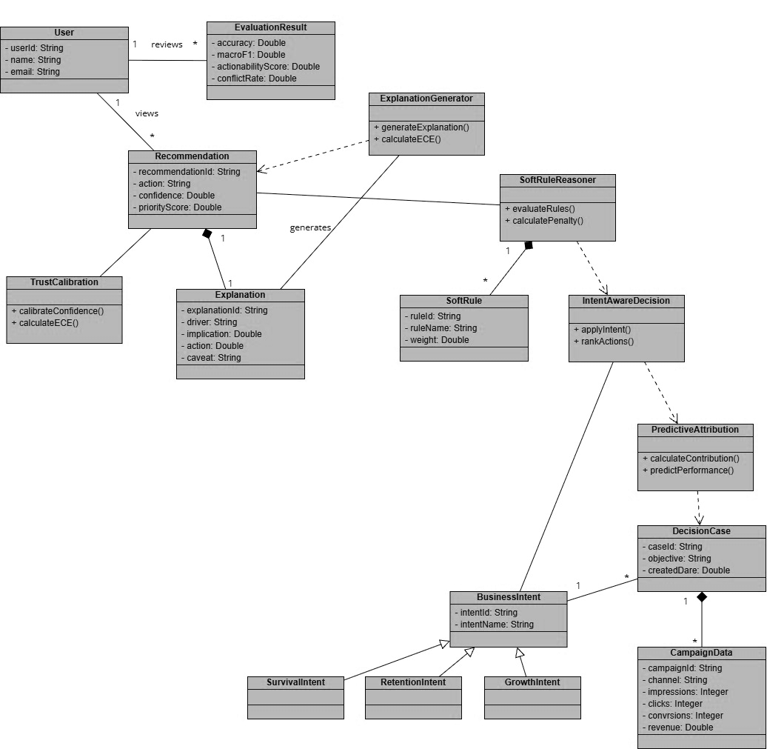
Figure 4.3 Class Diagram

Figure 4.3 illustrates the class diagram of the Intent-Aware Logic-Constrained Neuro-Symbolic Decision Support System with Trust Calibration for SME Multi-Channel Marketing. The system integrates predictive analytics, symbolic reasoning, intent modelling, trust calibration, and explanation generation to produce transparent and reliable marketing recommendations.

The main components and their roles are described as follows:

- User: Represents the SME manager who interacts with the system to view recommendations and review evaluation results.
- EvaluationResult: Stores the evaluation metrics (accuracy, macro F1, actionability score, and conflict rate) produced from system assessments.
- Recommendation: The core output delivered to the user, containing the recommended action, confidence level, and priority score.
- ExplanationGenerator: Generates structured explanations and calculates Expected Calibration Error (ECE) for calibration assessment.
- SoftRuleReasoner: Evaluates weighted soft rules and computes penalties for rule violations, ensuring recommendations align with business constraints.
- SoftRule: Defines individual business rules with associated weights used during reasoning.
- IntentAwareDecision: Adjusts and ranks recommended actions according to the detected business intent.
- Predictive Attribution: Performs predictive attribution to estimate channel contributions and forecast performance.
- Decision Case: Represents a specific marketing decision scenario with its objective and contextual information.
- BusinessIntent: Defines the type of business intent guiding decision-making (Survival, Retention, Growth).
- CampaignData: Contains multi-channel marketing campaign data used for prediction and attribution.
- TrustCalibration: Calibrates the confidence scores of recommendations and computes ECE for trust assessment.
- Explanation: Stores the structured explanation consisting of driver, implication, action, and caveat.
Key Relationships:
  - A User views many Recommendations and reviews many EvaluationResults.
  - A Recommendation is generated with one Explanation, calibrated by TrustCalibration, and explained by ExplanationGenerator.
  - Recommendation is produced based on SoftRuleReasoner evaluation results.
  - SoftRuleReasoner uses many SoftRules and influences IntentAwareDecision.
  - IntentAwareDecision relies on Predictive Attribution, which uses data from DecisionCase.
  - A BusinessIntent can be associated with many DecisionCases.
  - Each DecisionCase is linked to many CampaignData records.
  - BusinessIntent has three subtypes: SurvivalIntent, RetentionIntent, and Growth Intent.

Use Case Diagram
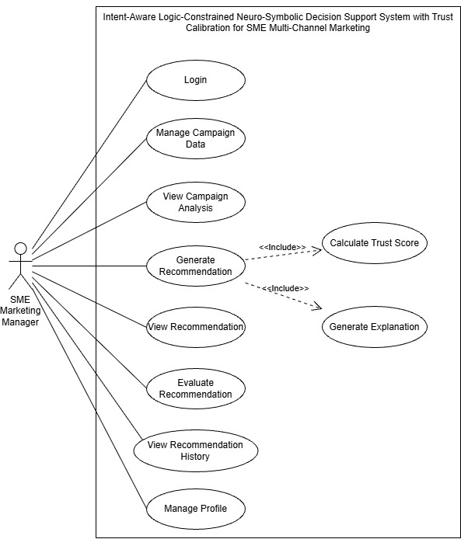
Figure 4.4 Use Case Diagram
The Use Case Diagram illustrates the interactions between the SME Marketing Manager and the proposed Intent-Aware Logic-Constrained Neuro-Symbolic Decision Support System with Trust Calibration for SME Multi-Channel Marketing. It shows the main functionalities provided by the system and how the user interacts with them to support marketing decision-making.
The diagram contains a single primary actor, the SME Marketing Manager, who is responsible for managing campaign data, generating marketing recommendations, and evaluating system outputs. The actor interacts with several use cases within the system boundary.
1. Login
The Login use case allows the SME Marketing Manager to authenticate and securely access the system. User credentials are verified before granting access to marketing data and recommendation functionalities.
2. Manage Campaign Data
The Manage Campaign Data use case enables the manager to add, edit, update, or remove campaign information from different marketing channels such as social media, email marketing, and online advertisements. This campaign data serves as input for the recommendation engine.
3. View Campaign Analysis
The View Campaign Analysis use case allows the manager to examine historical campaign performance metrics such as impressions, clicks, conversions, and revenue generation. These analytics provide insights into the effectiveness of previous marketing strategies.
4. Generate Recommendation
The Generate Recommendation use case is the core functionality of the system. Based on campaign performance data, business objectives, symbolic business rules, and marketing intent, the system generates intelligent recommendations for future actions, such as increasing advertising budget allocation, changing channels, or adjusting campaign strategies.
This use case includes two additional processes:
- Calculate Trust Score
- Generate Explanation
These are modelled using the <<include>> relationship because they are mandatory processes executed whenever recommendations are generated.
5. Calculate Trust Score
The Calculate Trust Score use case computes a confidence value for each recommendation generated by the neuro-symbolic reasoning engine. Trust calibration helps users understand the reliability and uncertainty associated with the recommendation, improving transparency and reducing over-reliance on AI decisions.
6. Generate Explanation
The Generate Explanation use case provides explainable AI capabilities by describing the reasoning behind each recommendation. The explanation may include contributing campaign metrics, activated business rules, predicted outcomes, and confidence levels, enabling users to better understand and justify the suggested actions.
7. View Recommendation
The View Recommendation use case allows the manager to review the generated recommendations together with their trust scores and explanations before making a final marketing decision.
8. Evaluate Recommendation
The Evaluate Recommendation use case enables the manager to provide feedback on recommendation quality and usefulness. This feedback is later used to assess system performance and improve future recommendations.
9. View Recommendation History
The View Recommendation History use case allows the manager to access previously generated recommendations, trust scores, explanations, and evaluation results. Historical records support auditing and performance monitoring of marketing decisions over time.
10. Manage Profile
The Manage Profile use case enables the SME Marketing Manager to update personal information, change passwords, and maintain account settings to ensure secure and personalized system usage.
Include Relationships
The use case diagram contains two <<include>> relationships:
- Generate Recommendation → Calculate Trust Score
  - Every recommendation generated by the system must be accompanied by a trust score to indicate its confidence level and reliability.
- Generate Recommendation → Generate Explanation
  - Every recommendation must also include an explanation to improve interpretability and user trust in the AI-generated decisions.
Summary
Overall, the use case diagram demonstrates how the proposed system integrates neuro-symbolic reasoning, business rule constraints, explainable AI, and trust calibration to support SME marketing managers in making informed and transparent multi-channel marketing decisions. By combining recommendation generation with trust assessment and explanation mechanisms, the system aims to improve both decision quality and user confidence in AI-assisted marketing strategies.

Activity Diagram
A1. Overall System Workflow
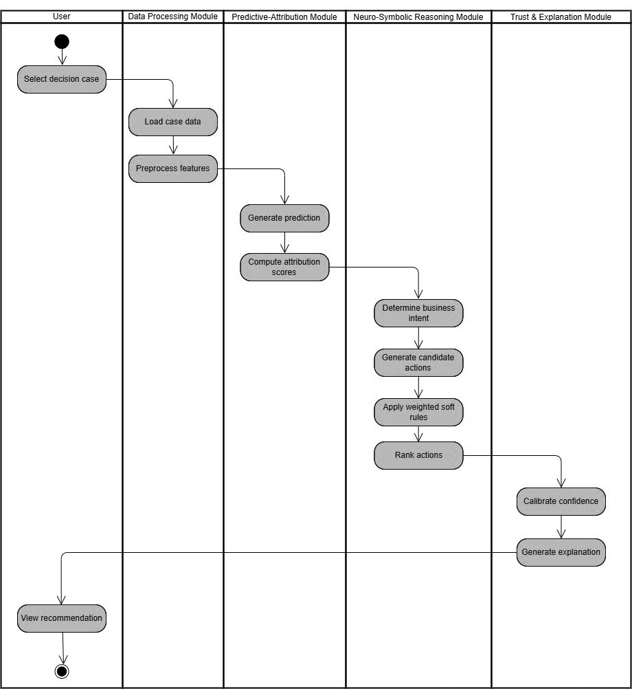
Figure 4.5 Overall System Workflow
Figure 4.5 illustrates the activity flow of the proposed Intent-Aware Logic-Constrained Neuro-Symbolic Decision Support System with Trust Calibration for SME Multi-Channel Marketing. The workflow is divided into five major components, namely the User, Data Processing Module, Predictive-Attribution Module, Neuro-Symbolic Reasoning Module, and Trust & Explanation Module.
The process begins when the SME Marketing Manager selects a decision case that requires marketing decision support. The selected case is forwarded to the Data Processing Module, where the system loads the relevant campaign information and preprocesses the input features to ensure consistency and suitability for machine learning analysis. This preprocessing stage includes data cleaning, normalization, and feature transformation.
The processed data is then passed to the Predictive-Attribution Module. In this module, the predictive model generates performance predictions for the selected campaign scenario. Subsequently, attribution scores are computed to identify the relative contribution of each feature or marketing channel towards the predicted outcome. These attribution scores provide insight into the factors influencing the prediction results.
Next, the Neuro-Symbolic Reasoning Module receives the prediction outputs and attribution information to perform higher-level reasoning. The system first determines the current business intent, such as growth maximization, customer retention, or business survival. Based on the identified intent, multiple candidate actions are generated as potential recommendations. The system then applies weighted soft rules that represent domain knowledge and business constraints to evaluate each candidate action. Finally, the actions are ranked according to their predicted effectiveness and compliance with business objectives and constraints.
The ranked recommendations are subsequently forwarded to the Trust and Explanation Module. In this stage, confidence calibration is performed to estimate the reliability of the generated recommendations and produce a trust score for each action. The system then generates human-readable explanations that describe the reasoning process, influential factors, and business rules involved in producing the recommendation.
After completing the recommendation generation process, the final recommendation, together with its trust score and explanation, is presented to the SME Marketing Manager for review and decision-making. The activity diagram demonstrates the integration of predictive analytics, symbolic reasoning, trust calibration, and explainable artificial intelligence to provide transparent, reliable, and context-aware decision support for SME marketing management.
A2. Decision Recommendation Generation
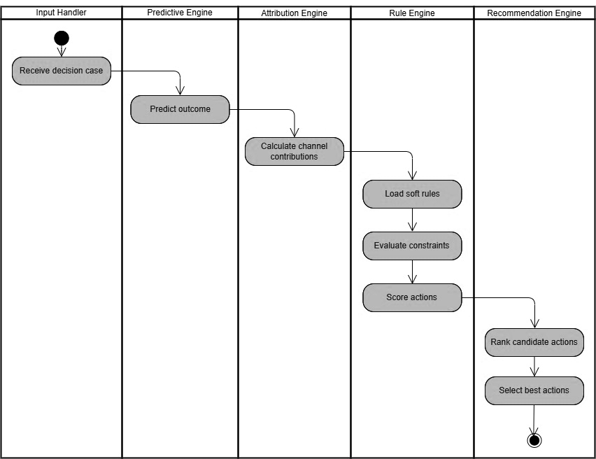
Figure 4.6 Decision Recommendation Generation Workflow
Figure 4.6 illustrates the activity flow of the recommendation generation process in the proposed Intent-Aware Logic-Constrained Neuro-Symbolic Decision Support System for SME Multi-Channel Marketing. The workflow is divided into five major components, namely the Input Handler, Predictive Engine, Attribution Engine, Rule Engine, and Recommendation Engine.
The process begins when the Input Handler receives a decision case submitted by the user. The decision case contains relevant marketing information and business context that require analysis and recommendation generation. The received input is then forwarded to the Predictive Engine for further processing.
Within the Predictive Engine, the system predicts the expected outcome of the decision case using the selected machine learning model. The prediction may include expected campaign performance indicators such as conversion rate, revenue, customer acquisition, or return on investment.
The prediction results are subsequently passed to the Attribution Engine, where channel contribution scores are calculated to determine the influence of each marketing channel on the predicted outcome. This process enables the system to identify which channels contribute positively or negatively towards the overall marketing objective.
The calculated attribution information is then forwarded to the Rule Engine. The Rule Engine first loads a set of weighted soft rules that represent domain knowledge, business objectives, and operational constraints. These rules are then used to evaluate the feasibility and suitability of potential marketing actions. Based on the evaluation results, the system assigns scores to the candidate actions according to their expected effectiveness and compliance with the defined business rules.
The scored actions are subsequently transferred to the Recommendation Engine, where the candidate actions are ranked according to their scores and predicted benefits. The system then selects the best actions as the final recommendations for the user.
Finally, the recommendation generation process terminates after the optimal actions have been identified and prepared for presentation to the user. This activity flow demonstrates how predictive analytics, attribution analysis, and rule-based reasoning are integrated to produce intelligent, explainable, and business-aware marketing recommendations for SMEs.
A3. Trust Calibration & Explanation
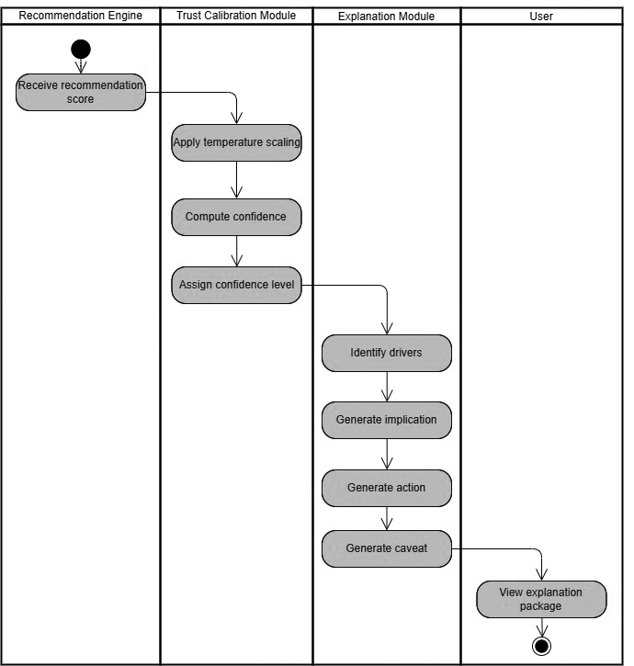
Figure 4.7 Trust Calibration & Explanation Workflow
Figure 4.7 illustrates the workflow of the Trust Calibration and Explanation Generation process in the proposed Intent-Aware Logic-Constrained Neuro-Symbolic Decision Support System for SME Multi-Channel Marketing. The activity is divided into four major components, namely the Recommendation Engine, Trust Calibration Module, Explanation Module, and User.
The process begins when the Recommendation Engine produces a recommendation score for the selected marketing action and forwards it to the Trust Calibration Module. The trust calibration process aims to improve the reliability and interpretability of the recommendation confidence values generated by the predictive model.
Within the Trust Calibration Module, the system first applies temperature scaling to calibrate the raw prediction scores produced by the recommendation engine. Temperature scaling reduces overconfidence and improves the alignment between predicted probabilities and actual outcomes. After calibration, the system computes the confidence value associated with the recommendation and subsequently assigns an appropriate confidence level to indicate the reliability of the generated recommendation.
The calibrated confidence information is then passed to the Explanation Module. In this module, the system first identifies the key drivers that contributed to the recommendation decision, such as influential marketing channels, campaign performance indicators, or business objectives. Based on these drivers, the system generates the business implications associated with the recommendation and proposes the corresponding action that should be taken by the marketing manager.
In addition, the Explanation Module generates a caveat section that highlights potential risks, uncertainties, or assumptions associated with the recommendation. This ensures that users are aware of the limitations of the recommendation and can make more informed decisions.
Finally, the generated explanations, confidence information, recommended actions, and caveats are combined into an explanation package and presented to the user for review. The activity diagram demonstrates how trust calibration and explainable artificial intelligence techniques are integrated to improve transparency, reliability, and user confidence in AI-assisted marketing decisions.
A4. Experimental Evaluation Workflow
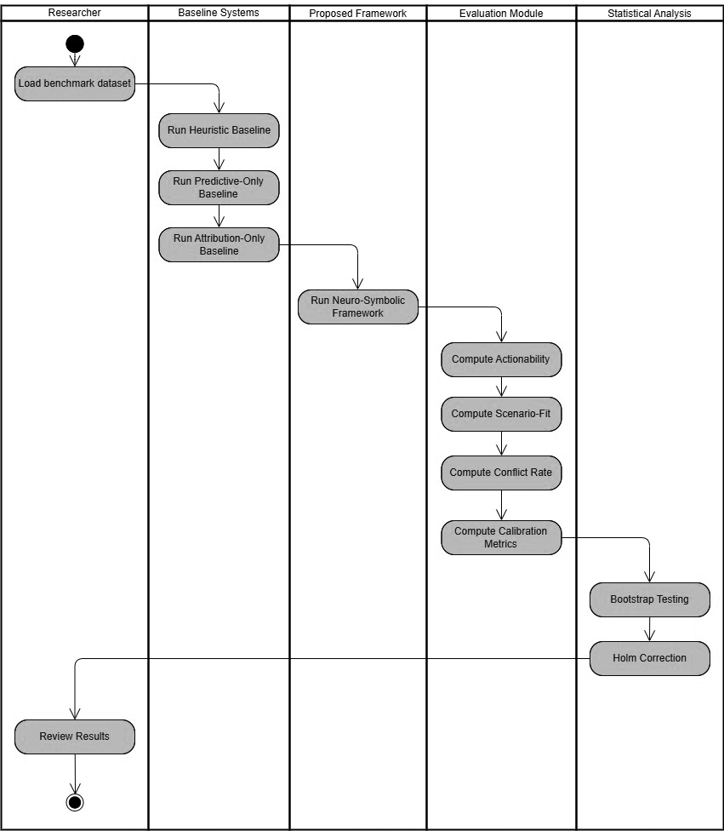
Figure 4.8 Experimental Evaluation Workflow
Figure 4.8 illustrates the evaluation workflow used to assess the performance of the proposed Intent-Aware Logic-Constrained Neuro-Symbolic Decision Support System with Trust Calibration for SME Multi-Channel Marketing. The process is divided into five major components, namely the Researcher, Baseline Systems, Proposed Framework, Evaluation Module, and Statistical Analysis Module.
The evaluation process begins when the researcher loads the benchmark dataset containing predefined marketing decision cases and ground truth outcomes. The benchmark dataset is used to ensure fair and consistent comparisons among different approaches.
The dataset is first evaluated using several baseline methods. The first baseline is the Heuristic Baseline, which generates recommendations using manually defined business rules and expert knowledge without machine learning capabilities. The second baseline is the Predictive-Only Baseline, which relies solely on predictive modelling to generate recommendations without incorporating symbolic reasoning or business constraints. The third baseline is the Attribution-Only Baseline, which utilises attribution information to guide decision-making but does not perform higher-level reasoning or intent-aware recommendation generation.
After evaluating the baseline approaches, the same dataset is processed using the proposed Neuro-Symbolic Framework. The framework integrates predictive modelling, attribution analysis, intent-aware reasoning, soft-rule constraints, trust calibration, and explainable artificial intelligence to generate recommendations for each decision case.
The generated outputs are subsequently passed to the Evaluation Module, where multiple evaluation metrics are computed. The Actionability Score measures the practical usefulness of the generated recommendations for real-world business decision-making. The Scenario-Fit Score evaluates the extent to which the recommendations align with the intended business objectives and decision context. The Conflict Rate measures the frequency of recommendations that violate business rules or generate contradictory actions. In addition, Calibration Metrics are computed to assess the quality and reliability of the confidence estimates produced by the trust calibration component.
The evaluation results are then forwarded to the Statistical Analysis Module for significance testing. The system first performs Bootstrap Testing to estimate the robustness and stability of the evaluation results through repeated sampling procedures. Subsequently, Holm Correction is applied to adjust for multiple hypothesis testing and reduce the probability of false positive findings when comparing multiple methods simultaneously.
Finally, the researcher reviews the evaluation outcomes and comparative results to determine the effectiveness of the proposed framework relative to the baseline approaches. This evaluation workflow ensures that the proposed system is assessed not only in terms of predictive performance but also with respect to recommendation quality, business relevance, trustworthiness, and statistical significance.
A5. Dataset Preparation

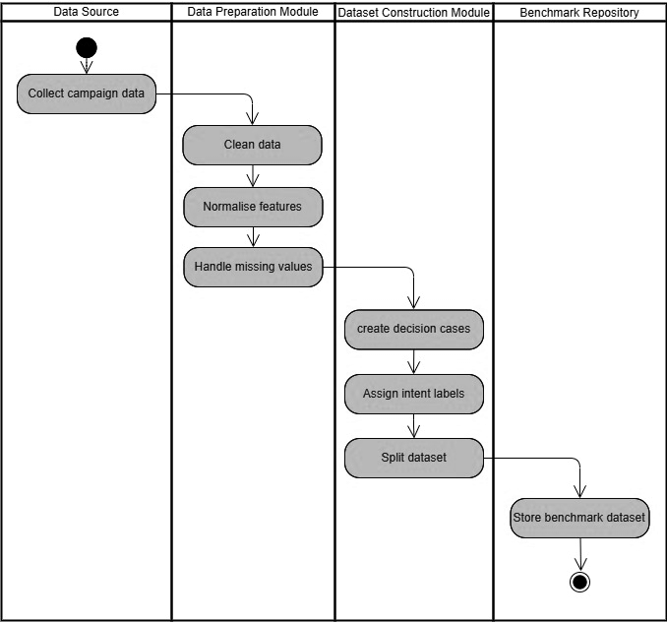
Figure 4.9 Dataset Preparation Workflow
Figure 4.9 illustrates the workflow for constructing the benchmark dataset used in the proposed Intent-Aware Logic-Constrained Neuro-Symbolic Decision Support System with Trust Calibration for SME Multi-Channel Marketing. The process is divided into four major components, namely the Data Source, Data Preparation Module, Dataset Construction Module, and Benchmark Repository.
The process begins at the Data Source stage, where campaign data from multiple marketing channels are collected. The collected data may include campaign performance indicators such as impressions, clicks, conversions, advertising expenditure, revenue, and customer engagement metrics. These data serve as the foundation for developing and evaluating the proposed decision support framework.
The collected campaign data are subsequently forwarded to the Data Preparation Module for preprocessing. The first preprocessing step involves cleaning the data to remove duplicate records, inconsistent entries, and erroneous values that may affect model performance. The system then normalizes the feature values to ensure that variables with different scales can be processed effectively by the machine learning algorithms. Missing values are subsequently identified and handled using appropriate imputation techniques to improve data quality and maintain dataset consistency.
After preprocessing, the cleaned data are passed to the Dataset Construction Module. In this stage, individual marketing decision cases are created from the processed campaign records. Each decision case represents a specific business scenario requiring marketing recommendations. The system then assigns business intent labels to each decision case, such as growth, customer retention, or business survival, to support intent-aware decision-making within the neuro-symbolic framework.
Following the labeling process, the dataset is divided into separate subsets for training, validation, and testing purposes. Dataset splitting ensures fair evaluation and prevents information leakage between model development and performance assessment stages.
Finally, the constructed benchmark dataset is stored in the Benchmark Repository for future use in model training, baseline comparisons, and evaluation experiments. The benchmark repository serves as a centralized storage location that ensures reproducibility and consistency throughout the research process.
This activity workflow demonstrates the systematic process used to prepare high-quality benchmark data for developing, training, and evaluating the proposed neuro-symbolic decision support framework.

Sequence Diagram
S1. Main System Interaction
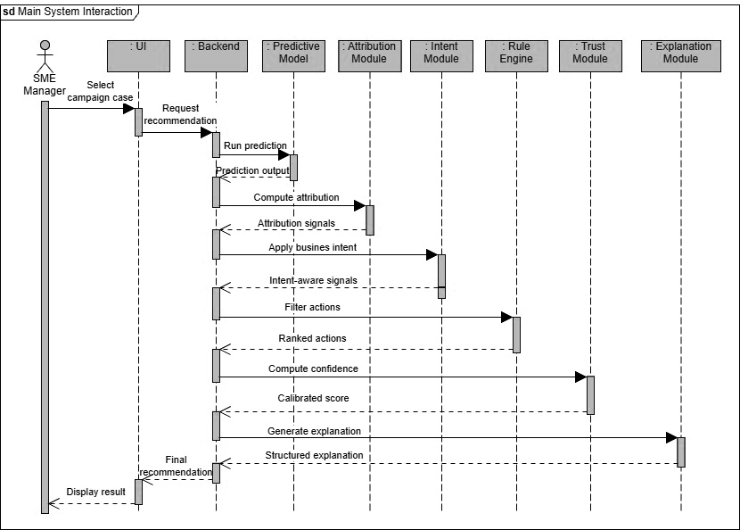
Figure 4.10 Main System Interaction
Figure 4.10 illustrates the sequence of interactions between the SME Marketing Manager and the various components of the proposed Intent-Aware Logic-Constrained Neuro-Symbolic Decision Support System with Trust Calibration for SME Multi-Channel Marketing during the recommendation generation process.
The sequence begins when the SME Marketing Manager selects a campaign case through the user interface. The selected campaign information is transmitted from the UI to the Backend, which initiates the recommendation generation process by sending a request to the predictive model.
The Predictive Model analyzes the campaign data and generates prediction outputs representing the expected marketing performance outcomes. These prediction results are returned to the backend and subsequently forwarded to the Attribution Module for contribution analysis. The Attribution Module computes attribution signals that identify the relative importance and influence of different marketing channels and campaign features on the predicted outcomes.
The generated attribution signals are then passed to the Intent Module, where the system incorporates the current business objective or strategic intent into the decision-making process. Examples of business intents include business growth, customer retention, and business survival. The Intent Module generates intent-aware signals that guide the recommendation process according to the selected business objective.
The intent-aware signals are subsequently forwarded to the Rule Engine, where business constraints and weighted soft rules are applied to filter and evaluate candidate actions. The Rule Engine produces a set of ranked actions that satisfy both predictive insights and business requirements.
The ranked actions are then sent to the Trust Module for confidence calibration. The Trust Module computes calibrated confidence scores to estimate the reliability and trustworthiness of each recommendation. These calibrated scores are returned to the backend for further processing.
Next, the backend forwards the calibrated recommendations to the Explanation Module, which generates structured explanations describing the reasoning process behind each recommendation. The explanations typically include influential factors, business implications, recommended actions, and potential caveats associated with the recommendation.
Finally, the backend consolidates the recommendation results, confidence scores, and explanations into a final recommendation package and sends it back to the user interface. The SME Marketing Manager can then review the recommendation and use the information to support marketing decision-making.
This sequence diagram demonstrates the interaction between predictive analytics, attribution analysis, intent-aware reasoning, business rule evaluation, trust calibration, and explainable artificial intelligence within the proposed neuro-symbolic decision support framework.
S2. Predictive-Attribution Backbone Sequence
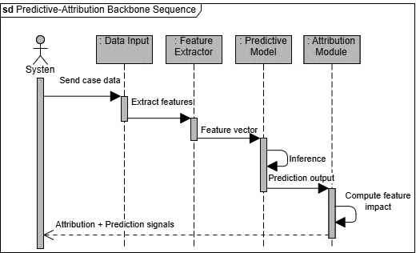
Figure 4.11 Predictive-Attribution Backbone Sequence
Figure 4.11 illustrates the sequence of interactions within the Predictive-Attribution Backbone of the proposed Intent-Aware Logic-Constrained Neuro-Symbolic Decision Support System for SME Multi-Channel Marketing. This component is responsible for generating predictive insights and identifying the contribution of individual features or marketing channels to the predicted outcomes.
The process begins when the system sends the selected decision case data to the Data Input component. The decision case contains relevant campaign information, including marketing channel performance indicators, customer engagement metrics, expenditure data, and historical campaign outcomes.
Upon receiving the case data, the Data Input component forwards the information to the Feature Extractor, where relevant features are identified and transformed into a structured feature vector suitable for machine learning processing. The feature extraction process converts raw campaign data into numerical representations that can be interpreted by the predictive model.
The generated feature vector is subsequently passed to the Predictive Model. The predictive model performs inference using the extracted features to estimate the expected campaign outcome, such as conversion rate, revenue generation, customer acquisition performance, or return on investment. The prediction process produces a prediction output that represents the expected effectiveness of the campaign under the current business conditions.
The prediction output is then forwarded to the Attribution Module, which computes the impact and contribution of individual features towards the prediction result. The attribution analysis identifies the relative importance of marketing channels and campaign characteristics in influencing the predicted outcome. This enables the system to determine which factors contribute positively or negatively to campaign performance.
Finally, the Attribution Module returns both the attribution signals and prediction outputs to the system. These outputs serve as inputs for the subsequent neuro-symbolic reasoning and recommendation generation components of the proposed framework.
This sequence diagram demonstrates the integration of predictive modelling and attribution analysis to produce both performance predictions and interpretable feature contribution information, thereby improving the transparency and explainability of AI-assisted marketing decisions.
S3. Weighted Soft-Rule Reasoning Sequence
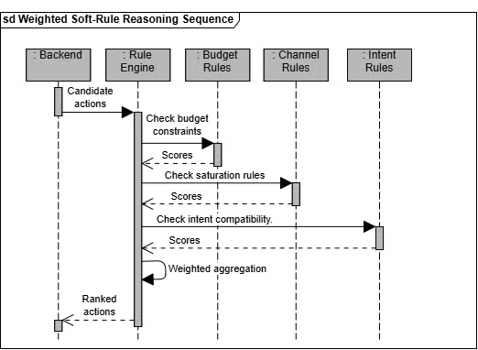
Figure 4.12 Weighted Soft-Rule Reasoning Sequence
Figure 4.12 illustrates the sequence of interactions involved in the Weighted Soft-Rule Reasoning process within the proposed Intent-Aware Logic-Constrained Neuro-Symbolic Decision Support System for SME Multi-Channel Marketing. This component is responsible for incorporating business knowledge and operational constraints into the recommendation generation process through the use of weighted soft rules.
The process begins when the Backend submits a set of candidate actions generated from the predictive and attribution components to the Rule Engine for evaluation. These candidate actions represent potential marketing decisions that may improve campaign performance or achieve business objectives.
The Rule Engine first evaluates the candidate actions against the Budget Rules component by checking budget-related constraints, such as spending limitations and resource availability. The Budget Rules component returns a score indicating the suitability of each candidate action with respect to financial constraints.
Next, the Rule Engine evaluates the candidate actions using the Channel Rules component. This stage checks channel-specific constraints and saturation rules, such as avoiding excessive investment in already saturated marketing channels or limiting expenditure on underperforming channels. The Channel Rules component returns a corresponding score for each candidate action based on channel suitability.
Subsequently, the Rule Engine consults the Intent Rules component to determine whether the candidate actions align with the current business objective or strategic intent. Examples of business intents include business growth, customer retention, and business survival. The Intent Rules component evaluates the compatibility between candidate actions and business goals and returns an intent compatibility score.
After obtaining scores from all rule categories, the Rule Engine performs weighted aggregation to combine the individual rule scores according to their predefined importance weights. This weighted evaluation approach allows the system to balance multiple business considerations while maintaining flexibility in decision-making.
Finally, the Rule Engine produces a set of ranked actions and returns them to the Backend for subsequent trust calibration and explanation generation processes. The ranked actions represent recommendations that not only maximize predictive performance but also satisfy business objectives and operational constraints.
This sequence diagram demonstrates how weighted soft-rule reasoning integrates domain knowledge, business strategy, and operational limitations into the recommendation generation process, thereby improving the practicality, reliability, and business relevance of the proposed framework.
S4. Trust Calibration Sequence
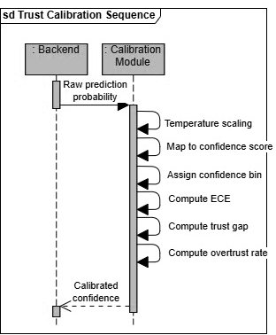
Figure 4.13 Trust Calibration Sequence
Figure 4.13 illustrates the sequence of interactions involved in the Trust Calibration process of the proposed Intent-Aware Logic-Constrained Neuro-Symbolic Decision Support System for SME Multi-Channel Marketing. The purpose of this component is to improve the reliability and interpretability of recommendation confidence values by aligning predicted probabilities with actual model performance.
The process begins when the Backend sends the raw prediction probabilities generated by the recommendation engine to the Calibration Module. These probabilities represent the initial confidence estimates produced by the predictive model before calibration.
Upon receiving the prediction probabilities, the Calibration Module first applies temperature scaling, a post-processing calibration technique used to reduce model overconfidence and improve probability estimation accuracy. Temperature scaling adjusts the predicted probabilities without affecting the ranking of recommendations, thereby producing more reliable confidence values.
Following calibration, the adjusted probabilities are mapped into confidence scores that represent the estimated likelihood of recommendation correctness. The calibrated confidence scores are then assigned to predefined confidence bins to facilitate calibration analysis and reliability assessment.
Next, the Calibration Module computes the Expected Calibration Error (ECE), which measures the difference between predicted confidence and actual prediction accuracy across all confidence intervals. A lower ECE value indicates better alignment between confidence estimates and observed outcomes.
The system subsequently computes the trust gap, which represents the discrepancy between user trust expectations and the actual reliability of the recommendation system. In addition, the module calculates the overtrust rate, which measures the frequency with which users may place excessive trust in recommendations with insufficient confidence or reliability.
After completing the calibration and evaluation procedures, the Calibration Module returns the final calibrated confidence values to the Backend. These calibrated confidence scores are then used by the explanation generation component and presented to users together with the recommendations to improve transparency and trustworthiness.
This sequence diagram demonstrates how trust calibration techniques are incorporated into the proposed framework to provide more reliable confidence estimates and support informed decision-making in AI-assisted marketing applications.
S5. Explanation Generation Sequence
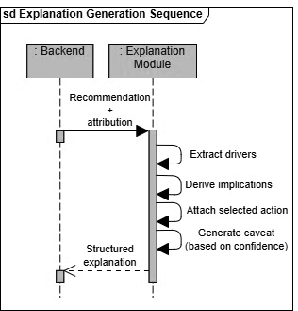
Figure 4.14 Explanation Generation Sequence
Figure 4.14 illustrates the sequence of interactions involved in the Explanation Generation process within the proposed Intent-Aware Logic-Constrained Neuro-Symbolic Decision Support System for SME Multi-Channel Marketing. The purpose of this component is to provide transparent and interpretable explanations that help users understand the reasoning behind the generated recommendations.
The process begins when the Backend sends the final recommendation together with the corresponding attribution information to the Explanation Module. The recommendation contains the selected marketing action, while the attribution information contains the contribution scores of individual features and marketing channels that influenced the recommendation.
Upon receiving the input, the Explanation Module first performs driver extraction to identify the most influential factors contributing to the recommendation. These drivers may include campaign performance indicators, marketing channel effectiveness, customer engagement metrics, or business objectives that significantly affected the decision-making process.
After identifying the important drivers, the module derives the business implications associated with the recommendation. This step explains the expected impact of the recommendation on business performance, such as increasing customer acquisition, improving conversion rates, reducing marketing costs, or enhancing customer retention.
The system then attaches the selected action to the explanation package, clearly indicating the recommended marketing decision that should be implemented by the user. This ensures that the explanation remains directly connected to the actionable recommendation generated by the framework.
Subsequently, the Explanation Module generates an appropriate caveat statement based on the calibrated confidence score provided by the trust calibration component. The caveat informs users about potential uncertainties, assumptions, or risks associated with the recommendation, particularly when the confidence level is low or when the decision is based on limited evidence.
Finally, the Explanation Module compiles all generated information into a structured explanation package and returns it to the Backend. The explanation package typically contains the recommendation drivers, business implications, selected action, confidence level, and associated caveats. This structured explanation is subsequently presented to the user together with the recommendation results.
This sequence diagram demonstrates how explainable artificial intelligence techniques are integrated into the proposed framework to improve transparency, interpretability, and user trust in AI-assisted marketing recommendations.

Database Design

ER Diagram
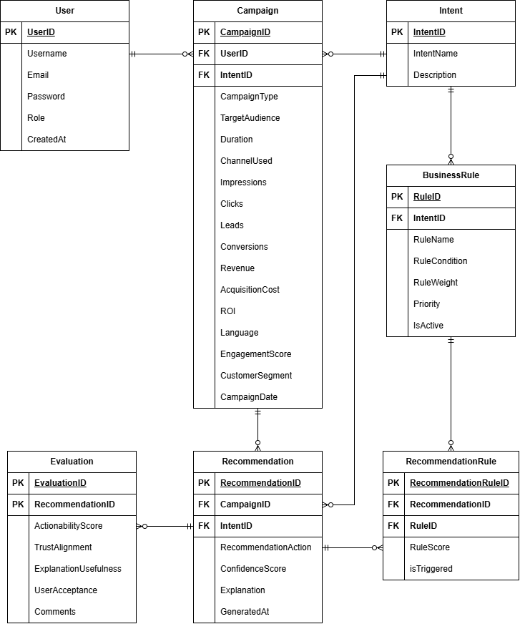
Figure 4.15 Entity Relationship Diagram
Figure 4.15 presents the Entity Relationship Diagram (ERD) for the proposed Intent-Aware Logic-Constrained Neuro-Symbolic Decision Support System with Trust Calibration for SME Multi-Channel Marketing. The database design consists of seven main entities, namely User, Campaign, Intent, BusinessRule, Recommendation, RecommendationRule, and Evaluation. These entities store campaign information, business objectives, recommendation outputs, rule evaluations, and user feedback required by the proposed framework.
The User entity stores information about SME marketing managers who use the system. It contains attributes such as UserID, Username, Email, Password, Role, and CreatedAt. A single user may create and manage multiple marketing campaigns, resulting in a one-to-many relationship between the User and Campaign entities.
The Campaign entity stores campaign-related information used for prediction and recommendation generation. Each campaign is associated with one user and one business intent through the foreign keys UserID and IntentID. The entity contains various campaign characteristics and performance indicators including campaign type, target audience, duration, marketing channels, impressions, clicks, leads, conversions, revenue, acquisition cost, return on investment, engagement score, customer segment, and campaign date. These attributes serve as input features for the predictive and attribution components of the framework.
The Intent entity represents the strategic business objective associated with a campaign or recommendation. Examples of business intents include business growth, customer retention, and business survival. Each intent contains an identifier, name, and description. A single intent may be associated with multiple campaigns and business rules, resulting in one-to-many relationships with the Campaign and BusinessRule entities.
The BusinessRule entity stores the weighted soft rules used by the neuro-symbolic reasoning module. Each rule belongs to a specific business intent through the IntentID foreign key. The entity stores information such as rule name, rule condition, rule weight, rule priority, and activation status. These rules are used to evaluate candidate actions and ensure that recommendations satisfy business objectives and operational constraints.
The Recommendation entity stores the recommendations generated by the proposed framework. Each recommendation is associated with a campaign and an intent using the CampaignID and IntentID foreign keys. The entity contains the recommended action, calibrated confidence score, generated explanation, and recommendation generation timestamp. A campaign may generate multiple recommendations over time, resulting in a one-to-many relationship between Campaign and Recommendation.
The RecommendationRule entity acts as an associative entity that records the relationship between recommendations and the business rules that influenced them. Each record stores the rule score assigned during evaluation and indicates whether the rule was triggered during recommendation generation. This many-to-many relationship enables the system to maintain explainability and auditability by tracking which business rules contributed to each recommendation.
The Evaluation entity stores user feedback and evaluation metrics for generated recommendations. Each evaluation record is associated with a single recommendation and contains metrics such as actionability score, trust alignment, explanation usefulness, user acceptance, and user comments. These evaluation results are used to assess recommendation quality and overall system effectiveness.
The relationships among these entities support the complete workflow of the proposed framework, from campaign data collection and intent identification to recommendation generation, rule evaluation, trust calibration, explanation generation, and user feedback collection. The database design therefore provides the necessary data foundation for implementing predictive analytics, neuro-symbolic reasoning, explainable artificial intelligence, and trust calibration within the proposed decision support system.

Database Schema
User
Table 4.3 User Table
Field | Type
UserID (PK) | INT
Username | VARCHAR(100)
Email | VARCHAR(100)
Password | VARCHAR(255)
Role | VARCHAR(20)
CreatedAt | DATETIME

Campaign
Table 4.4 Campaign Table
Field | Type
CampaignID (PK) | VARCHAR(20)
UserID (FK) | INT
IntentID (FK) | INT
CampaignType | VARCHAR(50)
TargetAudience | VARCHAR(100)
Duration | INT
ChannelUsed | VARCHAR(50)
Impressions | INT
Clicks | INT
Leads | INT
Conversions | INT
Revenue | DECIMAL(12,2)
AcquisitionCost | DECIMAL(12,2)
ROI | DOUBLE
Language | VARCHAR(50)
EngagementScore | DOUBLE
CustomerSegment | VARCHAR(100)
CampaignDate | DATE

Intent
Table 4.5 Intent Table
Field | Type
IntentID (PK) | INT
IntentName | VARCHAR(30)
Description | TEXT

Recommendation
Table 4.6 Recommendation Table
Field | Type
RecommendationID (PK) | INT
CampaignID (FK) | VARCHAR(20)
IntentID (FK) | INT
RecommendedAction | TEXT
ConfidenceScore | DOUBLE
Explanation | TEXT
GeneratedAt | DATETIME

Evaluation
Table 4.7 Evaluation Table
Field | Type
EvaluationID (PK) | INT
RecommendationID (FK) | INT
ActionabilityScore | DOUBLE
TrustAlignment | DOUBLE
ExplanationUsefulness | DOUBLE
UserAcceptance | DOUBLE
Comments | TEXT

Recommendation
Table 4.8 Recommendation Table
Field | Type
RecommendationRuleID (PK) | INT
RecommendationID (FK) | INT
RuleID (FK) | INT
RuleScore | DOUBLE
IsTriggered | BOOLEAN

BusinessRule
Table 4.8 Business Rule Table
Field | Type
RuleID (PK) | INT
IntentID (FK) | INT
RuleName | VARCHAR(100)
RuleCondition | TEXT
RuleWeight | DOUBLE
Priority | INT
IsActive | BOOLEAN

Algorithm Design

Algorithm 1: Predictive Attribution
Purpose
The Predictive Attribution algorithm analyses historical marketing campaign data to estimate campaign effectiveness and identify influential performance factors. The resulting performance score provides quantitative evidence for subsequent recommendation generation.
Detailed Description
The algorithm begins by loading campaign records from the database. The data is validated to ensure completeness and consistency before feature extraction is performed. Relevant marketing indicators, including impressions, clicks, conversions, engagement score, acquisition cost, and ROI, are used as predictive features. A predictive model is then applied to estimate campaign performance. The resulting score represents the expected effectiveness of the campaign and serves as input for candidate action generation.
Pseudocode
Algorithm PredictiveAttribution
Input: CampaignData
Output: PerformanceScore
BEGIN
Load CampaignData
IF CampaignData is empty THEN
Return Error
END IF
Preprocess CampaignData
Validate Data Quality
Extract Features
Apply Predictive Model
Calculate PerformanceScore
Return PerformanceScore
END
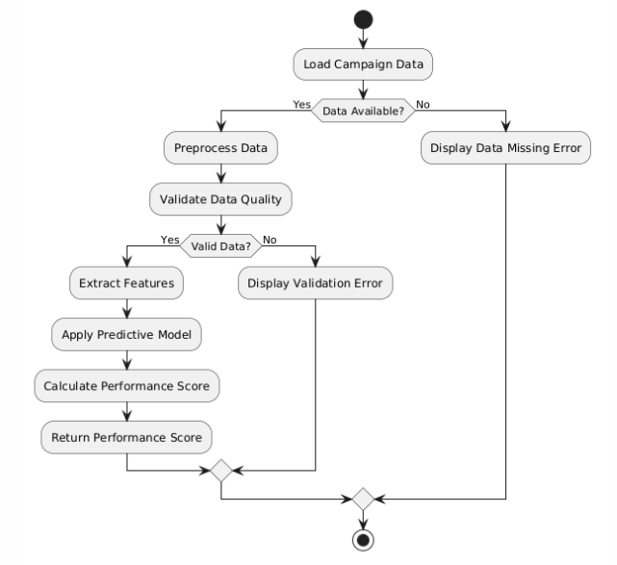
Figure 4.16 Predictive Attribution Algorithm Workflow

Algorithm 2: Logic-Constrained Reasoning
Purpose
The Logic-Constrained Reasoning algorithm applies symbolic business rules to candidate marketing actions. The objective is to ensure recommendations remain aligned with organisational constraints and business objectives.
Detailed Description
Candidate actions generated from predictive attribution are evaluated against a set of weighted business rules. Each rule contributes a score based on its relevance and importance. Actions violating critical rules receive penalties. The final ranking combines predictive performance and symbolic rule scores, producing an explainable recommendation.
Pseudocode
Algorithm LogicConstrainedReasoning
Input: CandidateActions, BusinessRules
Output: RecommendedAction
BEGIN
Load BusinessRules
FOR each Action
Score = 0
FOR each Rule
Evaluate Rule
IF RuleSatisfied THEN
Score += RuleWeight
ELSE
Score -= Penalty
END IF
END FOR
Store FinalScore
END FOR
Rank Actions
Return Best Action
END
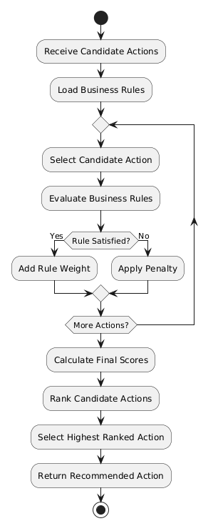
Figure 4.17 Logic-Constrained Reasoning Algorithm Workflow

Algorithm 3: Trust Calibration
Purpose
The Trust Calibration algorithm estimates recommendation confidence and adjusts system output to encourage appropriate user reliance on AI-generated recommendations.
Detailed Description
The algorithm receives recommendation scores from the reasoning module and estimates confidence using historical performance patterns. Calibration techniques are applied to reduce overconfidence or underconfidence. The resulting trust score is presented to users alongside the recommendation.
Pseudocode
Algorithm TrustCalibration
Input: RecommendationScore
Output: TrustScore
BEGIN
Receive RecommendationScore
Estimate Confidence
Apply Calibration
Generate TrustScore
Return TrustScore
END
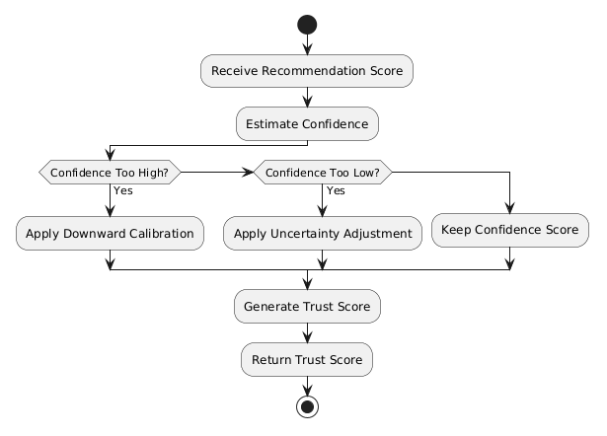
Figure 4.18 Trust Calibration Algorithm Workflow

Algorithm 4: Explanation Generation
Purpose
The Explanation Generation algorithm produces human-readable explanations that justify recommendations and improve transparency.
Detailed Description
The algorithm analyses the selected recommendation together with the underlying predictive and symbolic reasoning results. Key decision drivers are identified and translated into understandable business language. The explanation includes rationale, expected implications, recommended actions, and caveats.
Pseudocode
Algorithm ExplanationGeneration
Input: Recommendation
Output: Explanation
BEGIN
Receive Recommendation
Identify Key Drivers
Generate Implications
Generate Actions
Generate Caveats
Construct Explanation
Return Explanation
END
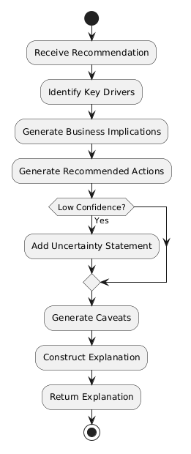
Figure 4.19 Explanation Generation Algorithm Workflow

Security and Privacy Design
The proposed system incorporates security and privacy mechanisms to protect user information, preserve the confidentiality of marketing data, and ensure that AI-generated recommendations are delivered in a responsible and trustworthy manner. Since the application assists marketers in decision-making rather than executing campaigns automatically, the system follows the principle of human-in-the-loop decision support, where users retain full control over accepting, modifying, or rejecting the generated recommendations.

Authentication and Access Control
The proposed web application implements user authentication to ensure that only authorised users can access the system and its recommendation services. During login, users are required to provide valid credentials, which are verified against the records stored in the MySQL database. Upon successful authentication, a secure user session is established to maintain the user's identity throughout the interaction with the system.
Access control is implemented using role-based permissions. Regular users are permitted to manage their own marketing campaigns, view recommendation histories, and generate AI-assisted recommendations. Administrative functions, such as managing benchmark datasets, system configuration, or knowledge rules, are restricted to authorised administrators only. This separation of privileges prevents unauthorised access to sensitive system resources and maintains data integrity.

Secure Data Storage
User accounts, campaign information, recommendation histories, and benchmark records are stored in a MySQL database hosted on the application server. Database access is restricted to authorised application components through secure database credentials, preventing direct public access to stored data. Only the information required for recommendation generation and system evaluation is retained, following the principle of data minimisation.
To further protect user information, passwords are never stored in plain text. Instead, they are securely hashed using a one-way cryptographic hashing algorithm before being stored in the database. Regular database backup procedures are also incorporated to reduce the risk of data loss and support system recovery in the event of hardware failure or unexpected incidents.

Privacy Protection and Data Minimisation
The recommendation engine primarily utilises campaign attributes, user preferences, marketing objectives, budget constraints, and audience characteristics. The system avoids collecting unnecessary personal information that does not contribute to recommendation quality.
During benchmark construction and experimental evaluation, all expert-provided recommendation cases are anonymised before inclusion in the gold-standard dataset. Individual marketing practitioners cannot be identified from the stored benchmark records, thereby protecting participant confidentiality throughout the evaluation process.
The recommendation system does not utilise personal customer information, behavioural tracking data, or external social media account credentials during recommendation generation unless explicitly authorised by the user.

Responsible AI Decision Support
The proposed system functions solely as a decision-support assistant. AI-generated recommendations are presented together with explanation information, confidence scores, activated reasoning rules, and supporting evidence. Final marketing decisions remain under the control of the user.
This design reduces the risk of excessive reliance on AI-generated outputs while improving recommendation transparency. Users are encouraged to review the generated explanations before applying recommendations to actual marketing campaigns.
By combining authentication, secure cloud storage, encrypted communication, privacy-preserving data collection, and transparent human oversight, the proposed system satisfies the security and privacy requirements identified in Chapter 3 while supporting responsible deployment of neuro-symbolic AI technologies.

User Interface Design

Login
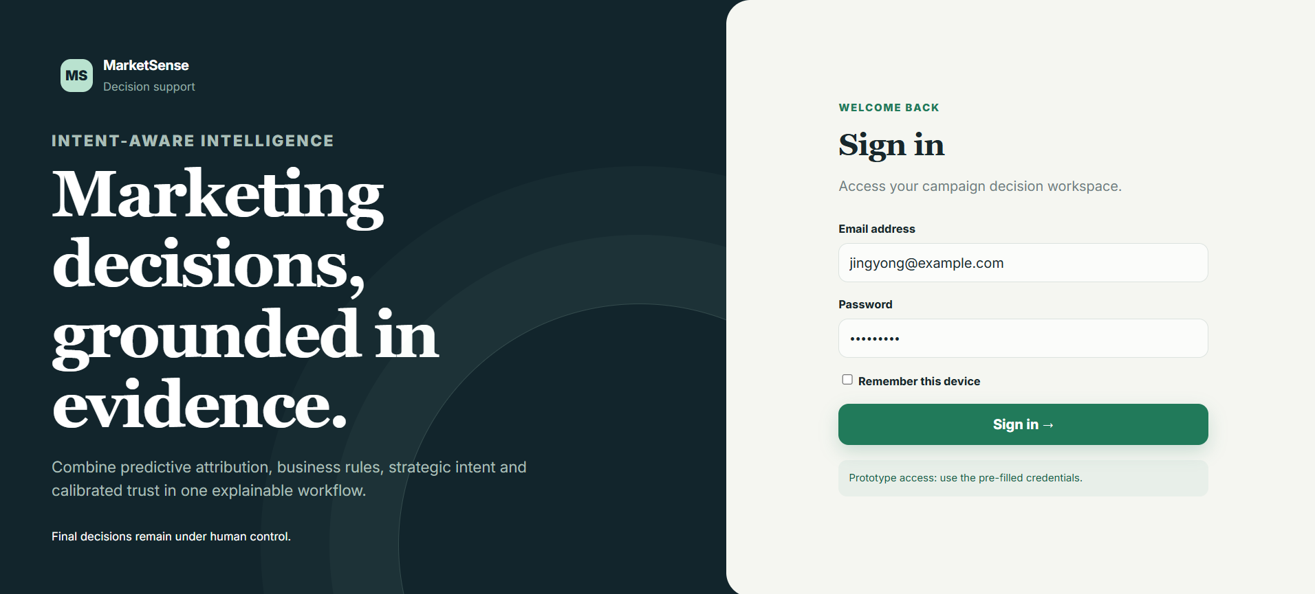

Figure 4.20 Login Page
The Login screen serves as the entry point to the proposed decision support system. It authenticates registered users before granting access to marketing data and recommendation functions. User authentication ensures that campaign information, recommendation history, and evaluation records are accessible only to authorised users, thereby improving system security and protecting sensitive business information.

Dashboard
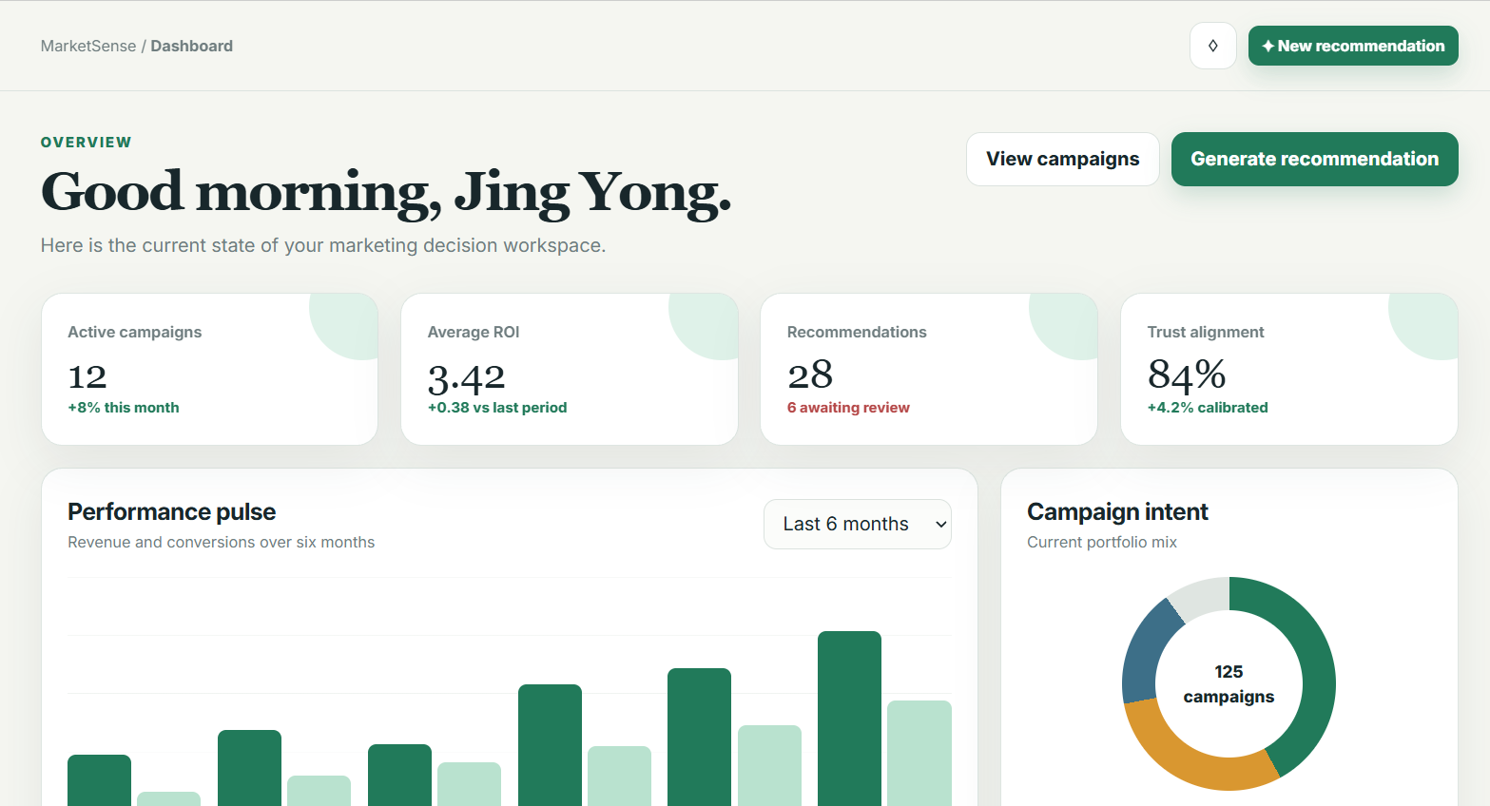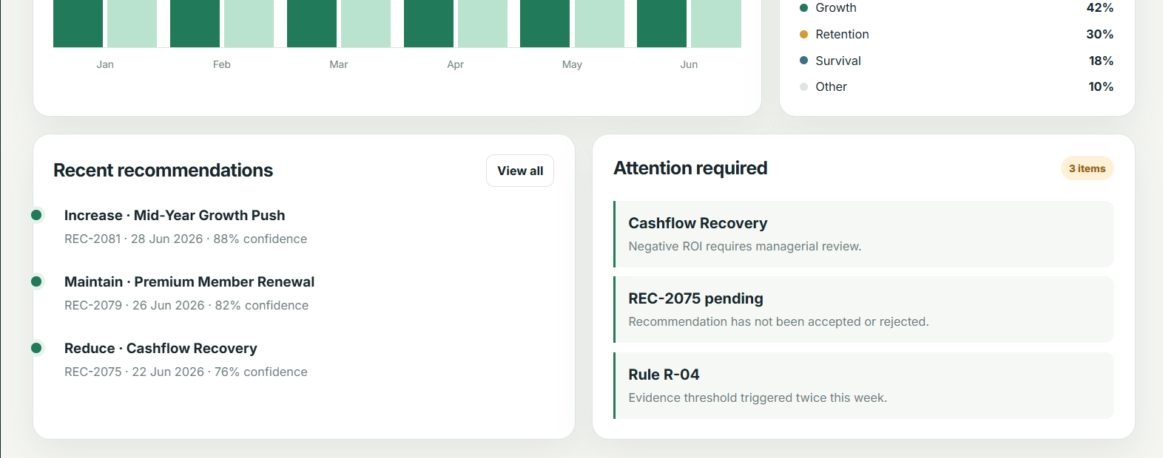

Figure 4.21 Dashboard Page
The Dashboard provides users with an overview of the system after successful authentication. It summarises important campaign statistics, recent recommendation activities, and quick navigation to the system's major functions. By presenting essential information in a single interface, the dashboard enables SME managers to monitor marketing performance efficiently and access decision support features with minimal navigation.

Campaign Management
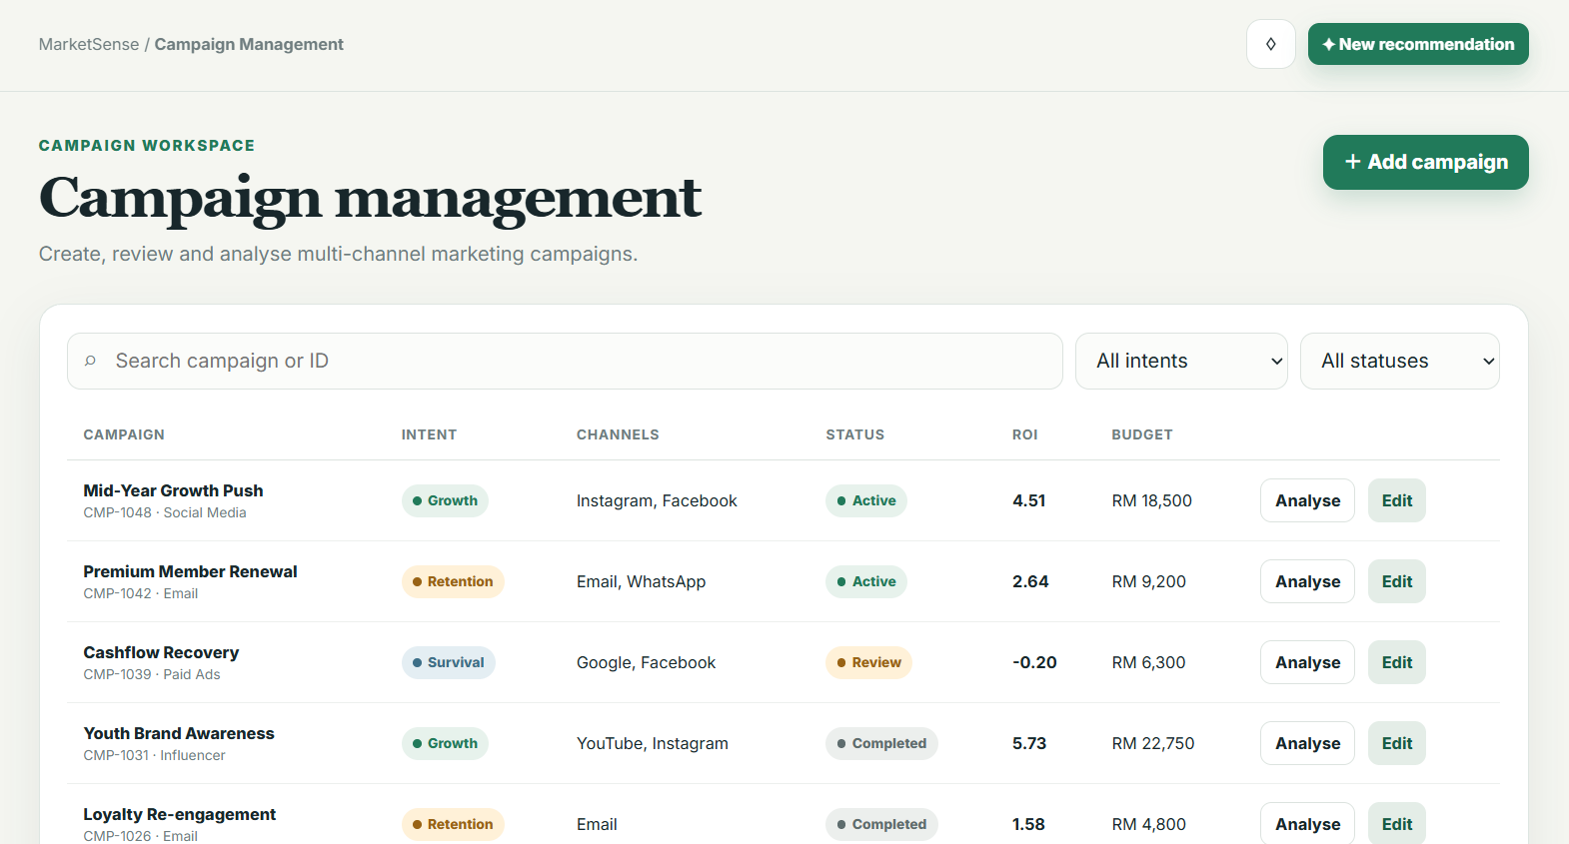

Figure 4.22 Campaign Management Page
The Campaign Management interface allows users to view, organise, search, and manage existing marketing campaigns. Campaign records can be reviewed before further analysis or recommendation generation. Centralising campaign information within a single interface simplifies campaign administration and ensures that recommendation requests are based on complete and up-to-date marketing data.

Add/Edit Campaign
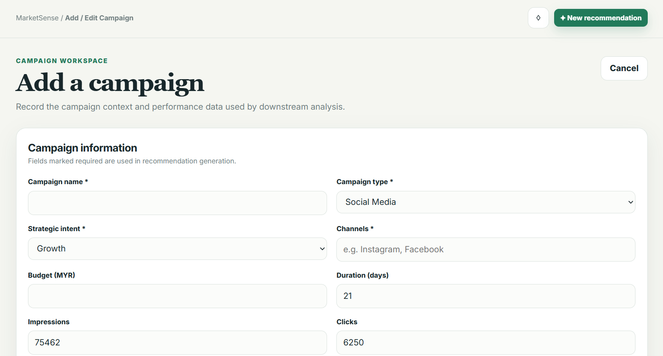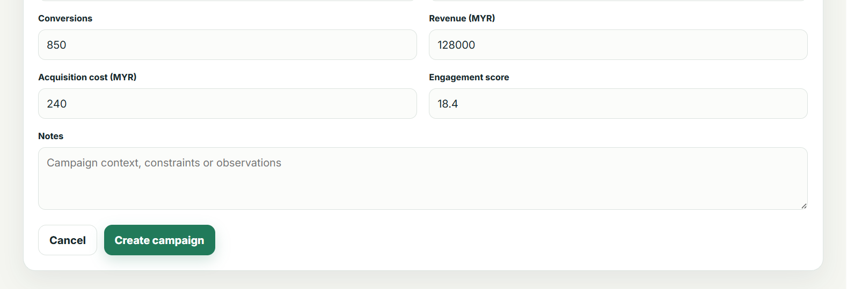

Figure 4.23 Add/Edit Campaign Page
The Add/Edit Campaign interface enables users to create new marketing campaigns or modify existing campaign information. Users may specify campaign objectives, marketing channels, budget allocation, target audience, and other relevant attributes required by the recommendation engine. Accurate campaign information improves the quality of predictive attribution and supports more reliable neuro-symbolic reasoning during recommendation generation.

Campaign Analysis
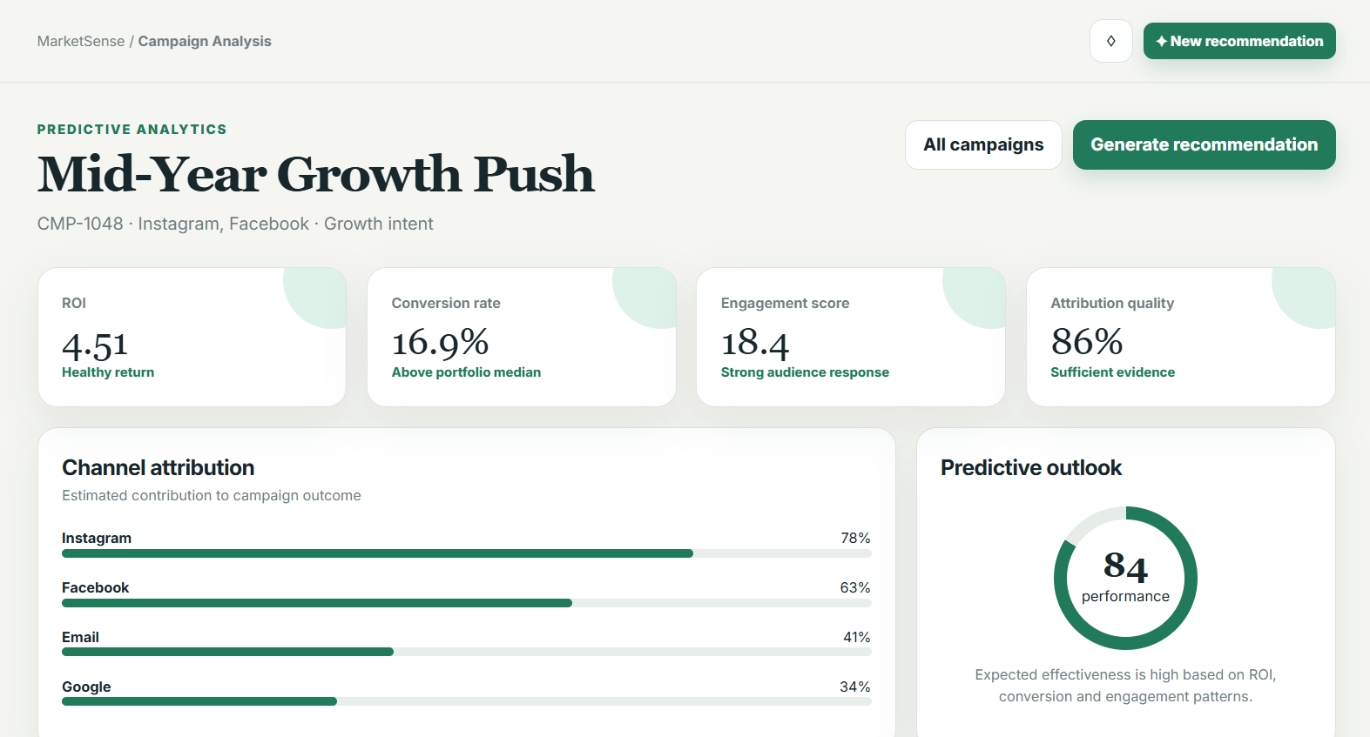

Figure 4.24 Campaign Analysis Page
The Campaign Analysis screen presents analytical summaries of campaign performance using visualisations and performance indicators. Users can review historical campaign outcomes before requesting AI-assisted recommendations. The analytical insights generated on this screen provide contextual information that supports informed managerial decision-making and complements the subsequent recommendation process.

Generate Recommendation
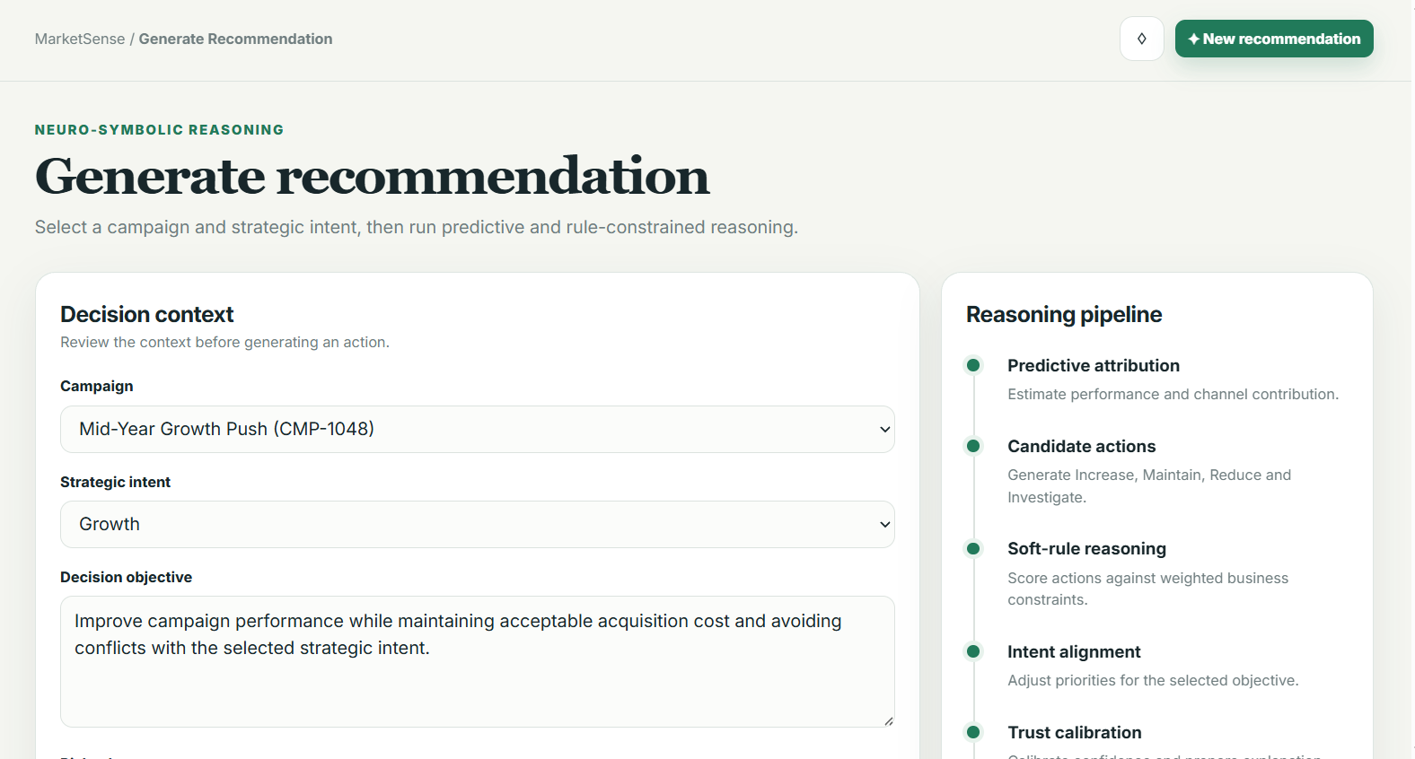

Figure 4.25 Generate Recommendation Page
The Generate Recommendation interface represents the core functionality of the proposed system. After selecting a campaign, users may initiate the recommendation process, which combines predictive attribution, neuro-symbolic reasoning, trust calibration, and explanation generation to produce ranked marketing recommendations. The interface maintains a human-in-the-loop workflow by requiring users to explicitly request recommendation generation before reviewing the results.

Recommendation Details
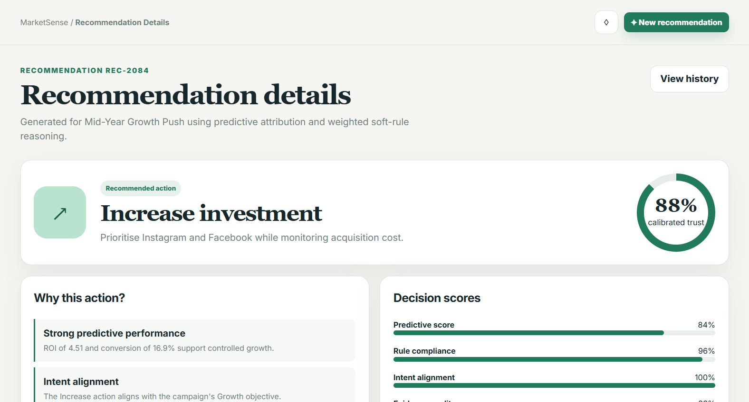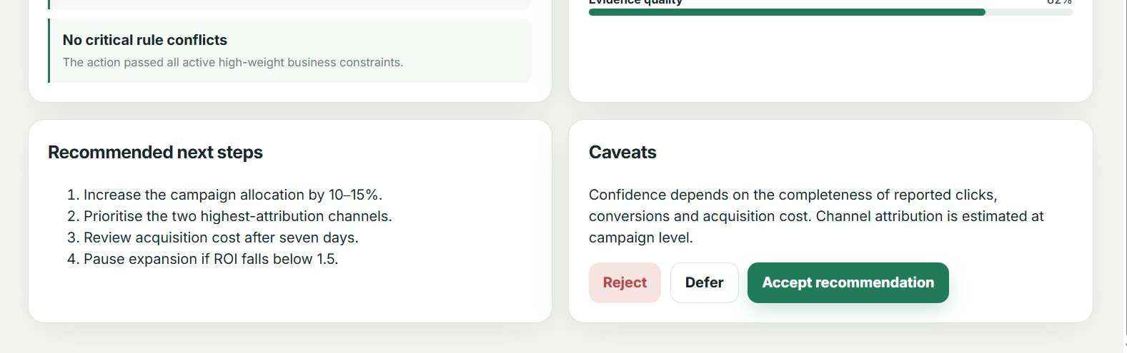

Figure 4.26 Recommendation Details Page
The Recommendation Details screen presents the complete reasoning outcome for a selected recommendation. In addition to the recommended marketing action, the interface displays confidence scores, trust calibration values, activated reasoning rules, and structured textual explanations. Presenting this supporting evidence improves transparency, enables users to understand the recommendation process, and promotes appropriate trust in AI-assisted decision making.

Recommendation History
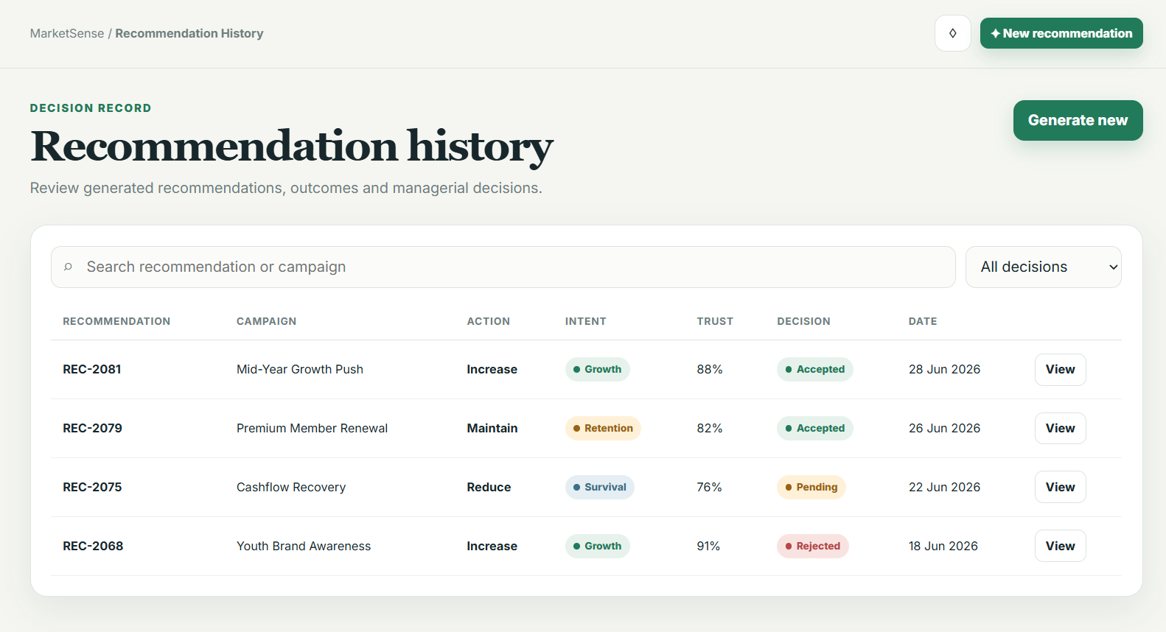

Figure 4.27 Recommendation History Page
The Recommendation History interface stores previously generated recommendations together with their associated campaign information, confidence values, explanations, and user decisions. Historical records enable users to review past recommendations, compare decision outcomes, and maintain an auditable record of AI-assisted marketing decisions. This functionality also supports the experimental evaluation described in Chapter 5 by preserving recommendation logs for subsequent analysis.

Evaluation
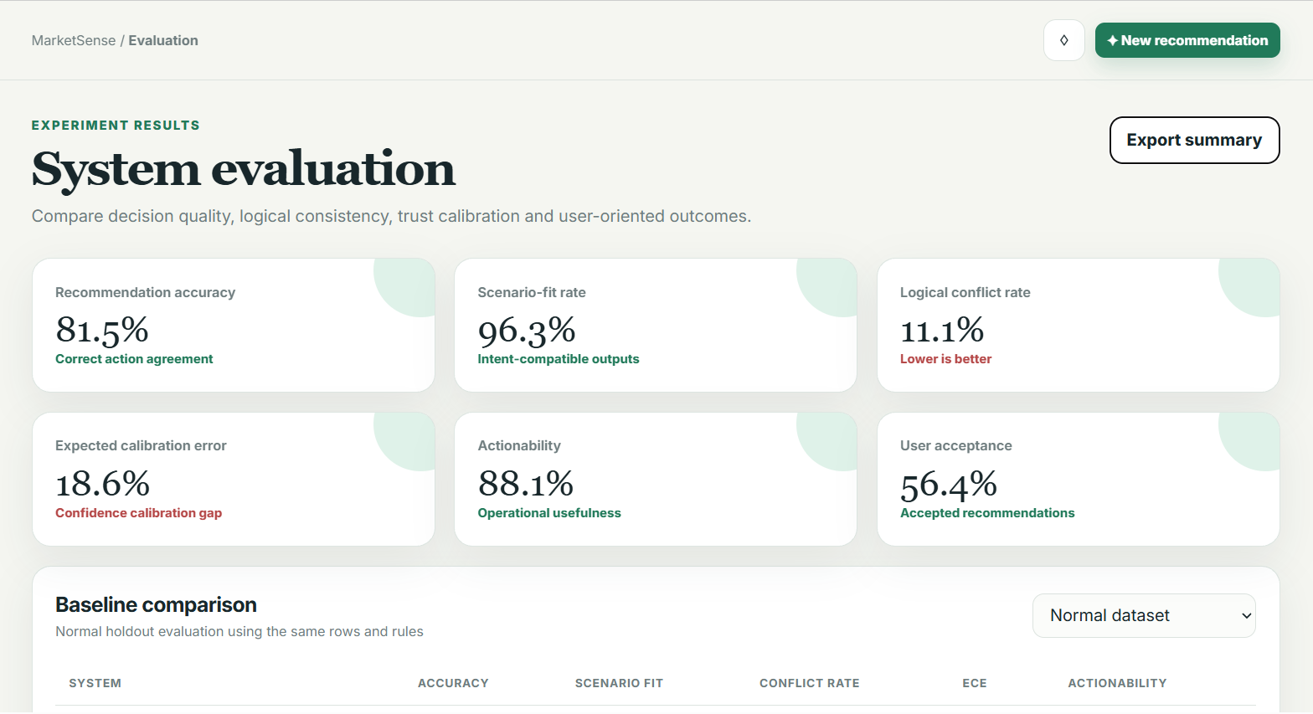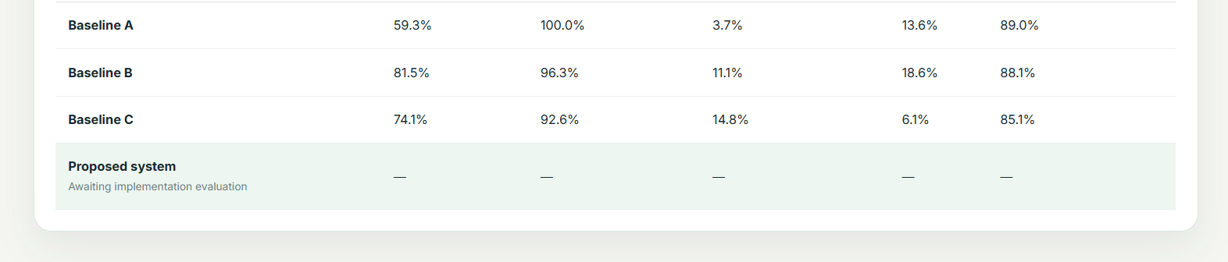

Figure 4.28 Evaluation Page
The Evaluation interface allows users to provide feedback regarding the usefulness, trustworthiness, and actionability of generated recommendations. User responses contribute to the human-centred evaluation methodology adopted in this research by measuring user acceptance, perceived explanation quality, and trust alignment. The collected evaluation results provide qualitative evidence to complement the quantitative performance metrics reported in the experimental study.

Profile
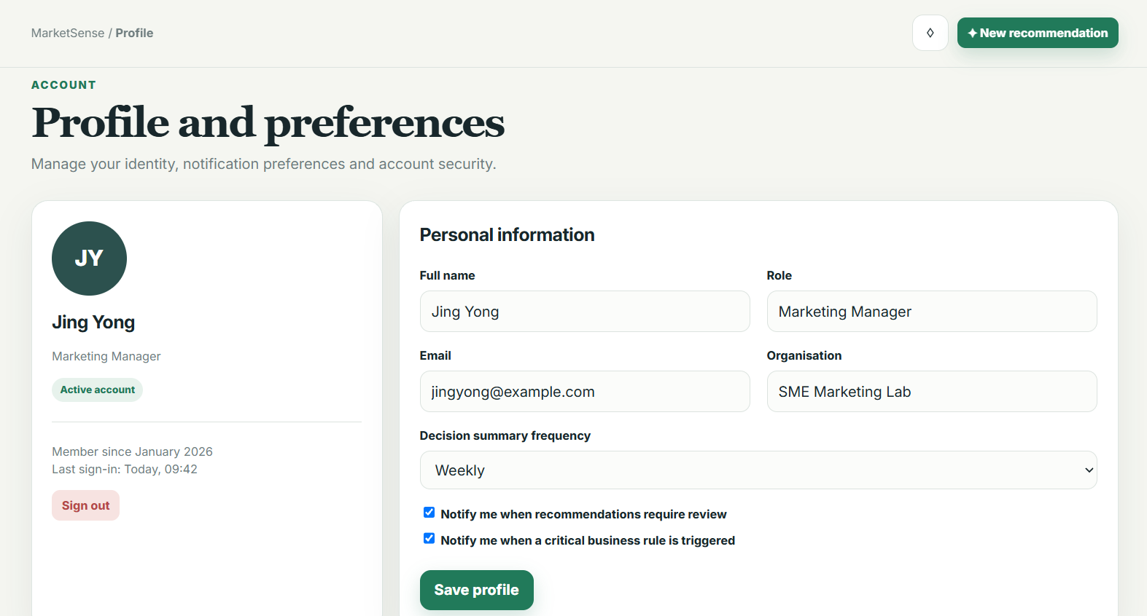

Figure 4.29 Profile Page
The Profile screen enables users to manage their personal account information and application preferences. Basic profile management functions improve usability by allowing users to maintain accurate account details while ensuring that recommendation history and evaluation records remain associated with the correct user account.

Rule Management (Admin)
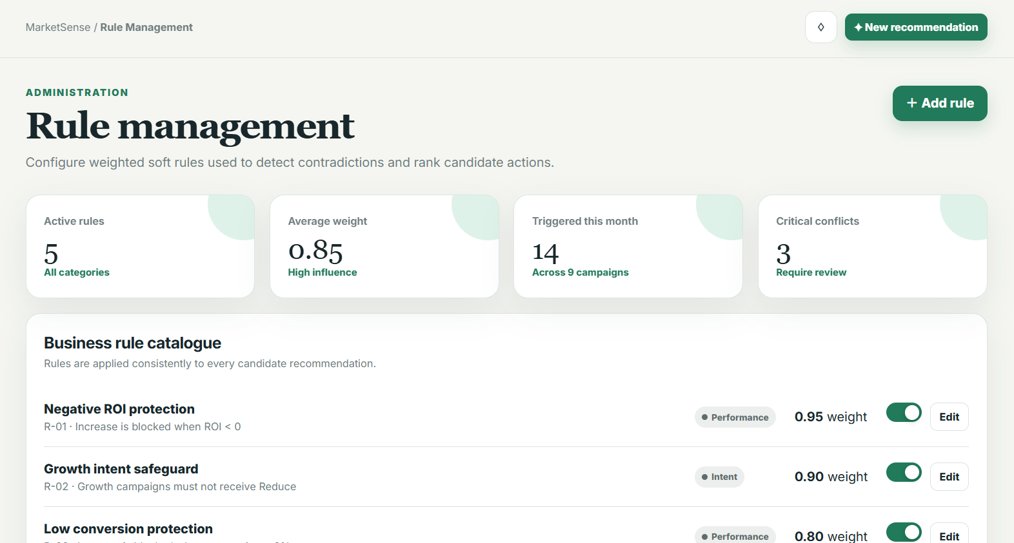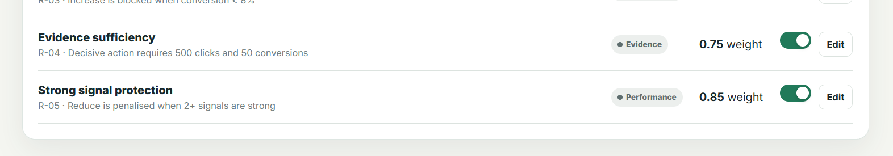

Figure 4.30 Rule Management Page
The Rule Management interface is accessible only to authorised administrators and supports the maintenance of the symbolic knowledge base used by the neuro-symbolic reasoning module. Administrators may add, modify, enable, or disable weighted business rules without changing the underlying prediction model. Separating rule management from application logic improves maintainability and allows the recommendation framework to adapt to evolving business policies while preserving transparency and consistency.

Evaluation Support Design
To support the experimental methodology described in Chapter 3 and facilitate comprehensive performance evaluation in Chapter 5, the proposed system is designed to record relevant execution information during every recommendation session. These records are used solely for experimental evaluation and system analysis, rather than influencing the recommendation process itself.

Recommendation Logging
Each generated recommendation is associated with a unique recommendation identifier together with its corresponding benchmark case. The system records the generated recommendation, activated reasoning rules, predicted campaign intent, confidence score, trust calibration score, execution latency, and timestamp.
These records enable direct comparison between system outputs and the gold-standard benchmark, allowing the evaluation metrics defined in Chapter 3 to be calculated consistently across all experimental scenarios.

Baseline Comparison Support
To ensure fair experimental comparison, the system records the inference method used for every evaluation run. The recorded baseline identifier distinguishes between:
- Baseline A: Large Language Model only;
- Baseline B: Rule-based reasoning only; and
- Proposed neuro-symbolic DeepProbLog framework.
Using identical benchmark inputs across all three configurations ensures that differences in recommendation quality can be attributed to the reasoning approach rather than variations in experimental data.

Confidence and Trust Recording
The calibrated confidence score generated by the predictive attribution model and the final trust calibration score produced by the neuro-symbolic reasoning module are stored for each recommendation.
These values support the calculation of confidence calibration metrics, including Expected Calibration Error (ECE), confidence distribution analysis, and trust alignment evaluation presented in Chapter 5.

Rule Activation and Explanation Logging
For every recommendation, the system records the soft reasoning rules activated during inference together with their associated confidence contributions. The generated explanation text and supporting evidence are also stored.
These records provide traceability for recommendation generation and enable qualitative assessment of explanation completeness, reasoning transparency, and actionability during experimental evaluation.

User Confirmation and Correction History
After reviewing the recommendation, users may accept, modify, or reject the suggested marketing strategy. The system records these interactions together with any subsequent corrections made by the user.
Although user feedback is not incorporated into the recommendation model during experimentation, these records provide additional evidence for analysing recommendation usefulness and identifying opportunities for future model improvement.

Performance Monitoring
Execution latency is measured from the moment the recommendation request is submitted until the complete recommendation package, including explanations and confidence scores, is returned to the user.
Latency measurements are automatically recorded to evaluate whether the proposed system satisfies the non-functional performance requirements established in Chapter 3. Additional runtime statistics such as successful inference completion and system exceptions are also logged to support reliability analysis.
By systematically recording recommendation outputs, reasoning evidence, confidence values, user interactions, and execution performance, the proposed design provides comprehensive support for the quantitative and qualitative evaluation methodology presented in Chapter 5 while maintaining reproducibility and experimental consistency.

Chapter Summary and Evaluation
This chapter presented the detailed system design of the proposed Intent-Aware Logic-Constrained Neuro-Symbolic Decision Support System with Trust Calibration. The overall architecture, workflow, UML models, database design, algorithms, and user interface design collectively provide a blueprint for system implementation.
The modular design ensures consistency with the research methodology and supports future extensibility. The following chapter presents the implementation and testing of the proposed system.

Chapter 5

System Testing, Results and Discussion

Implementation and Testing
A short introduction that describes what will be included in this chapter.
IMPORTANT NOTE TO STUDENTS: Include details about:

- Implementation
A detailed description of how you actually carried out the implementation (e.g., coding, etc.) of your system/prototype.
- Include code snippets and descriptions to show how the requirements of the application/prototype have been met –
  - For Smart Campus projects, code snippets of the MQTT protocol for both client side and server side has to be included with explanation.
- Include descriptions of important settings - Setting for server, network protocol, IP, database, security
- Note: this should not be a chronological account of the work you carried out.

- Testing
All test cases that have been carried out must be provided - To tabulate the test cases in tables

Note: Students may also opt to split Implementation and Testing into 2 separate chapters.

Sub-section 1 Heading
Sub-sections should be used to divide the chapter into logical parts.

Sub-subsection Heading
Sub-section numbering should be limited to a maximum of 3 levels (e.g. 5.3.1) in order to avoid confusion.

Sub-section 2 Heading

Sub-section 1 Heading
Sub-sections should be used to divide the chapter into logical parts.

Sub-subsection Heading
Sub-section numbering should be limited to a maximum of 3 levels (e.g. 5.3.1) in order to avoid confusion.

Sub-section 1 Heading
Sub-sections should be used to divide the chapter into logical parts.

Sub-subsection Heading
Sub-section numbering should be limited to a maximum of 3 levels (e.g. 5.3.1) in order to avoid confusion.

Chapter Summary and Evaluation
At the end of each chapter, evaluate the contents stated or discussed in the relevant sub-sections.

Chapter 6

Conclusion and Recommendations

Discussions and Conclusion
Each student is required to make an evaluation of the project he/she has embarked on. The project evaluation may include the following sections.
IMPORTANT NOTE TO STUDENTS: In this chapter, for problems related to code, hardware, internet connection, etc (where applicable):
  - List the technical problems faced and state how they were resolved
  - List the unsolved technical problems for future enhancement
  - List the achieved objectives/modules
  - List the incomplete parts for future enhancement - this is regardless the parts listed in the pre-determined scope. Suggestions for future improvement

Summary
Summarize the project including the problem and proposed solutions, justification of the choice of tools, techniques and methodologies used in this project.

Achievements
Students are required to evaluate the project’s achievement against project objectives, completion of the project, students’ view of the strengths and weaknesses of the work done.

Contributions
Discuss the creativity, innovativeness, contribution of the proposed system. Explain why the proposed system is necessary. Describe the marketability of the system.

Limitations and Future Improvements
Identify the limitations of the research or project. Provide suggestions for improvement or further development of the system or research in the future.

Issues and Solutions
Students are required to describe the various problems faced by students during the project development and explain what has been done to solve the problems. The valuable experiences gained or lessons learnt through the project as a whole. The issues may include technical issues, project management issues, team dynamics problems, and other difficulties encountered and lessons learnt. How the issues are solved or can be solved to ensure the project can be completed on time or to be improved in the future.

References
Anderl, E., Becker, I., von Wangenheim, F., & Schumann, J. H. (2016). Mapping the customer journey: Lessons learned from graph-based online attribution modeling. International Journal of Research in Marketing, 33(3), 457–474. https://doi.org/10.1016/j.ijresmar.2016.03.001
Barredo Arrieta, A., Díaz-Rodríguez, N., Del Ser, J., Bennetot, A., Tabik, S., Barbado, A., García, S., Gil-López, S., Molina, D., Benjamins, R., Chatila, R., & Herrera, F. (2020). Explainable artificial intelligence (XAI): Concepts, taxonomies, opportunities and challenges toward responsible AI. Information Fusion, 58, 82–115. https://doi.org/10.1016/j.inffus.2019.12.012
Berman, R. (2018). Beyond the last touch: Attribution in online advertising. Marketing Science, 37(5), 771–792. https://doi.org/10.1287/mksc.2018.1104
Dellermann, D., Ebel, P., Söllner, M., & Leimeister, J. M. (2019). Hybrid intelligence. Business & Information Systems Engineering, 61(5), 637–643. https://doi.org/10.1007/s12599-019-00595-2
Green, B., & Chen, Y. (2019). Disparate interactions: An algorithm-in-the-loop analysis of fairness in risk assessments. In Proceedings of the Conference on Fairness, Accountability, and Transparency (pp. 90–99). ACM. https://doi.org/10.1145/3287560.3287563
Guo, C., Pleiss, G., Sun, Y., & Weinberger, K. Q. (2017). On calibration of modern neural networks. In D. Precup & Y. W. Teh (Eds.), Proceedings of the 34th International Conference on Machine Learning (Vol. 70, pp. 1321–1330). PMLR.
Kaur, H., Nori, H., Jenkins, S., Caruana, R., Wallach, H., & Wortman Vaughan, J. (2020). Interpreting interpretability: Understanding data scientists' use of interpretability tools for machine learning. In Proceedings of the 2020 CHI Conference on Human Factors in Computing Systems (pp. 1–14). https://doi.org/10.1145/3313831.3376219
Lee, J. D., & See, K. A. (2004). Trust in automation: Designing for appropriate reliance. Human Factors, 46(1), 50–80. https://doi.org/10.1518/hfes.46.1.50_30392
Lepenioti, K., Bousdekis, A., Apostolou, D., & Mentzas, G. (2020). Prescriptive analytics: Literature review and research challenges. International Journal of Information Management, 50, 57–70. https://doi.org/10.1016/j.ijinfomgt.2019.04.003
Li, H., & Kannan, P. K. (2014). Attributing conversions in a multichannel online marketing environment: An empirical model and a field experiment. Journal of Marketing Research, 51(1), 40–56. https://doi.org/10.1509/jmr.13.0050
Marra, G., Dumančić, S., Manhaeve, R., & De Raedt, L. (2024). From statistical relational to neurosymbolic artificial intelligence: A survey. Artificial Intelligence, 328, 104062. https://doi.org/10.1016/j.artint.2023.104062
Okamura, K., & Yamada, S. (2020). Adaptive trust calibration for human-AI collaboration. PLOS ONE, 15(2), e0229132. https://doi.org/10.1371/journal.pone.0229132
Ribeiro, M. T., Singh, S., & Guestrin, C. (2016). "Why should I trust you?": Explaining the predictions of any classifier. In Proceedings of the 22nd ACM SIGKDD International Conference on Knowledge Discovery and Data Mining (pp. 1135–1144). https://doi.org/10.1145/2939672.2939778
Schemmer, M., Kühl, N., Benz, C., Bartos, A., & Satzger, G. (2023). Appropriate reliance on AI advice: Conceptualization and the effect of explanations. In Proceedings of the 28th International Conference on Intelligent User Interfaces (pp. 410–422). ACM. https://doi.org/10.1145/3581641.3584066
Vasconcelos, H., Jahanbakhsh, F., Krishna, S., et al. (2023). Explanations can reduce overreliance on AI systems during decision-making. In Proceedings of the AAAI/ACM Conference on AI, Ethics, and Society. https://doi.org/10.1145/3600211.3604680
Wedel, M., & Kannan, P. K. (2016). Marketing analytics for data-rich environments. Journal of Marketing, 80(6), 97–121. https://doi.org/10.1509/jm.15.0413
Bhuyan, B. P., Ramdane-Cherif, A., Tomar, R., & Singh, T. P. (2024). Neuro-symbolic artificial intelligence: A survey. Neural Computing and Applications, 36(21). https://doi.org/10.1007/s00521-024-09960-z
Himabindu, M., V, R., Gupta, M., Rana, A., Chandra, P. K., & Abdulaali, H. S. (2023). Neuro-symbolic AI: Integrating symbolic reasoning with deep learning. In 2023 10th IEEE Uttar Pradesh Section International Conference on Electrical, Electronics and Computer Engineering (UPCON). IEEE. https://doi.org/10.1109/UPCON59197.2023.10434380
Shakarian, P., Baral, C., Simari, G. I., Xi, B., & Pokala, L. (2023). Neuro symbolic reasoning and learning. Springer. https://doi.org/10.1007/978-3-031-39179-8

Appendices
In order to enhance better understanding of the project, students should as far as possible include all directly relevant materials, figures or diagrams in the main body rather than in the Appendix. The appendix is reserved only for items which may not directly be relevant or essential to enhance a reader’s understanding of the project, or which may interrupt the smooth reading of the project document (for example being too voluminous).
Appendices should only include supportive materials directly referred to in the writing and should be kept to a minimum, e.g. selected pages of an annual report, not the entire document. Examples of items included in Appendices are:
- Company’s report and documentation, such as sample invoice, purchase order form, etc.
- Project meeting documentation e.g. minutes of meetings, tracking documents, memos etc.
- Questionnaires and results, interview questions and results, pilot test and results, observation sheet and results, experiment test plan and results, etc.
- Analysis/design diagrams (only those not incorporated in the main body of the report).

If there is more than one appendix, they should be identified as A, B, etc (e.g. Appendix A). Formulae and equations in appendices should be given separate numbering: Eq. (A.1), Eq. (A.2), etc.; in a subsequent appendix, Eq. (B.1) and so on. Similarly for tables and figures: Table A.1; Fig. A.1, etc.

IMPORTANT NOTE TO STUDENTS

APPENDIX n User Guide
- List the username and password of multiple roles (if applicable)
- Provide clear screen shots of each page, explain the functions of each button

As a rough guide, the user guide should include the following sections:

System Document
In this section, students should provide the following pieces of information:
- System (hardware and software requirements). Students should describe the minimum hardware and software requirements to install the software application which has been developed by the students, for example, DBMS, OS, program development tools etc.
- Installation. Under this section, students should create an ‘installation’ CD and provide a brief step-by-step guide on how a new user can install the software on a computer system. Students should indicate any special setup information, such as the specific location of placing the database files, the SQL statements to add tables, etc. Software source code should also be included in this CD. Students are not required to print out the software code.
Operation Document
Under this section, students are required to provide a brief step-by-step guide on how to use the installed software. The guides should teach the user how to run the software and use its major functions and features. For example, steps show guide the users on how to run the system, e.g. to use an executable file or to use the IDE. The login information such as username and password for each of the different users (or roles) must be provided. Some screen interfaces would be useful.

APPENDIX n+1 Developer Guide*
*To be included for Smart Campus Projects and Real-Life Projects. This section should include the following:
- List the necessary software, installer, API, library that must be installed
- List the authentication details, such as username and password for all security

Other Appendices:
  - Supporting documents
  - Non-disclosure agreement (if applicable)
  - Other detailed documentation, such as important references, interview results, survey results, etc.

This page is intentionally left blank to indicate the back cover. Ensure that the back cover is black in color.

